# **Jenkins Task-04**

## (Task-01)

1. Setup Jenkins CICD pipeline using freestyle job using Docker containers using below code. <https://github.com/betawins/hiring-app.git> Stages:  
   Git Clone  
   SonarQube Integration  
   Maven Compilation  
   Nexus Artifactory  
   Slack Notification  
   Deploy On tomcat

**Task Title**

Setup Jenkins CI/CD Pipeline Using Freestyle Job with Docker Containers

**Overall Task Objective**

1. To design and implement an end-to-end **CI/CD pipeline** using **Jenkins Freestyle Job**.
2. To automate the complete application lifecycle starting from **source code retrieval** to **deployment on Apache Tomcat**.
3. To integrate **code quality checks**, **artifact management**, **notifications**, and **automated deployment**.
4. To ensure faster, reliable, and repeatable application delivery using DevOps best practices.

**Overall Task Prerequisites**

1. AWS EC2 instances configured for:
   1. Jenkins Server
   2. SonarQube Server
   3. Nexus Repository Server
   4. Apache Tomcat Server
2. Java 17 installed on all required servers.
3. Jenkins installed and accessible.
4. Docker installed and running (for containerized services).
5. Git installed and network access to GitHub repository.
6. SonarQube configured with a valid project and token.
7. Nexus Repository Manager running and accessible.
8. Slack workspace with Jenkins integration configured.
9. Required Jenkins plugins installed:
   1. Git Plugin
   2. SonarQube Scanner Plugin
   3. Maven Integration Plugin
   4. Nexus Artifact Uploader Plugin
   5. Slack Notification Plugin
   6. Deploy to Container Plugin
10. GitHub repository URL:
    1. <https://github.com/betawins/hiring-app.git>

Git Clone

**Steps Performed – Git Clone Stage**

**Job Creation**

1. Logged in to the existing Jenkins server that was created in previous tasks.
2. Clicked on **New Item** from the Jenkins dashboard.
3. Entered the job name as **Jenkins Task-4 _01**.
4. Selected **Freestyle project** as the job type.
5. Clicked **OK** to create the Jenkins job.

**Source Code Management Configuration**

1. Opened the job **Configuration** page.
2. Navigated to the **Source Code Management** section.
3. Selected **Git** as the source control option.
4. Entered the GitHub repository URL:  
   <https://github.com/betawins/hiring-app.git>
5. Kept **Credentials** as **None** since the repository is public.
6. Configured **Branches to build** as ***/main***.
7. Saved the job configuration.

**Build Execution**

1. Clicked on **Build Now** to trigger the Jenkins job.
2. Jenkins executed the job on the built-in node.
3. Jenkins connected to the GitHub repository and fetched the source code.
4. The latest commit from the main branch was checked out successfully.

**Verification**

1. Opened the **Console Output** of the build.
2. Verified that Git clone operations completed without any errors.
3. Confirmed that the source code was cloned into the Jenkins workspace:  
   /var/lib/jenkins/workspace/Jenkins Task-4 _01
4. Build completed with **SUCCESS** status.

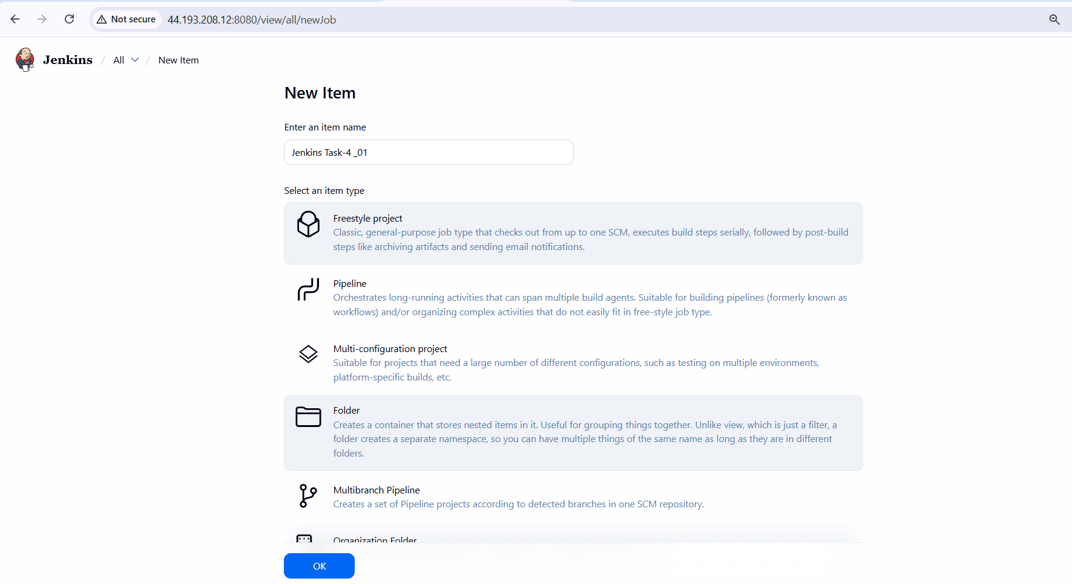

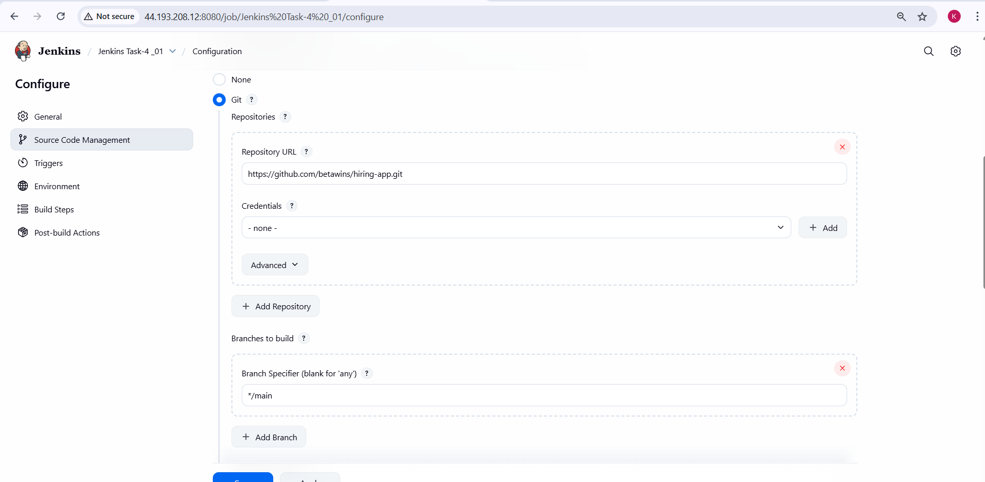

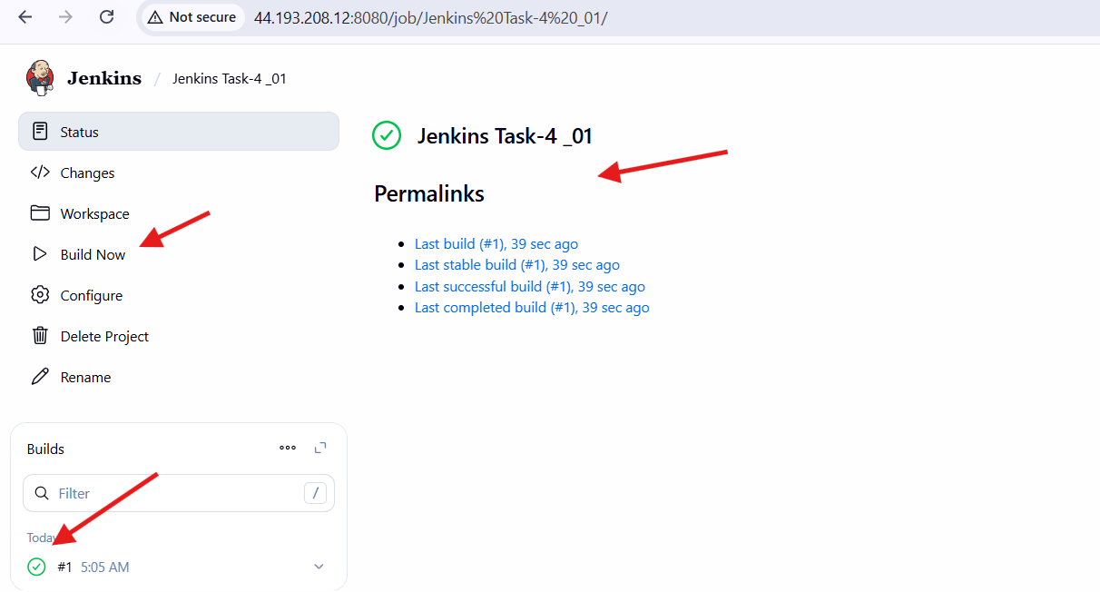

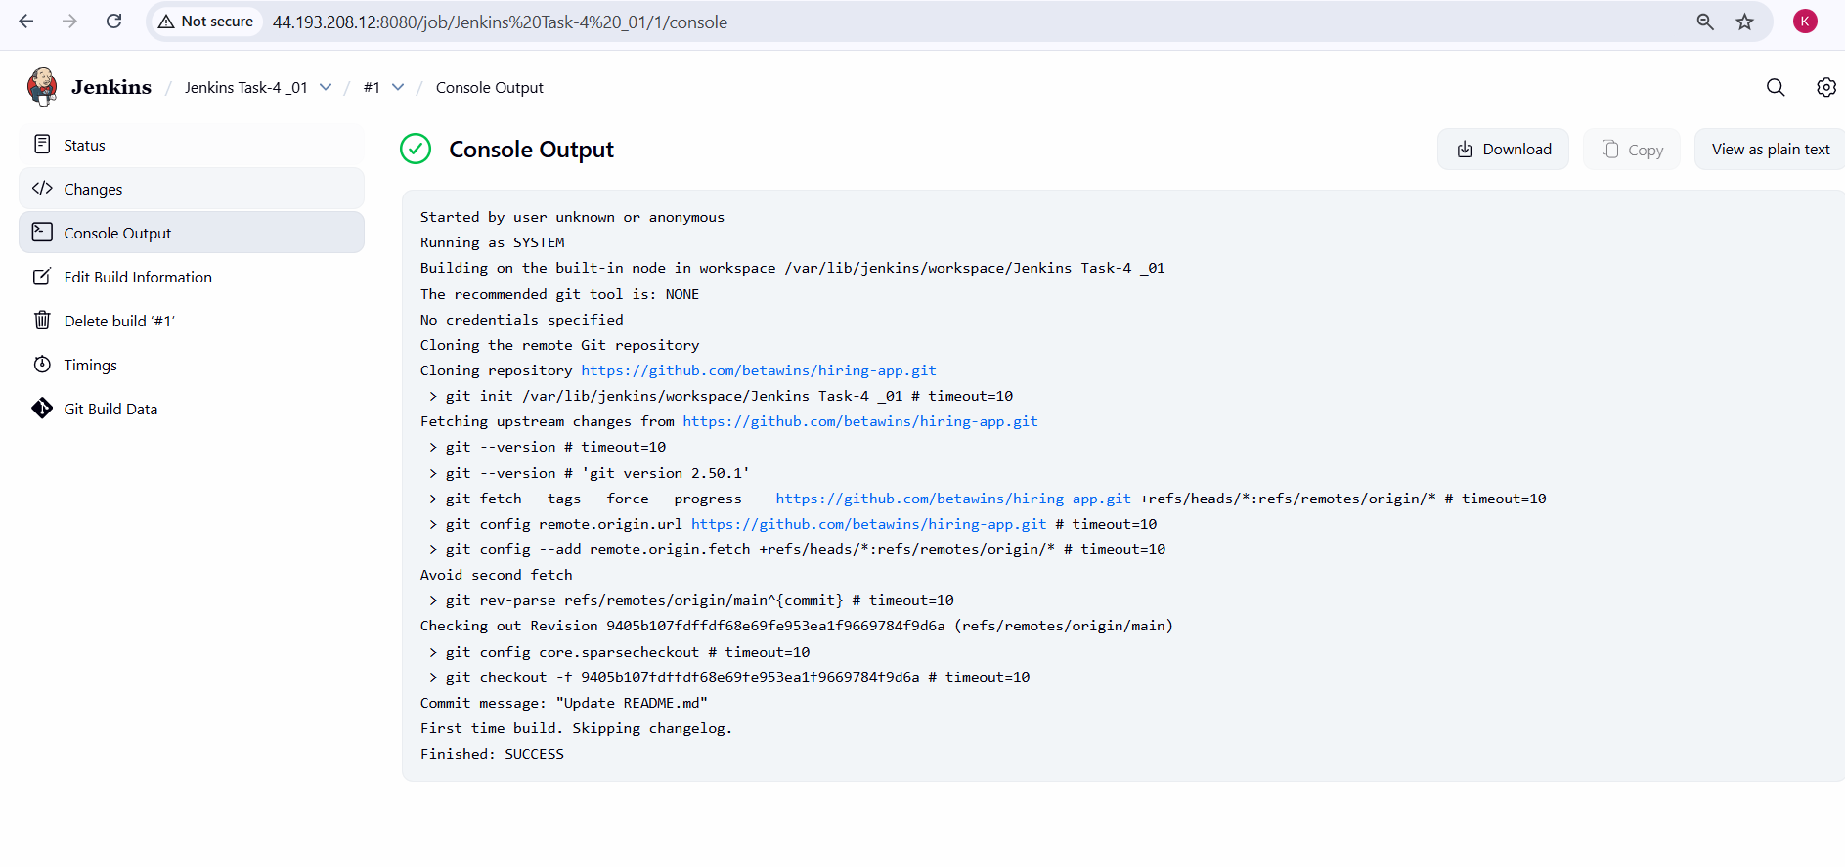

1. **SonarQube Integration**

**Steps Performed – SonarQube Integration**

**SonarQube Server Setup (Using Docker)**

1. Logged in to the **existing SonarQube EC2 server** created in previous tasks.
2. Started SonarQube using a Docker container with port mapping:
3. docker run -itd -p 9000:9000 sonarqube
4. Verified that the SonarQube container was running successfully.
5. Accessed the SonarQube web interface using:
6. http://<SonarQube-Server-IP>:9000

**SonarQube Token Generation**

1. Logged in to SonarQube as **Administrator**.
2. Navigated to **My Account → Security**.
3. Generated a new authentication token for Jenkins integration.
4. Copied and securely saved the generated token for later use.

**Jenkins Credential Configuration for SonarQube**

1. Logged in to the **existing Jenkins server**.
2. Navigated to **Manage Jenkins → Credentials → System → Global credentials**.
3. Added a new credential of type **Secret Text**.
4. Pasted the SonarQube authentication token.
5. Set the credential ID and description (example: Task-04sonar).
6. Saved the credential.

**SonarQube Server Configuration in Jenkins**

1. Navigated to **Manage Jenkins → System**.
2. Scrolled to the **SonarQube installations** section.
3. Added a new SonarQube server configuration.
4. Entered a name for the server (example: sonarqube-server).
5. Provided the SonarQube server URL:
6. http://<SonarQube-Server-IP>:9000
7. Selected the previously created SonarQube authentication token.
8. Saved the Jenkins system configuration.

**Jenkins Job Configuration for SonarQube Scan**

* Opened the existing Jenkins Freestyle job (**Jenkins Task-4 _01**).
* Added a build step to execute SonarQube analysis.
* Configured the job to run **SonarScanner** during the build.
* Ensured the scan uses the configured SonarQube server and authentication token.
* Saved the job configuration.

**Build Execution with SonarQube Analysis**

* Triggered the Jenkins job using **Build Now**.
* Jenkins executed the SonarQube scan after the Git clone stage.
* SonarScanner analyzed the source code successfully.
* Analysis report was generated and uploaded to the SonarQube server.
* Console output showed **ANALYSIS SUCCESSFUL**.

**Quality Gate Verification**

1. Navigated to the Jenkins job dashboard.
2. Verified that **SonarQube Quality Gate** status was displayed.
3. Confirmed that the Quality Gate result was **Passed**.
4. Logged in to the SonarQube dashboard.
5. Verified that the project analysis appeared with **Passed** status.

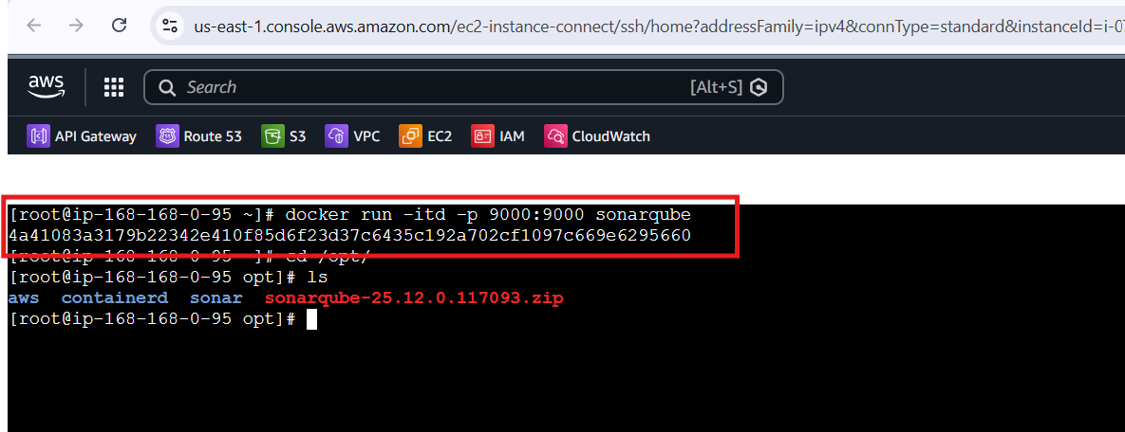

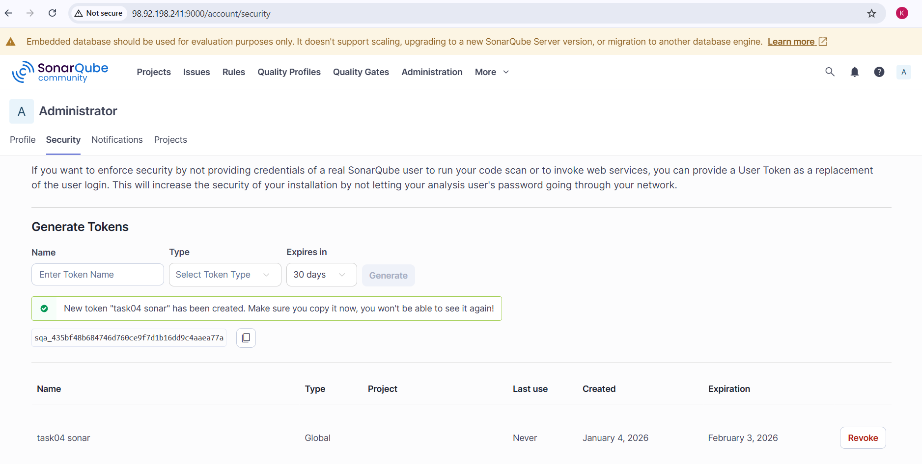

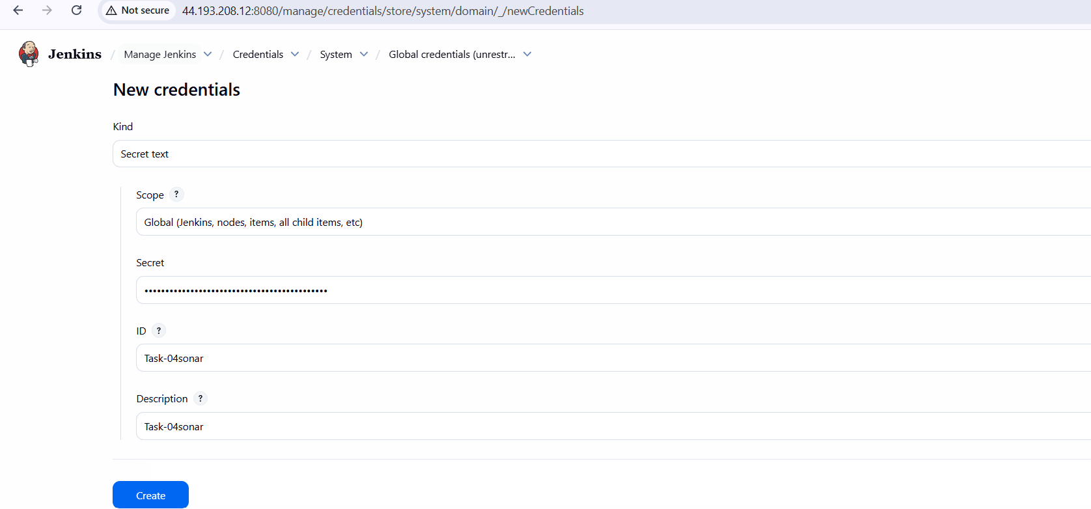

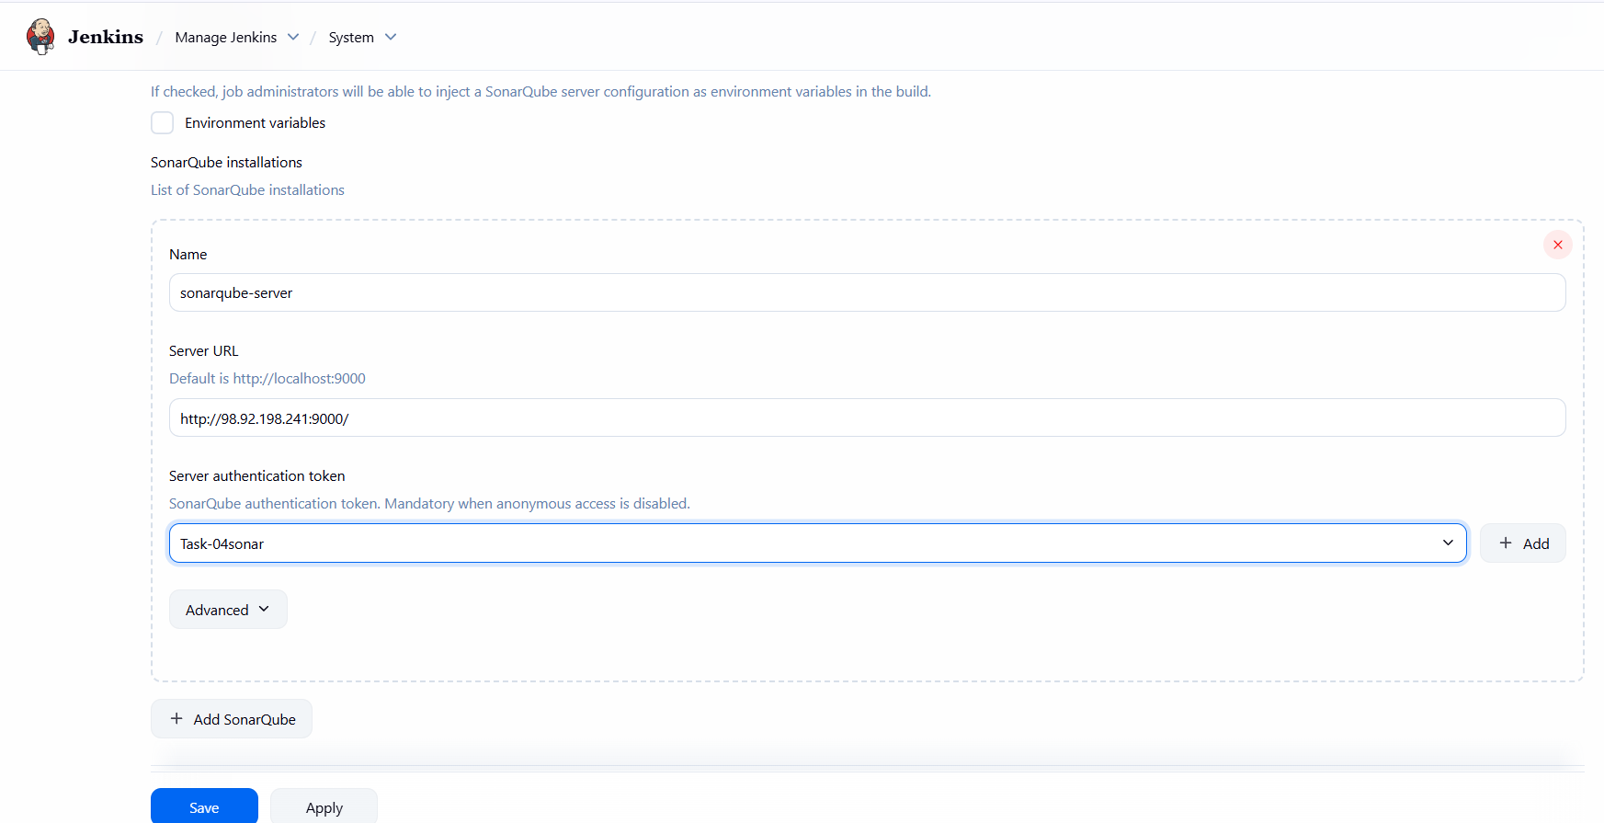

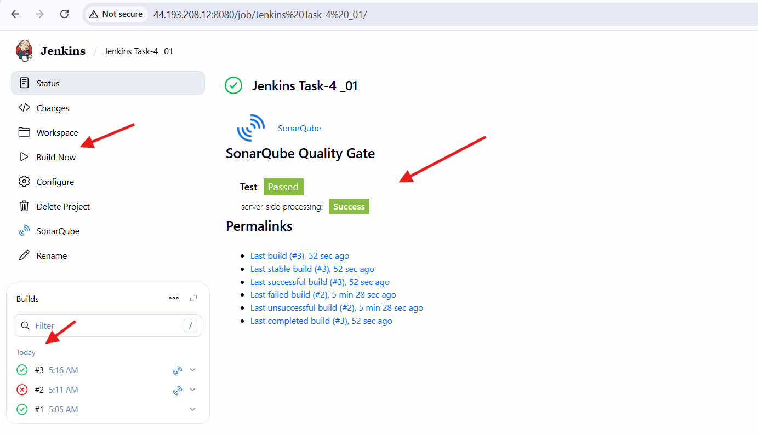

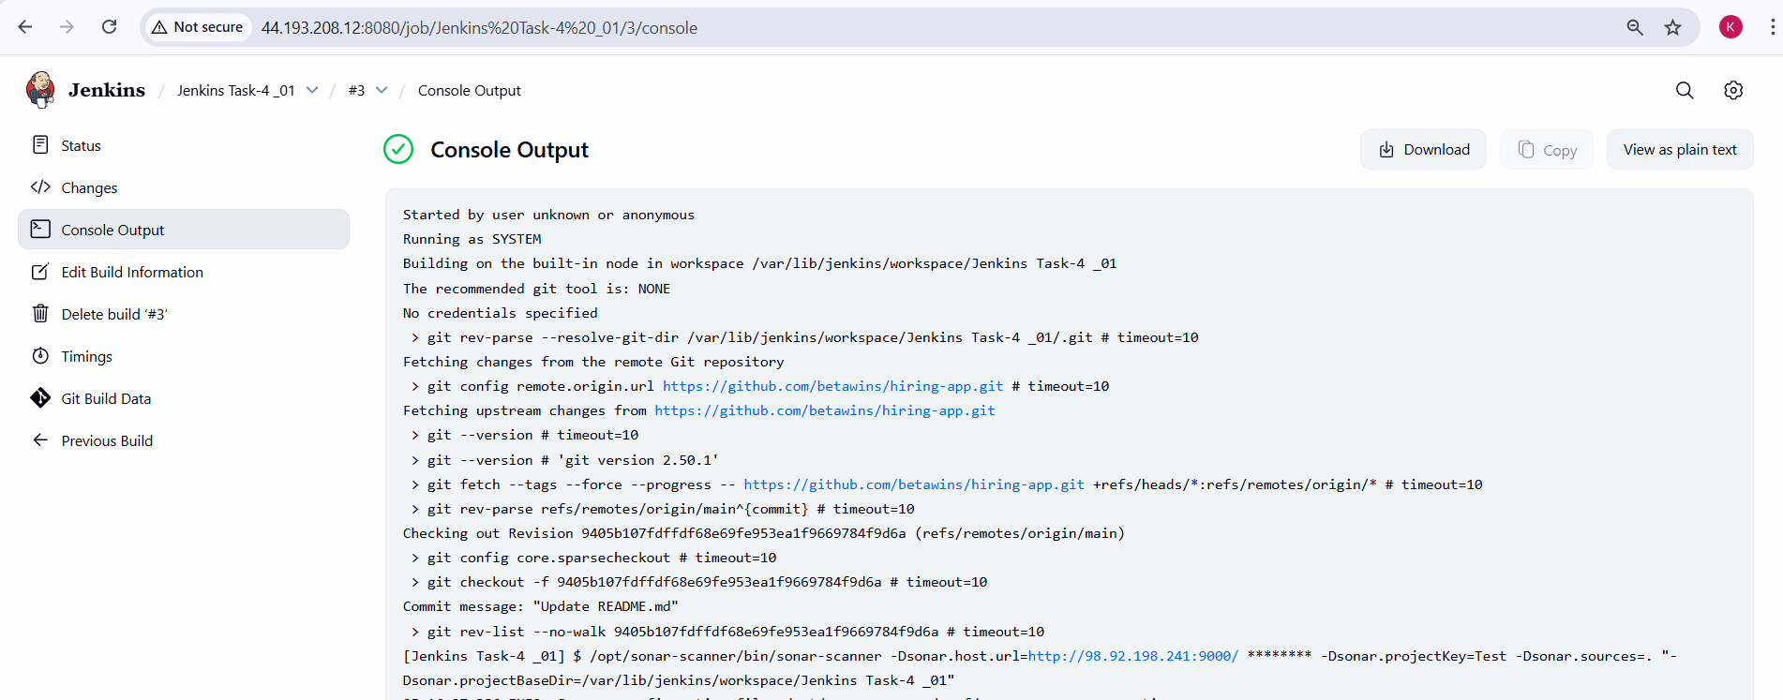

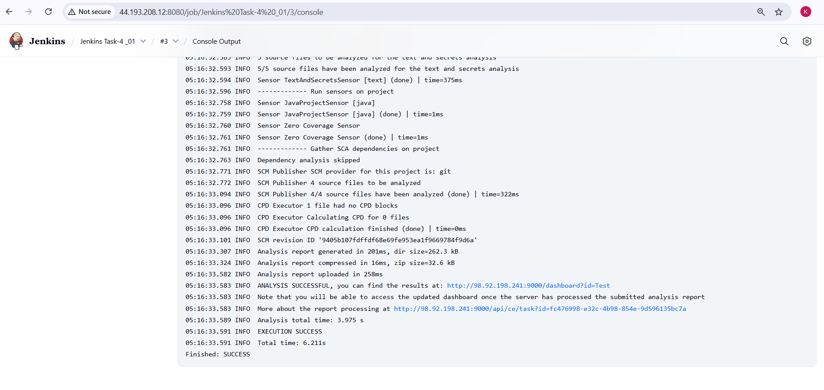

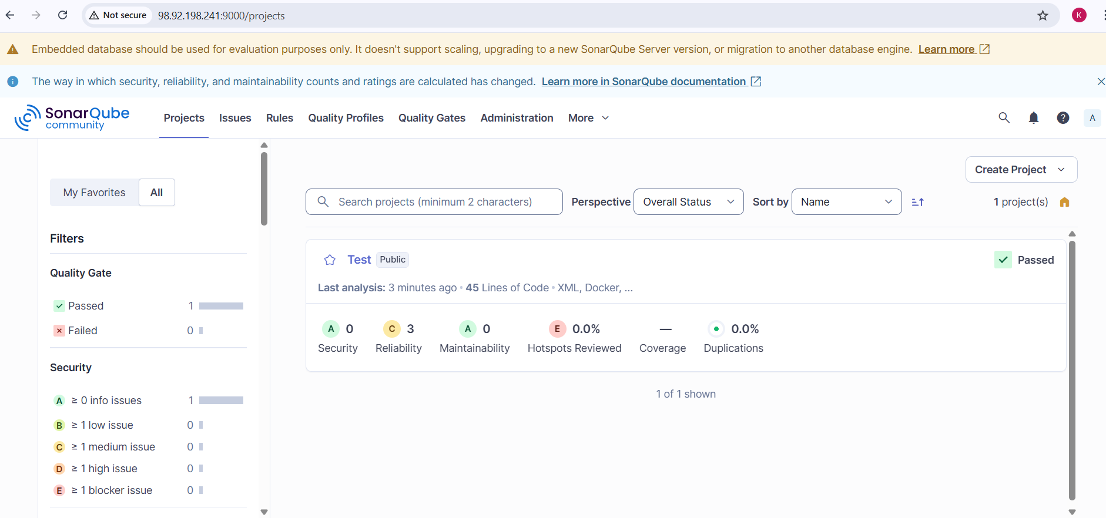

1. **Maven Compilation**

**Steps Performed – Maven Compilation**

**Maven Download**

1. Logged in to the existing Jenkins server EC2 instance created in previous tasks.
2. Opened the Apache Maven official website.
3. Selected **Apache Maven 3.9.12** binary (tar.gz) distribution.
4. Downloaded the Maven archive into the /opt directory using the terminal.

**Maven Installation**

1. Extracted the downloaded Maven archive.
2. Renamed the extracted folder to maven for standard naming.
3. Verified Maven directory structure under:
4. /opt/maven
5. Confirmed Maven binaries were available inside:
6. /opt/maven/bin

**Maven Environment Variable Configuration**

1. Edited the .bash_profile file.
2. Added Maven environment variables:
   1. Set M2_HOME=/opt/maven
   2. Updated PATH to include $M2_HOME/bin
3. Saved the configuration.
4. Reloaded the environment variables using:
5. source ~/.bash_profile
6. Verified Maven was accessible from the terminal.

**Maven Configuration in Jenkins**

1. Logged in to Jenkins dashboard.
2. Navigated to **Manage Jenkins → Tools**.
3. Added a new **Maven installation**.
4. Set the Maven name as **MVN_HOME**.
5. Provided Maven home directory as:
6. /opt/maven
7. Disabled automatic Maven installation.
8. Saved the Jenkins tool configuration.

**Jenkins Job Configuration for Maven Build**

1. Opened the existing Jenkins Freestyle job **Jenkins Task-4 _01**.
2. Navigated to **Build Steps**.
3. Added the build step **Invoke top-level Maven targets**.
4. Selected **MVN_HOME** as the Maven version.
5. Entered the Maven goals:
6. clean install
7. Saved the job configuration.

**Maven Build Execution**

1. Triggered the Jenkins job using **Build Now**.
2. Jenkins executed Maven after the SonarQube stage.
3. Maven downloaded required dependencies from the central repository.
4. Source code compilation completed successfully.
5. WAR file was generated inside the workspace.

**Maven Repository Verification**

1. Navigated to Jenkins Maven local repository:
2. /var/lib/jenkins/.m2/repository
3. Verified that project artifacts were stored under:
4. /var/lib/jenkins/.m2/repository/in/javahome/hiring/0.1
5. Confirmed presence of hiring-0.1.pom and related files.
6. Observed correct ownership by the **jenkins** user.

**Jenkins Workspace Verification**

* Navigated to the Jenkins workspace:
* /var/lib/jenkins/workspace/Jenkins Task-4 _01
* Verified project structure including:
  + pom.xml
  + src directory
  + target directory
* Navigated to the target folder.
* Confirmed successful generation of:

hiring.war

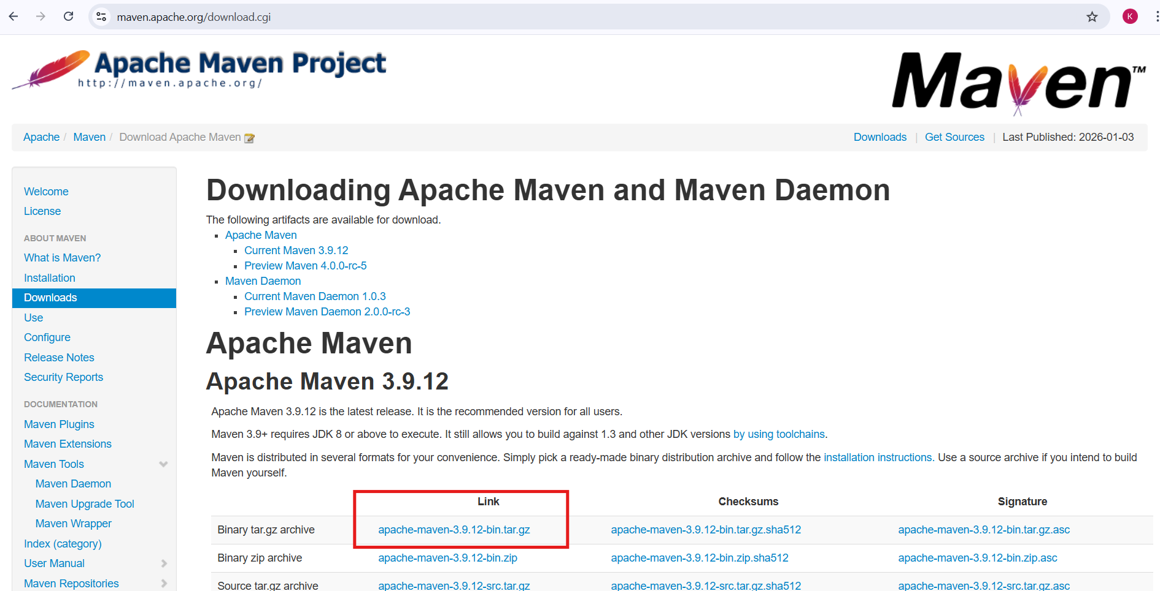

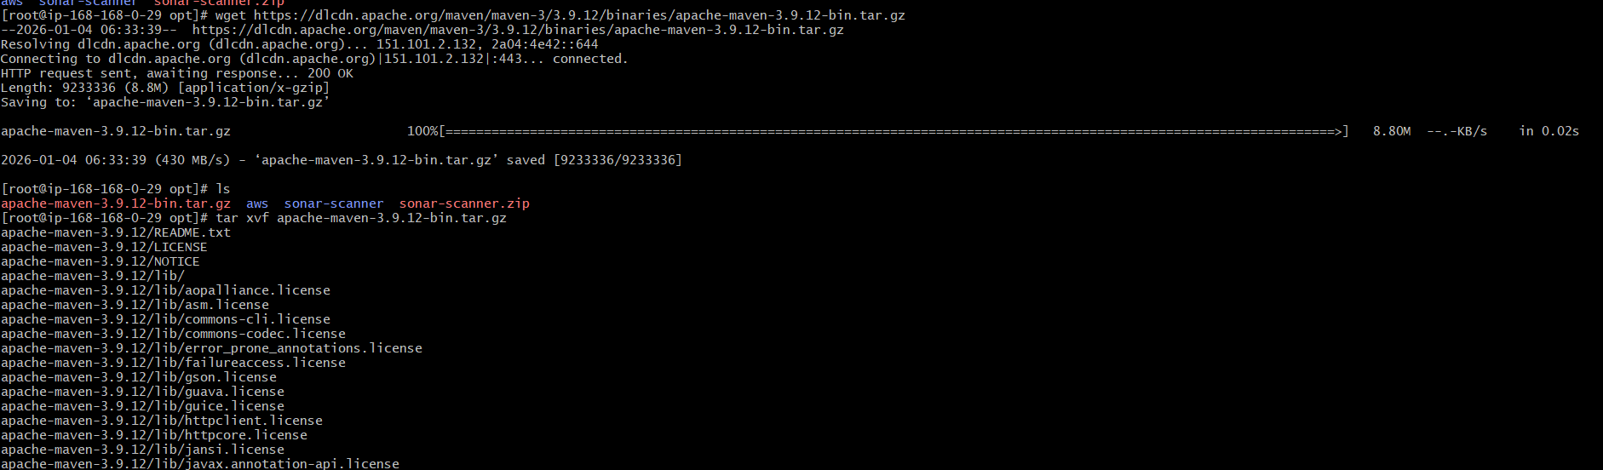

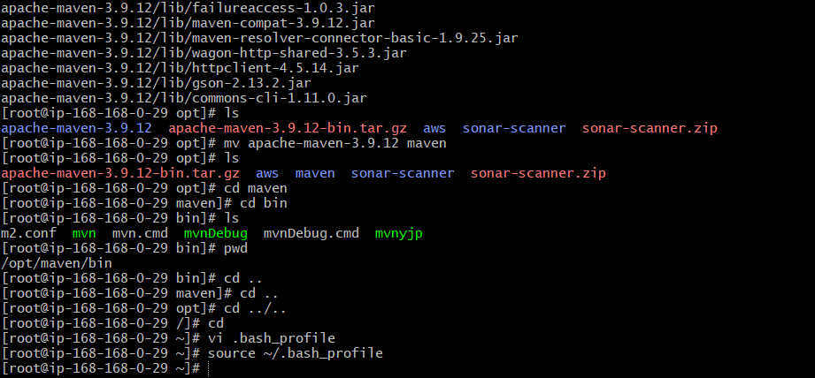

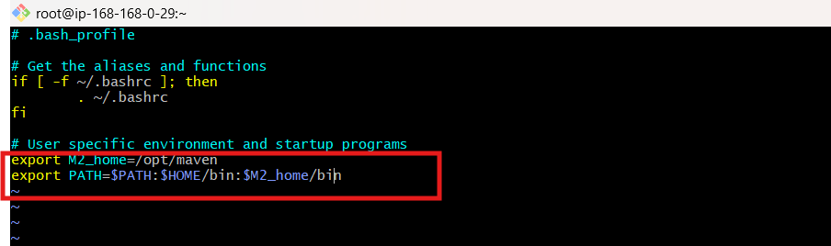

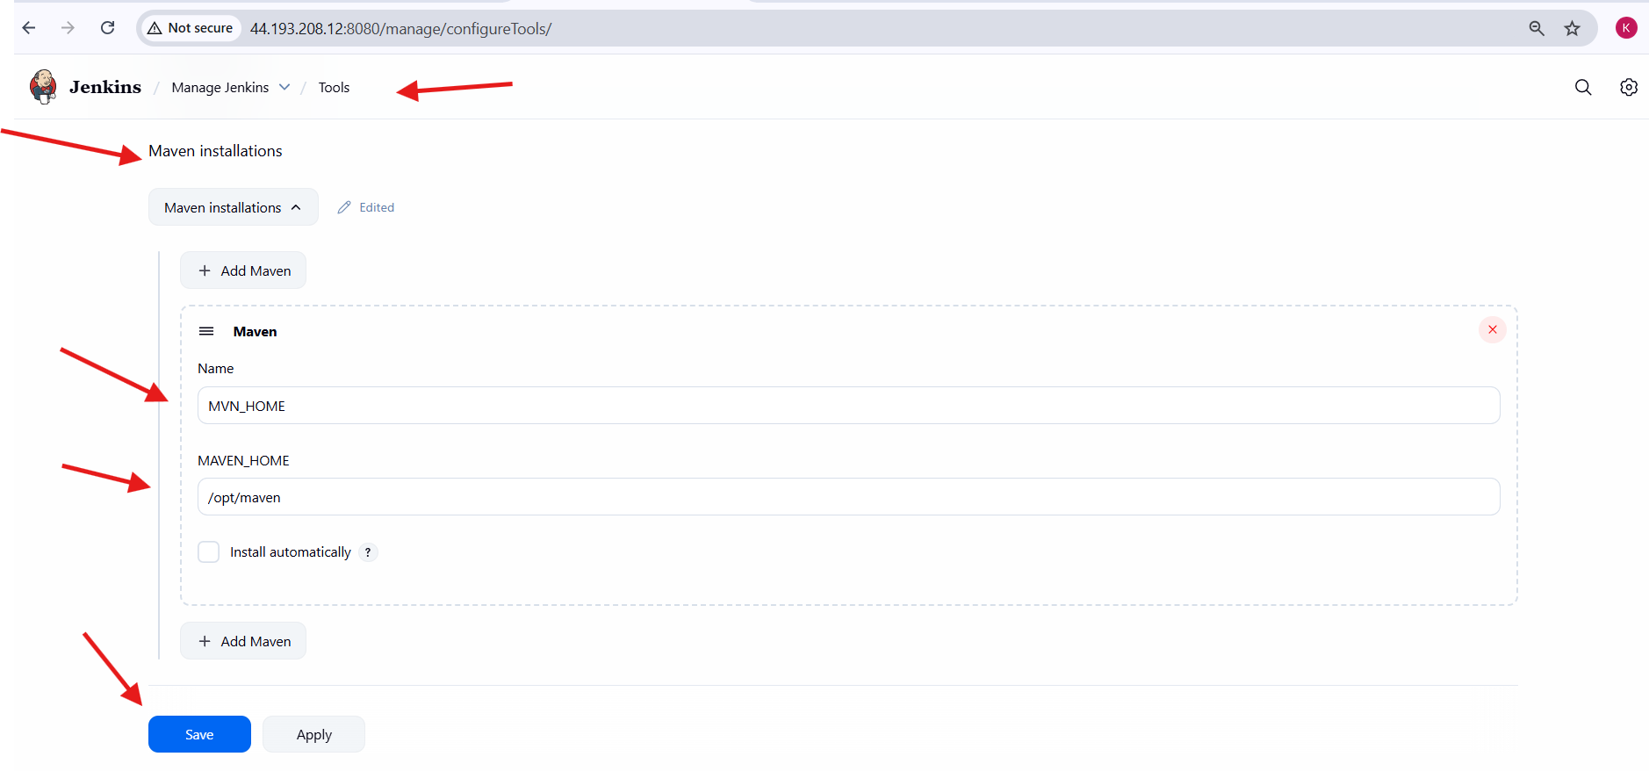

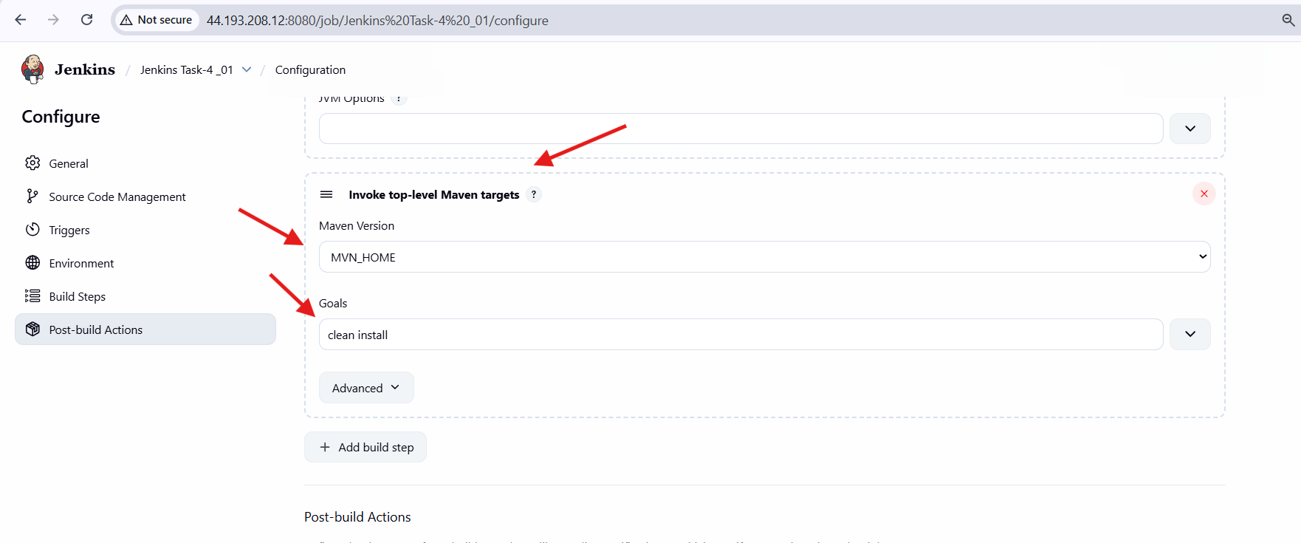

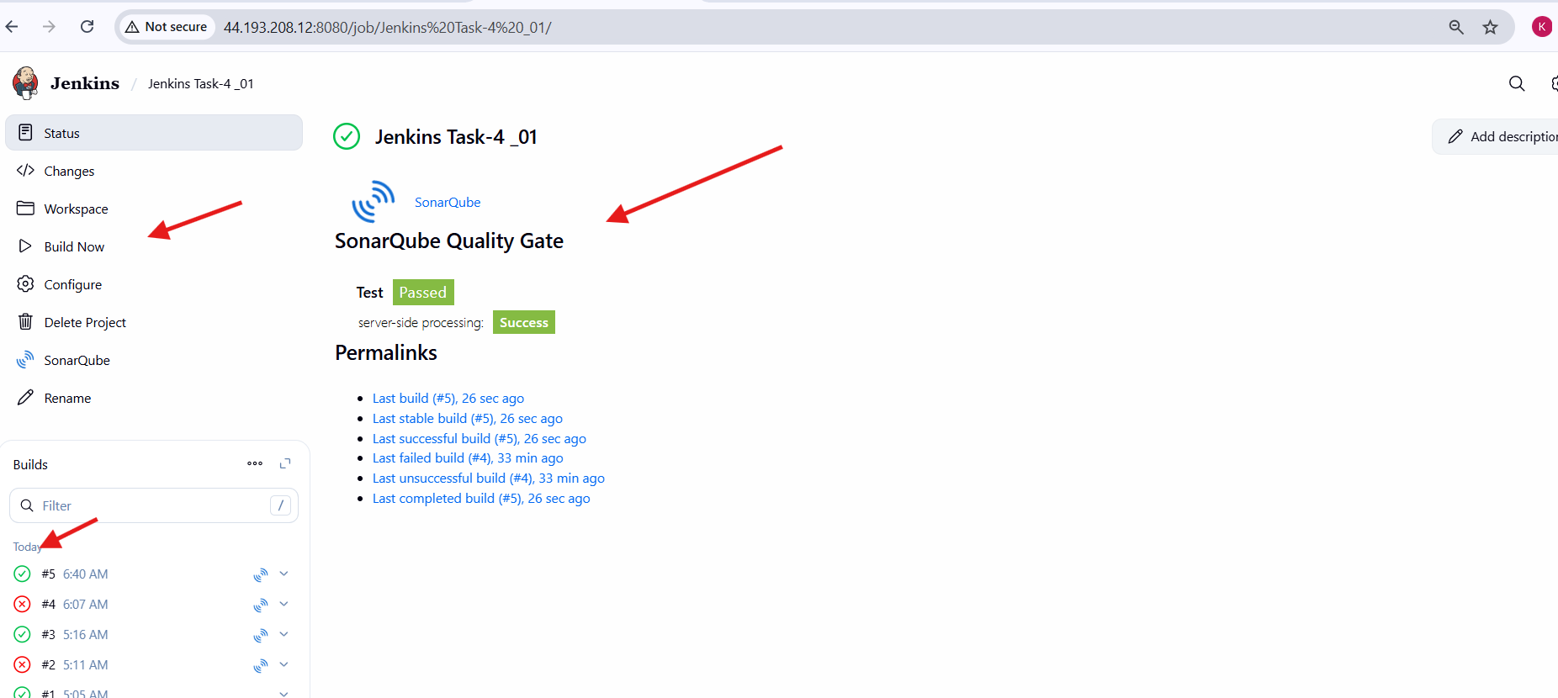

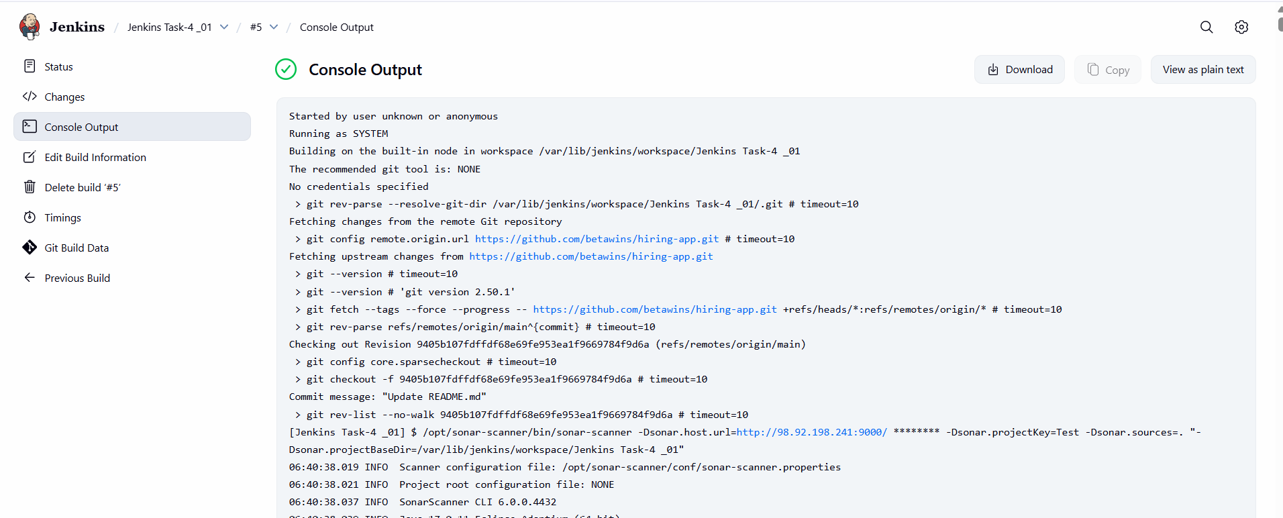

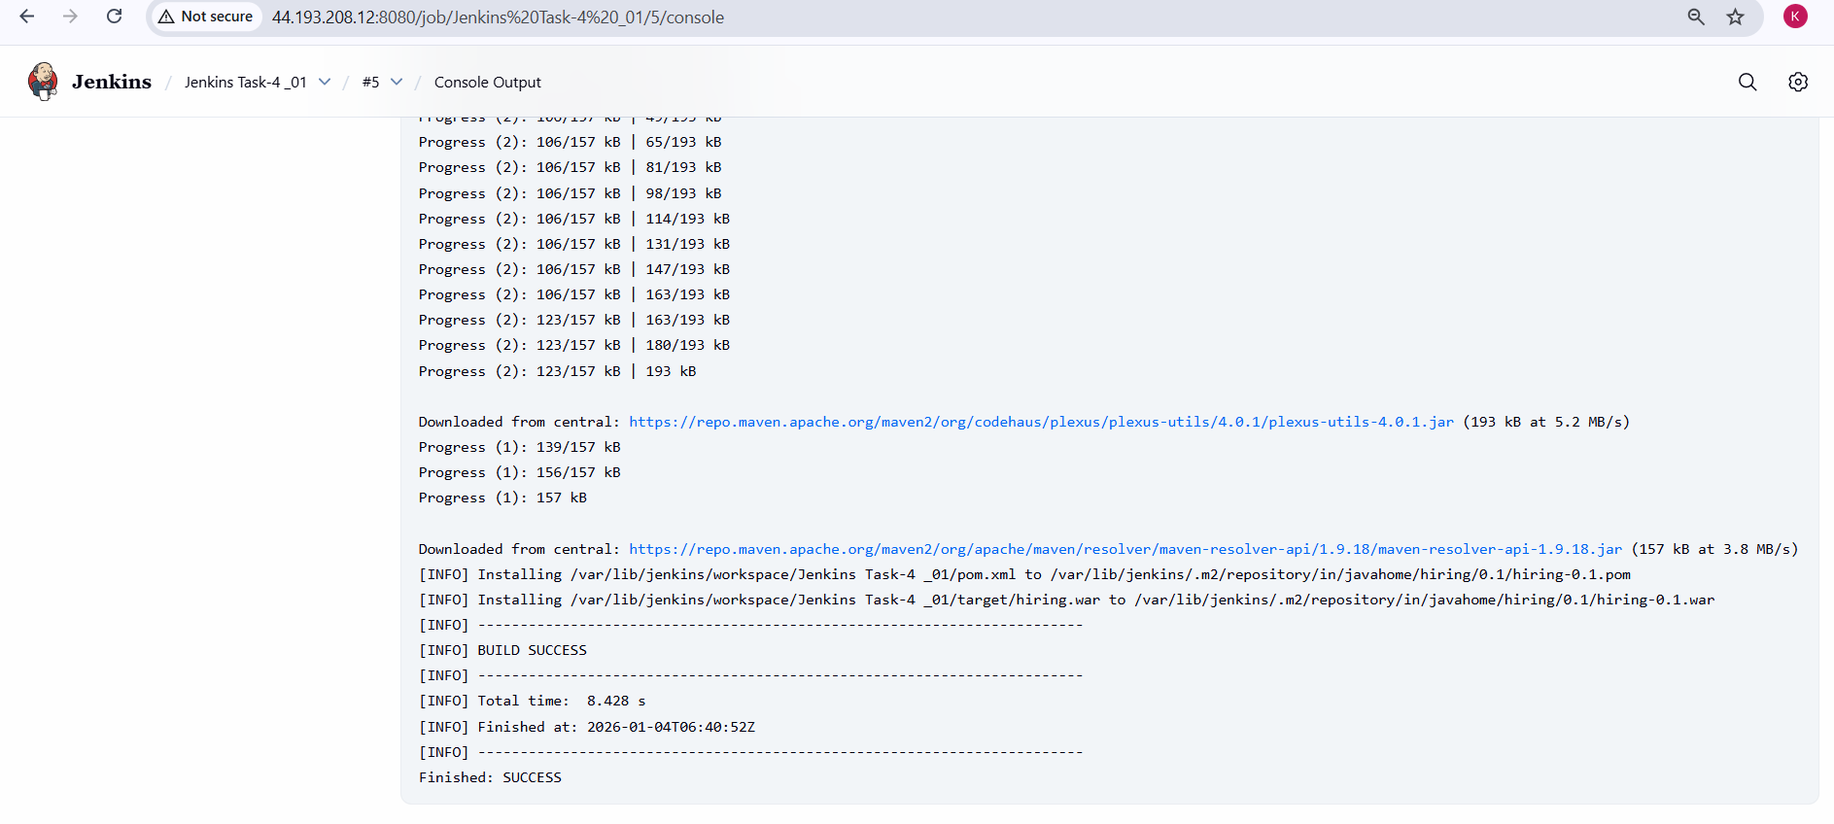

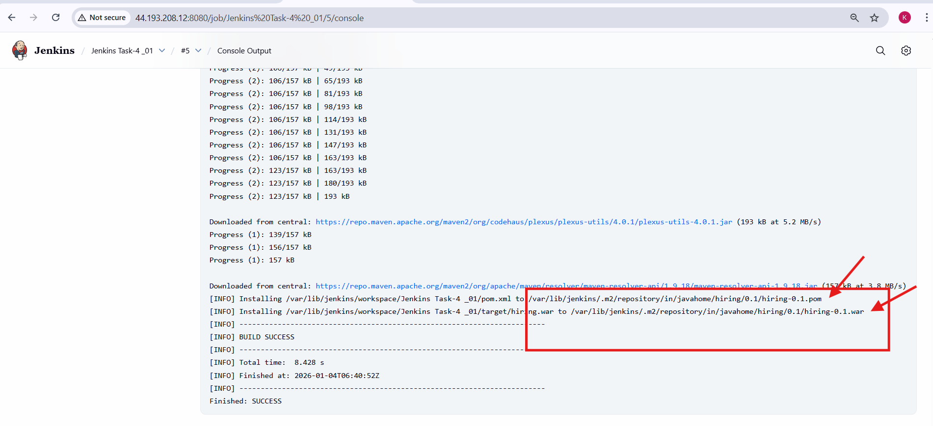

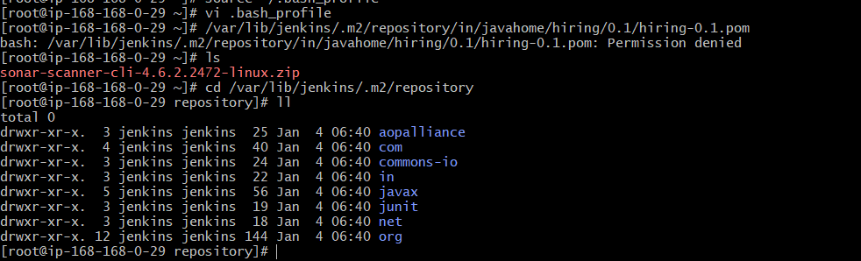

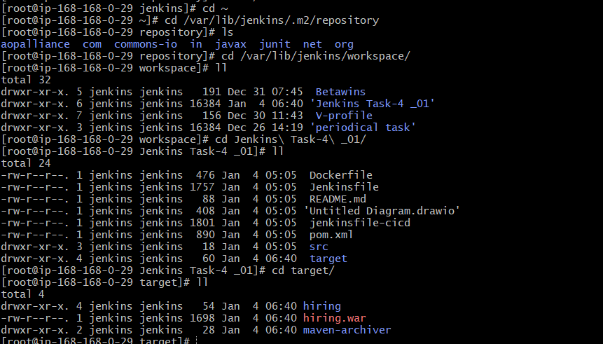

**4.Nexus Artifactory**

**Nexus Artifactory – Steps Performed**

**1. Launch Nexus EC2 Server**

* Logged in to AWS Console.
* Started the existing EC2 instance created for Nexus.
* Verified instance state is **Running**.
* Connected to the Nexus EC2 server using SSH.

**2. Install Java (Prerequisite for Nexus)**

1. Installed Java 17 (Amazon Corretto) on Nexus server.
2. Verified Java installation to ensure Nexus compatibility.

**3. Download Nexus Repository Manager**

1. Navigated to Sonatype official download page.
2. Selected **Nexus Repository Manager 3.x for Linux (x86_64)**.
3. Downloaded the archive:
4. nexus-3.87.1-01-linux-x86_64.tar.gz
5. Stored the file under /opt directory.

**4. Extract and Prepare Nexus Directory**

1. Extracted the downloaded Nexus archive.
2. Renamed extracted folder to:
3. /opt/nexus
4. Confirmed Nexus directory structure (bin, etc, deploy, jdk).

**5. Configure Nexus to Run as Non-Root User**

1. Edited Nexus startup script:
2. /opt/nexus/bin/nexus
3. Updated the following property:
4. run_as_user="ec2-user"
5. Ensured Nexus runs securely as a non-root user.

**6. Fix Nexus Data Directory Permissions**

1. Verified Nexus data directory:
2. /opt/sonatype-work
3. Changed ownership to Nexus user:
4. chown -R ec2-user:ec2-user /opt/sonatype-work
5. Updated permissions:
6. chmod -R 755 /opt/sonatype-work

**7. Start Nexus Service**

1. Navigated to Nexus binary directory:
2. cd /opt/nexus/bin
3. Started Nexus service:
4. ./nexus start
5. Verified Nexus process is running using:
6. ps -ef | grep nexus

**8. Verify Nexus Port and Access**

1. Verified Nexus is listening on port **8081**:
2. ss -lntp | grep 8081
3. Accessed Nexus UI from browser:
4. http://<NEXUS_PUBLIC_IP>:8081

**9. Login to Nexus Web Interface**

1. Retrieved initial admin password from:
2. /opt/sonatype-work/nexus3/admin.password
3. Logged in using:
   1. Username: admin
   2. Password: (from admin.password file)
4. Completed initial setup wizard.
5. Changed admin password.

**10. Create Maven Hosted Repository**

* Navigated to:
* Settings → Repositories → Create repository
* Selected repository type:
* maven2 (hosted)
* Configured repository:
  + Name: jenkins_task-4-nexus
  + Version policy: Mixed
  + Layout policy: Permissive
  + Blob store: default
* Saved repository configuration.

**11. Install Nexus Plugin in Jenkins**

* Opened Jenkins Dashboard.
* Navigated to:
* Manage Jenkins → Plugins → Available Plugins
* Searched for **Nexus Artifact Uploader** plugin.
* Installed the plugin.
* Verified successful installation in plugin download progress.

**12. Configure Nexus Credentials in Jenkins**

1. Navigated to:
2. Manage Jenkins → Credentials → Global
3. Added new credentials:
   1. Kind: Username & Password
   2. Username: admin
   3. Password: Nexus admin password
   4. ID: Nexus_cred
4. Saved credentials.

**13. Configure Nexus Artifact Upload in Jenkins Job**

1. Opened Jenkins job configuration.
2. Navigated to **Build Steps**.
3. Added **Nexus Artifact Uploader**.
4. Configured Nexus details:
   1. Nexus Version: NEXUS3
   2. Protocol: HTTP
   3. Nexus URL: http://<NEXUS_PUBLIC_IP>:8081
   4. Credentials: Nexus_cred
5. Configured artifact details:
   1. GroupId: in.javahome
   2. ArtifactId: hiring
   3. Version: 0.1
   4. Packaging: war
   5. File: target/hiring.war
   6. Repository: jenkins_task-4-nexus
6. Saved job configuration.

**14. Trigger Jenkins Job for Nexus Upload**

1. Triggered Jenkins job using **Build Now**.
2. Maven build completed successfully.
3. Nexus upload step executed.

**15. Verify Artifact Upload in Jenkins Console**

1. Checked Jenkins console output.
2. Confirmed:
   1. Artifact upload started
   2. Upload completed successfully
   3. No errors during upload

**16. Verify Artifact in Nexus Repository**

1. Logged into Nexus Web UI.
2. Navigated to:
3. Browse → jenkins_task-4-nexus
4. Verified repository path:
5. in/javahome/hiring/0.1/
6. Confirmed presence of:
7. hiring-0.1.war

**17. Nexus Artifactory Ready for Deployment**

1. Artifact successfully stored in Nexus.
2. WAR file available for:
   1. Tomcat deployment
   2. Future CI/CD stages

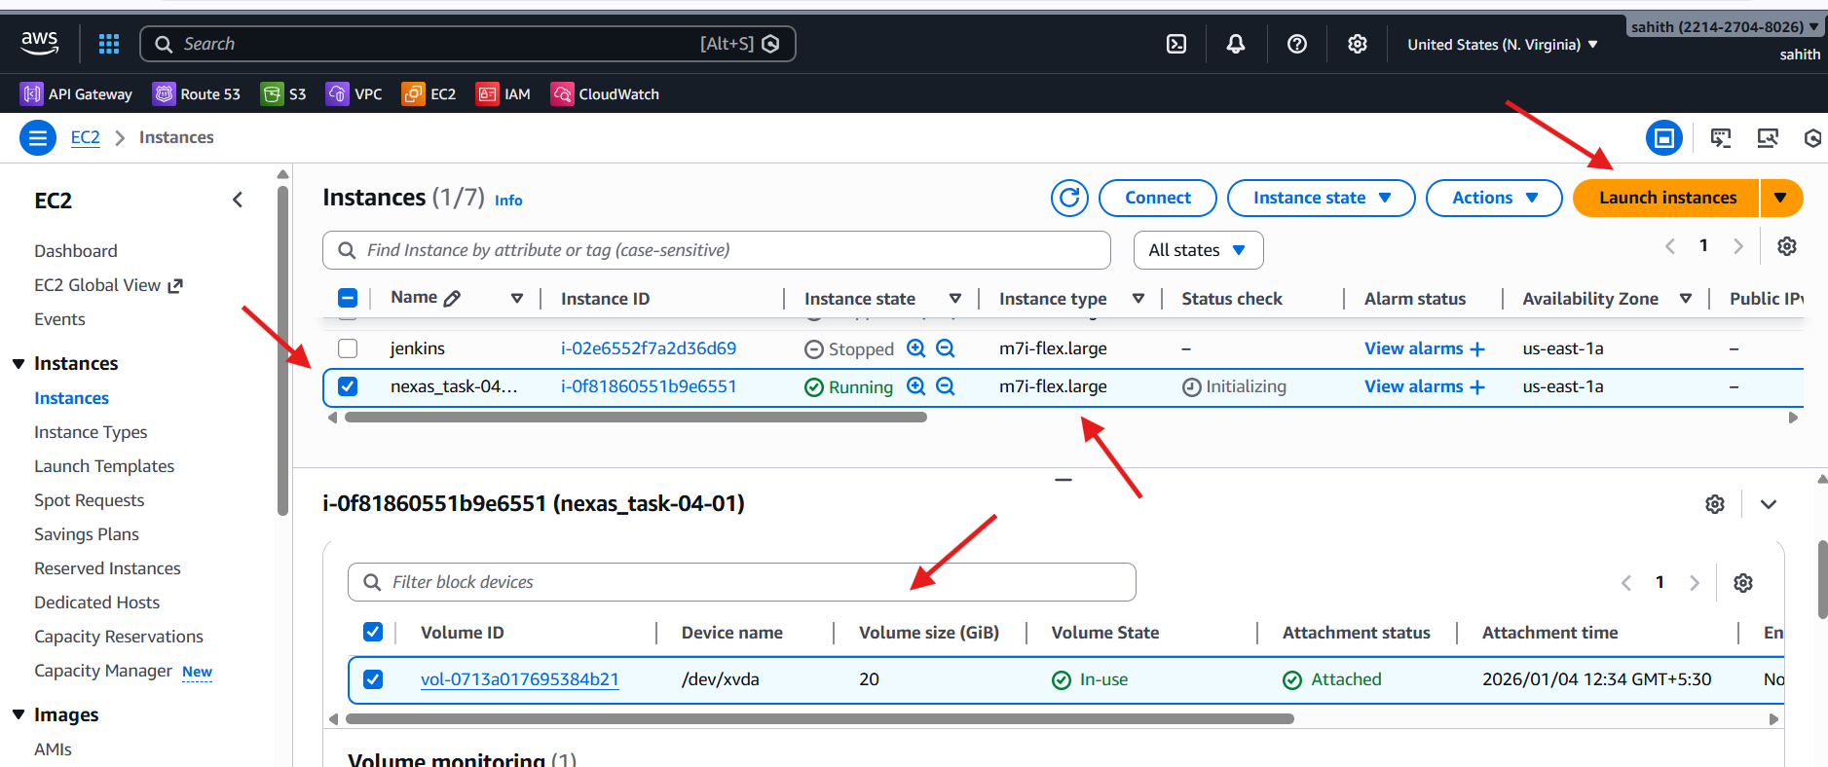

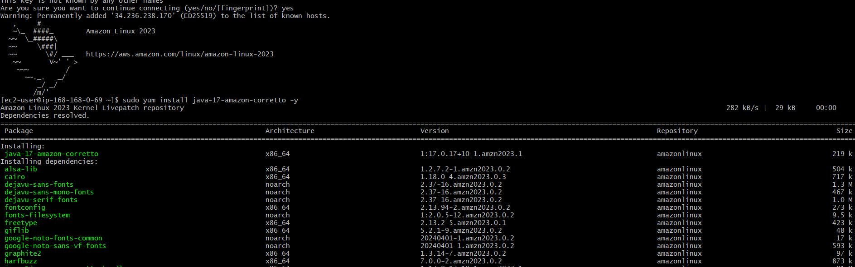

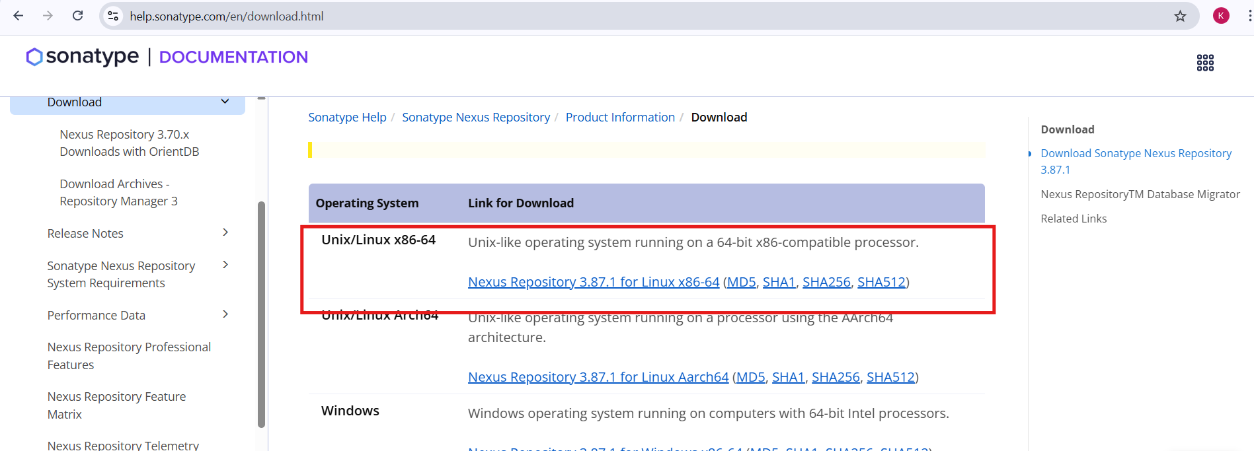

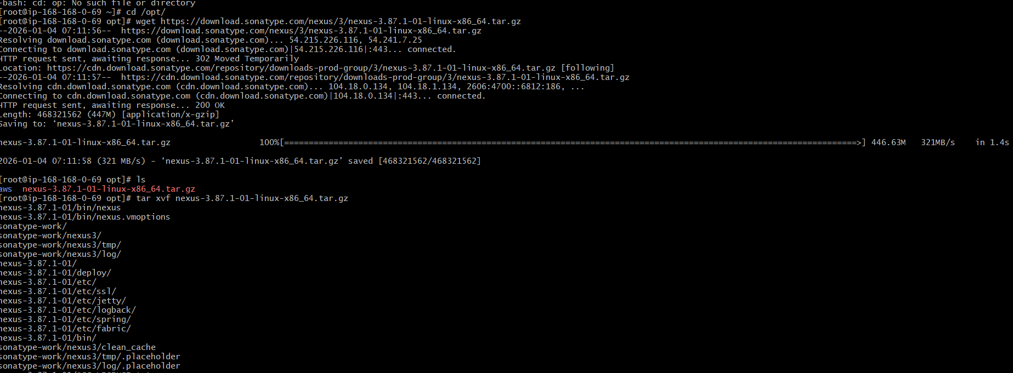

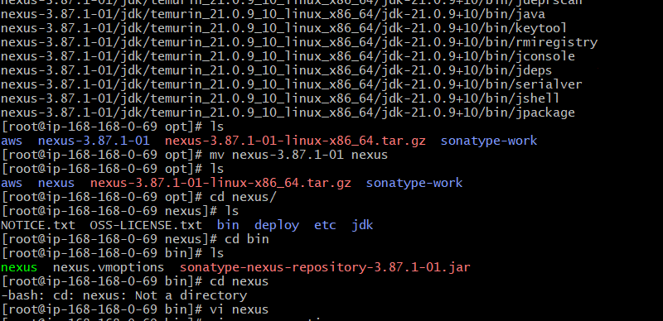

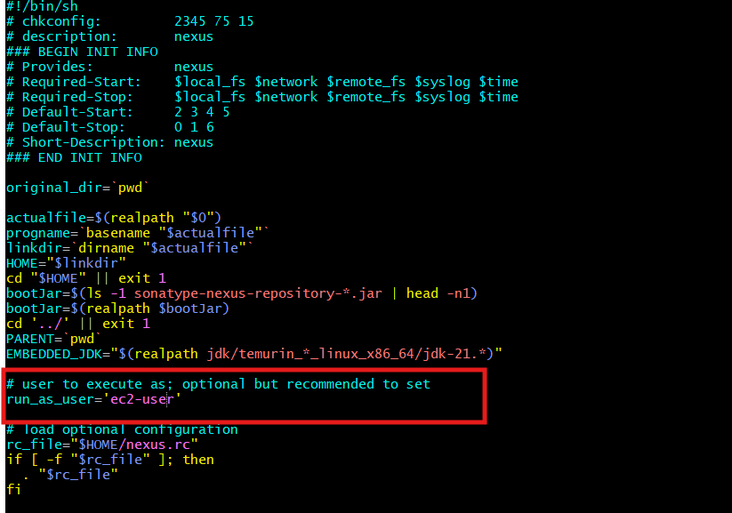

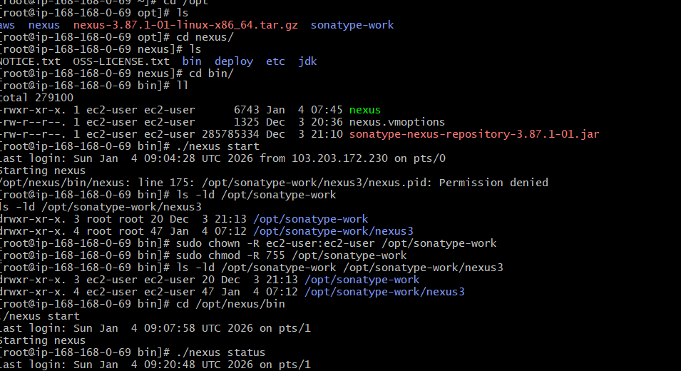

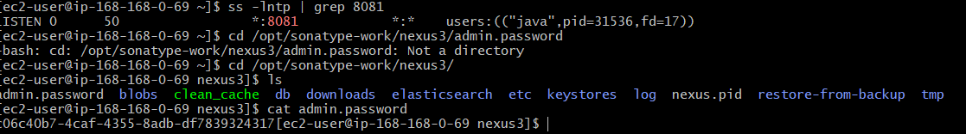

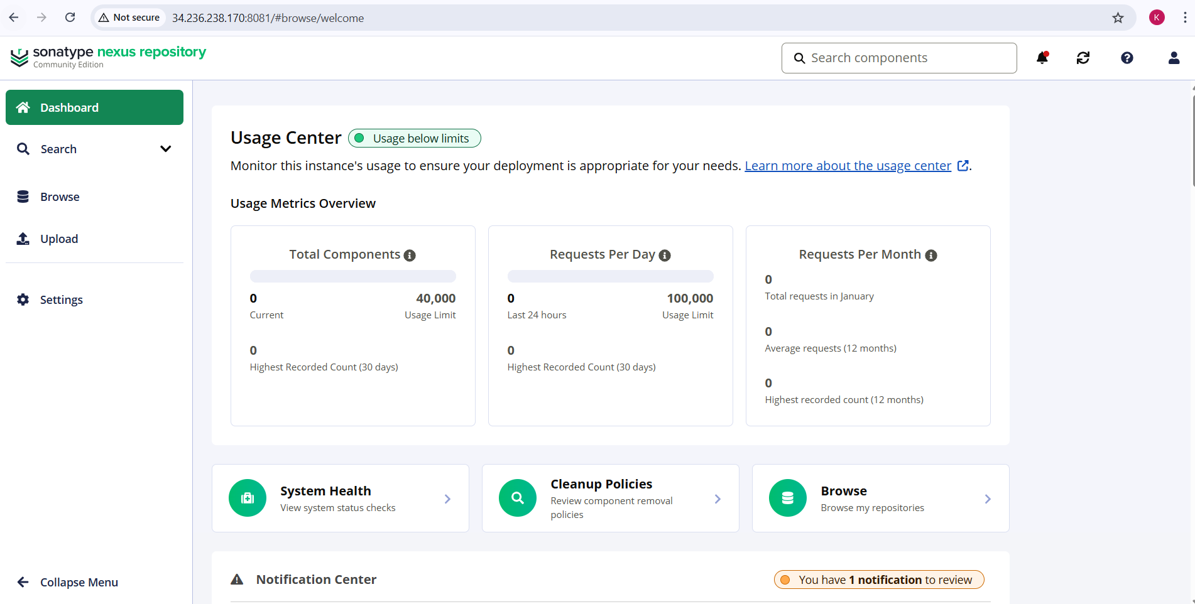

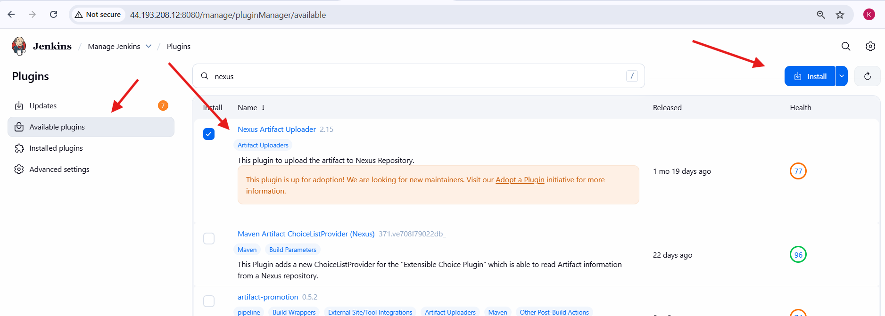

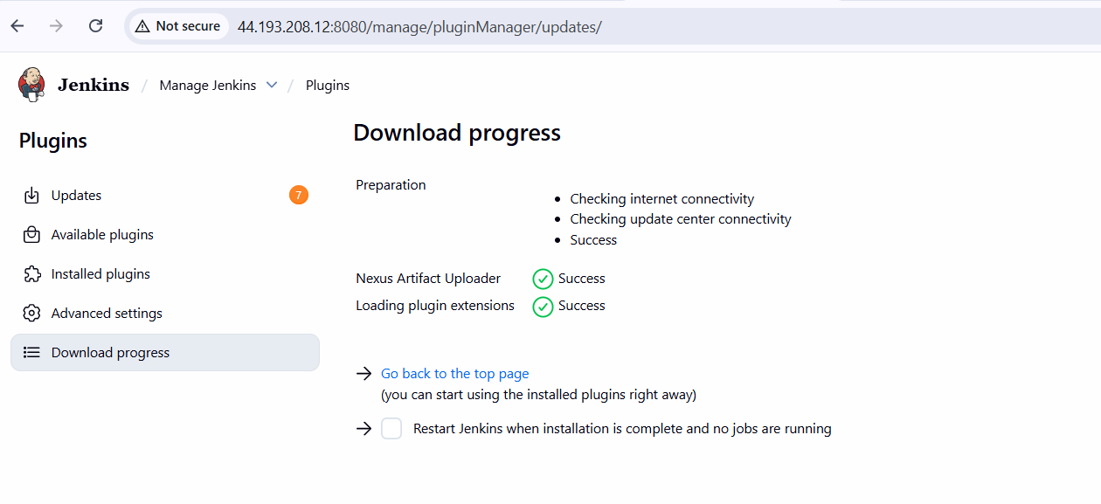

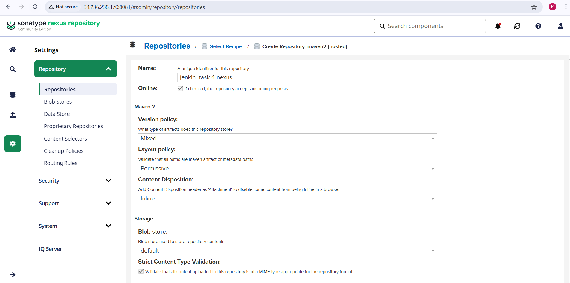

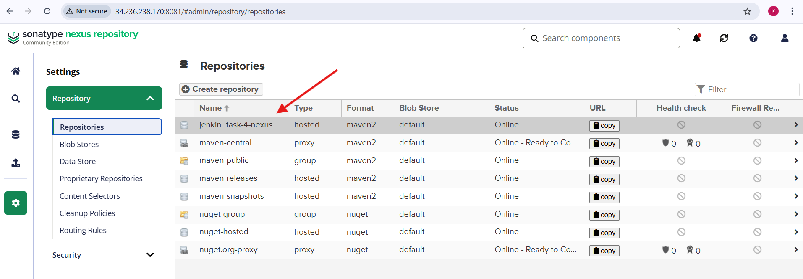

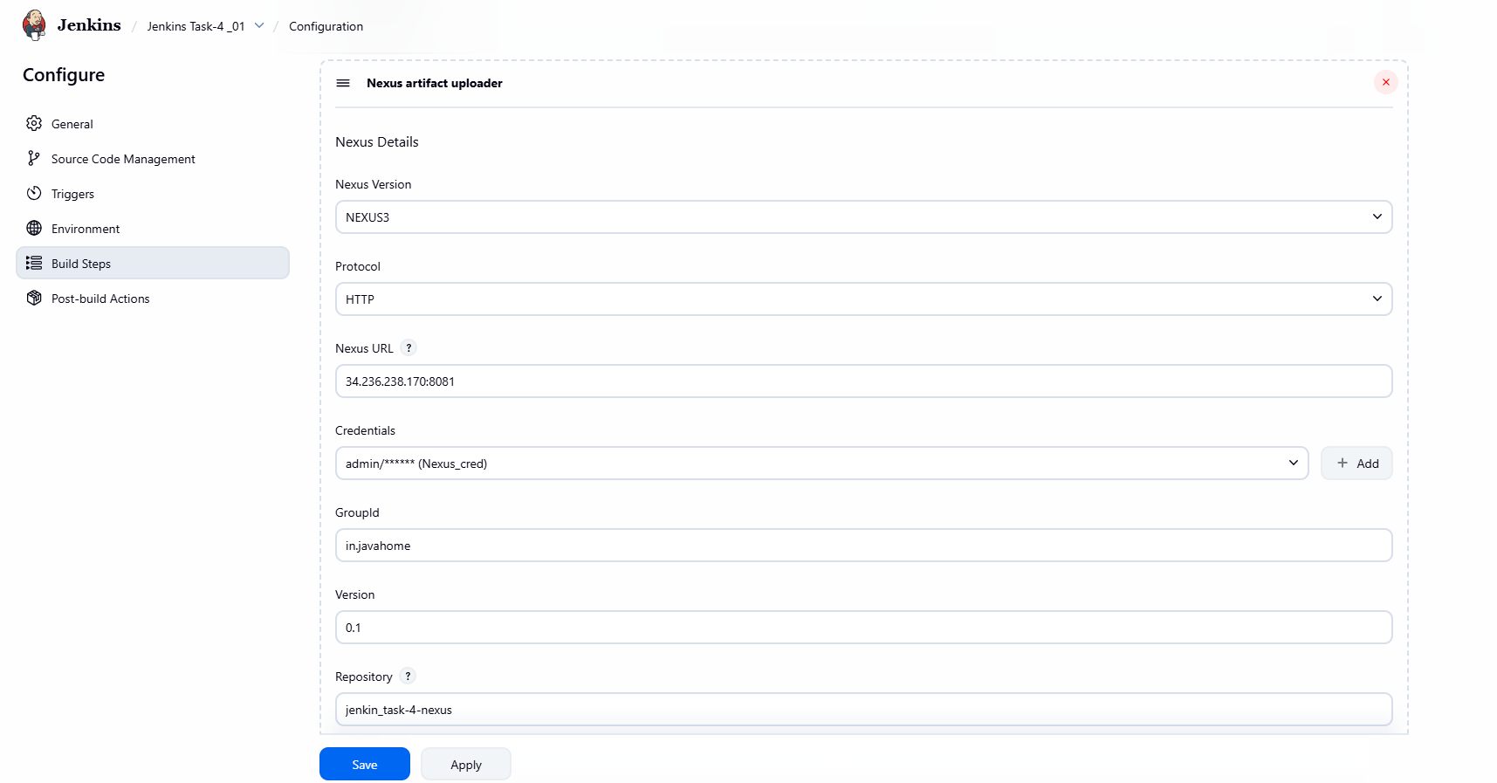

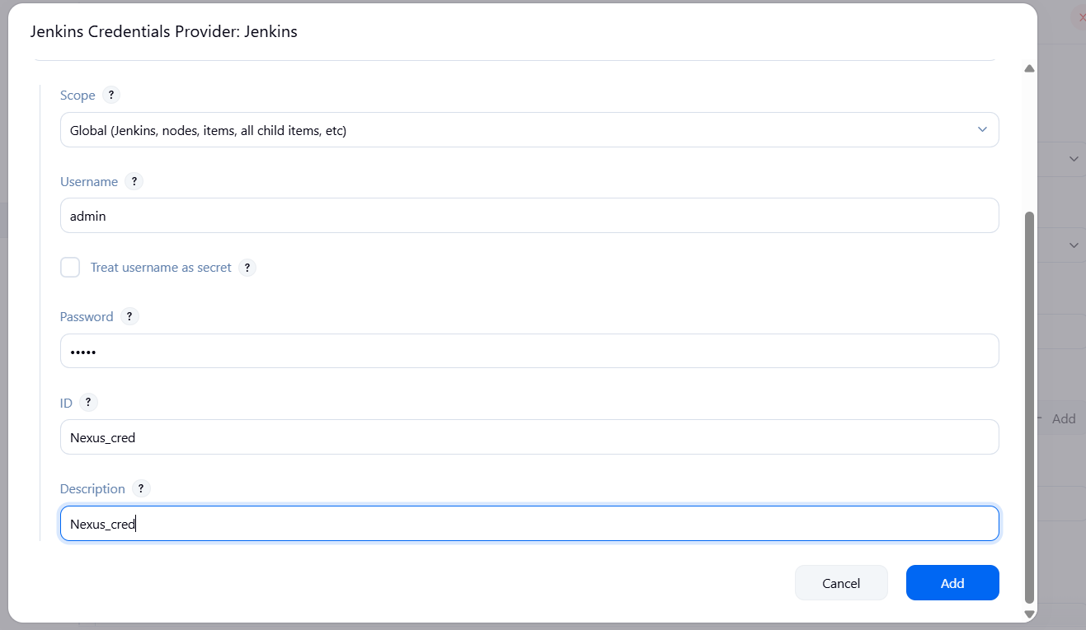

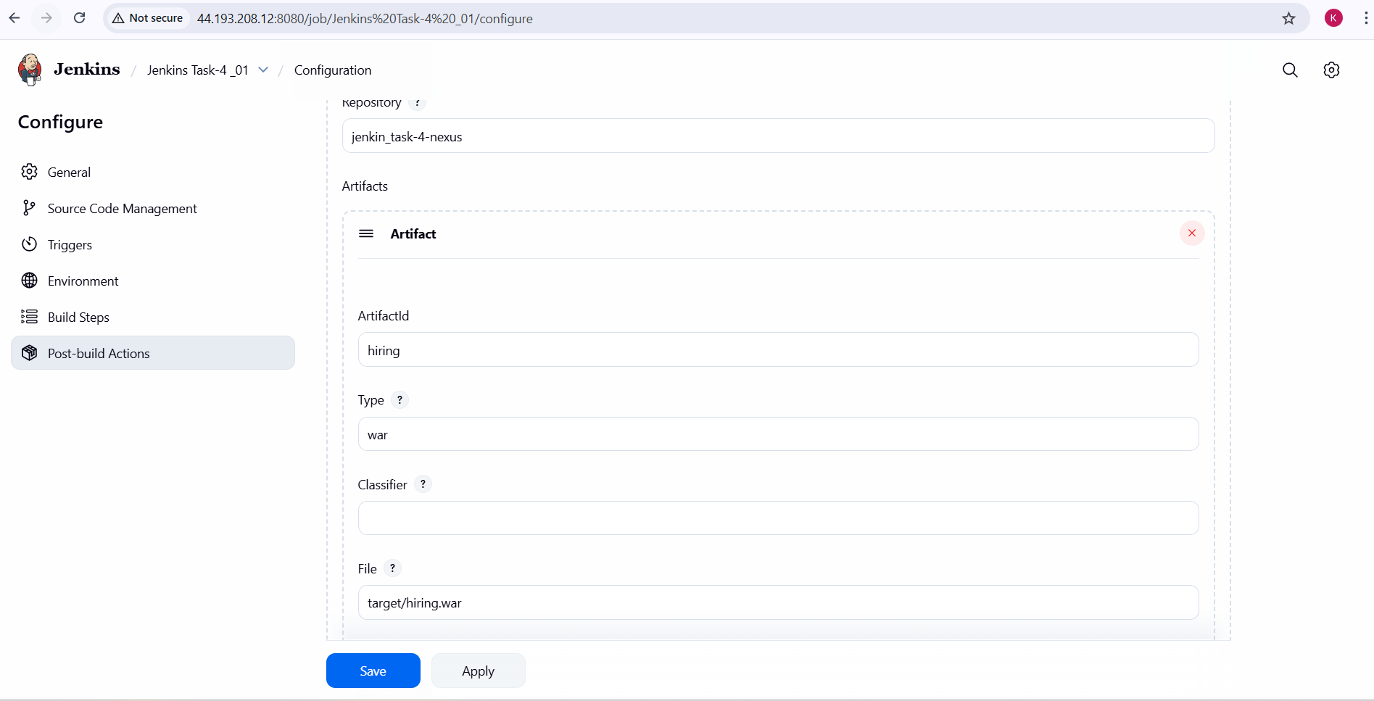

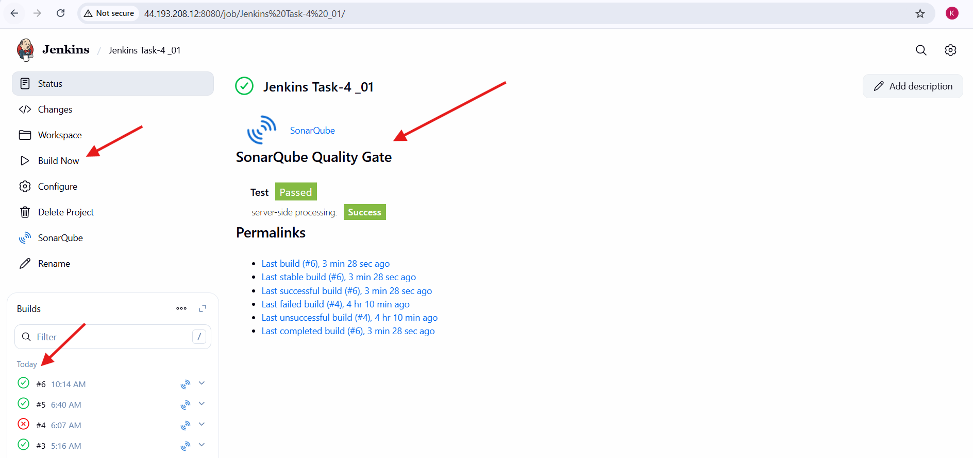

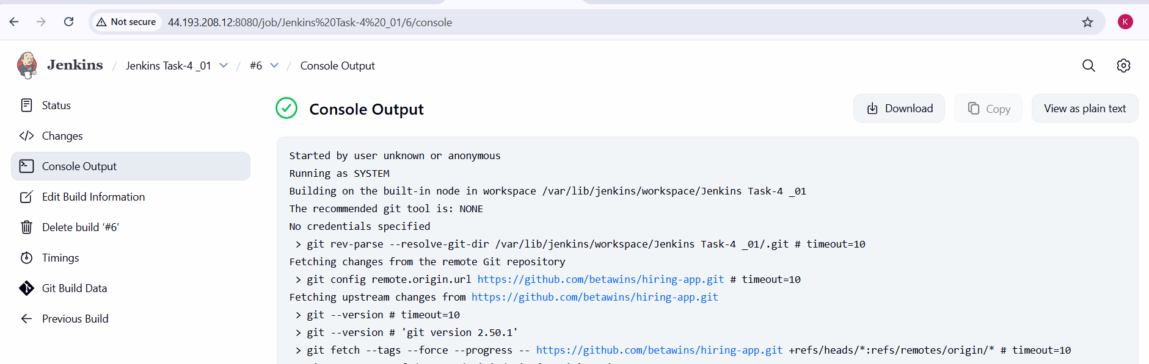

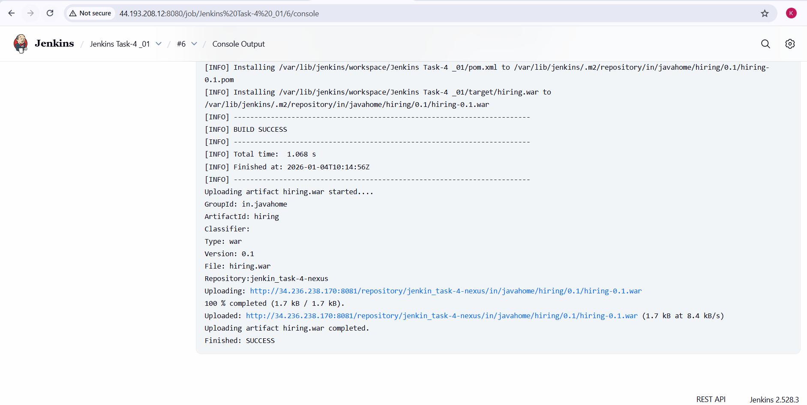

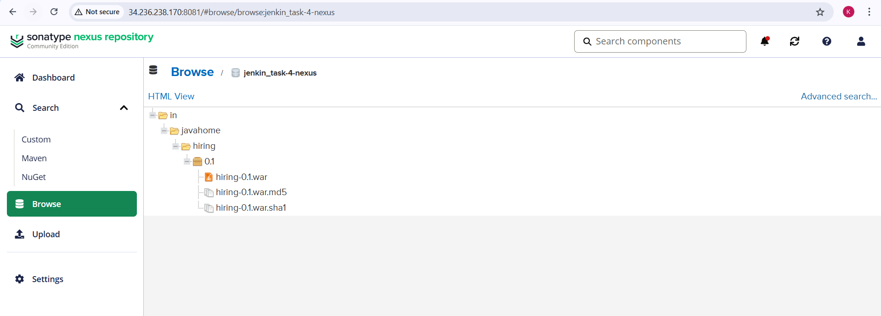

**5.Slack Notification**

**Slack Notification – Steps Performed**

**Slack Integration Prerequisites**

1. An existing Slack workspace and channel (for example: #jenkins-integration)
2. Jenkins server already installed and running
3. Jenkins Slack plugin installed
4. Incoming Webhook or Slack App configured (done in earlier tasks)

**Step 1: Install Slack Plugin in Jenkins**

1. Navigated to **Manage Jenkins → Plugins**
2. Searched for **Slack Notification Plugin**
3. Installed the plugin
4. Restarted Jenkins to apply the plugin changes

**Step 2: Configure Slack in Jenkins Global Settings**

* Navigated to **Manage Jenkins → Configure System**
* Scrolled to **Slack** section
* Entered:
  + **Workspace** name
  + **Default Channel** (e.g., #jenkins-integration)
  + **Slack Webhook URL** / Slack App credentials
* Tested the connection to confirm Jenkins can send messages to Slack
* Saved the configuration

**Step 3: Enable Slack Notifications in Jenkins Job**

* Opened the Jenkins freestyle job **Jenkins Task-4_01**
* Clicked **Configure**
* Scrolled to **Post-build Actions**
* Selected **Slack Notifications**

**Step 4: Configure Notification Triggers**

1. Enabled the following options:
   1. Notify Build Start
   2. Notify Success
   3. Notify Every Failure
2. Left unnecessary notifications unchecked to avoid spam
3. Saved the job configuration

**Step 5: Trigger Jenkins Job**

1. Clicked **Build Now**
2. Jenkins pipeline executed successfully
3. Build status changed to **SUCCESS**

**Step 6: Verify Slack Notifications**

1. Opened Slack channel #jenkins-integration
2. Verified notifications received for:
   1. Build Started
   2. Build Successful
3. Messages included:
   1. Job name
   2. Build number
   3. Build status
   4. Jenkins job link

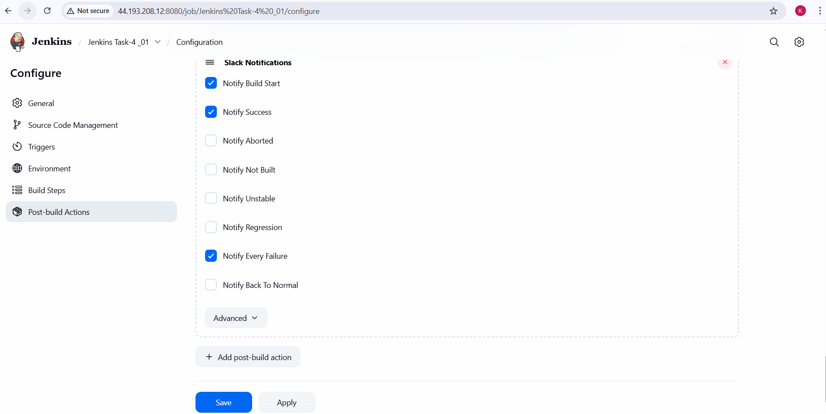

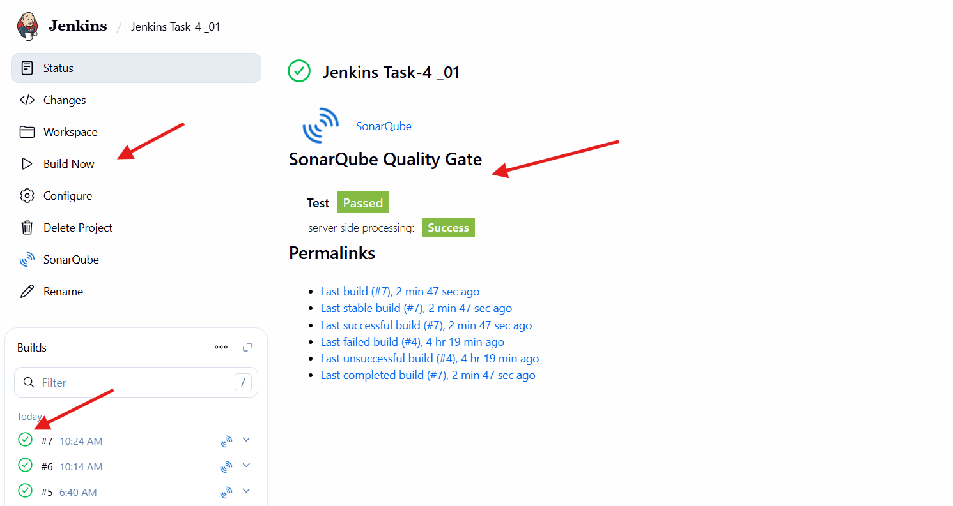

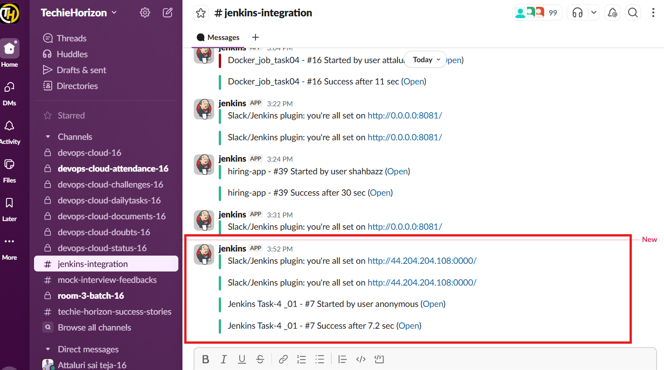

**6.Deploy On tomcat**

**Tomcat EC2 Instance Preparation**

1. Launched a new EC2 instance dedicated for Tomcat deployment.
2. Connected to the instance using SSH.
3. Updated the system packages.
4. Installed **Java 17 (Amazon Corretto)** as the required runtime for Tomcat.
5. Verified Java installation to ensure it was available in the system path.

**Download and Install Apache Tomcat**

1. Downloaded **Apache Tomcat 9.0.113** from the official Apache Tomcat website.
2. Extracted the downloaded archive in the /opt directory.
3. Renamed the extracted folder to /opt/tomcat for standard usage.
4. Verified the Tomcat directory structure (bin, conf, webapps, logs).

**Start Tomcat Server**

1. Navigated to /opt/tomcat/bin.
2. Started Tomcat using the startup script.
3. Confirmed Tomcat startup without errors.
4. Accessed the Tomcat default homepage using the public IP and port **8080**.

**Configure Remote Access for Tomcat Manager**

1. Located all context.xml files for:
   1. Manager application
   2. Host Manager application
2. Edited each context.xml file.
3. Removed IP-based access restrictions to allow remote connections.
4. Saved the configuration files.

**Configure Tomcat Users and Roles**

1. Opened tomcat-users.xml under /opt/tomcat/conf.
2. Defined required Tomcat roles:
   1. manager-gui
   2. manager-script
   3. manager-jmx
   4. manager-status
3. Created users with appropriate role permissions:
   1. Admin user with full manager access
   2. Deployer user for automated deployments
4. Saved the configuration file.

**Restart Tomcat After Configuration**

* Restarted Tomcat to apply configuration changes.
* Verified Tomcat Manager and Host Manager access via browser.
* Logged in successfully using configured credentials.

**Install Jenkins Deployment Plugin**

* Opened Jenkins dashboard.
* Navigated to **Manage Jenkins → Plugins → Available plugins**.
* Installed **Deploy to container** plugin.
* Verified successful plugin installation.

**Configure Tomcat Credentials in Jenkins**

1. Navigated to **Manage Jenkins → Credentials**.
2. Added new credentials of type **Username with password**.
3. Entered Tomcat admin username and password.
4. Assigned a unique credential ID.
5. Saved the credentials.

**Configure Jenkins Job for Tomcat Deployment**

1. Opened the existing Jenkins freestyle job configuration.
2. Added **Post-build Action → Deploy war/ear to a container**.
3. Selected **Tomcat 9.x Remote** as the container type.
4. Configured deployment details:
   1. WAR/EAR file path: **/*.war
   2. Tomcat URL with public IP and port 8080
   3. Selected configured Tomcat credentials
5. Saved the job configuration.

**Execute Deployment from Jenkins**

1. Triggered a Jenkins build using **Build Now**.
2. Monitored the build execution through Jenkins console output.
3. Verified WAR file upload and deployment messages.
4. Confirmed deployment completion without errors.

**Validate Application Deployment**

1. Accessed Tomcat Manager dashboard to verify deployed application.
2. Confirmed the application status as **running**.
3. Accessed the application URL from a browser.
4. Verified application loaded successfully.

**Final Verification**

1. Jenkins build completed with **SUCCESS** status.
2. Application deployment to Tomcat confirmed.
3. Slack notification received indicating successful deployment.

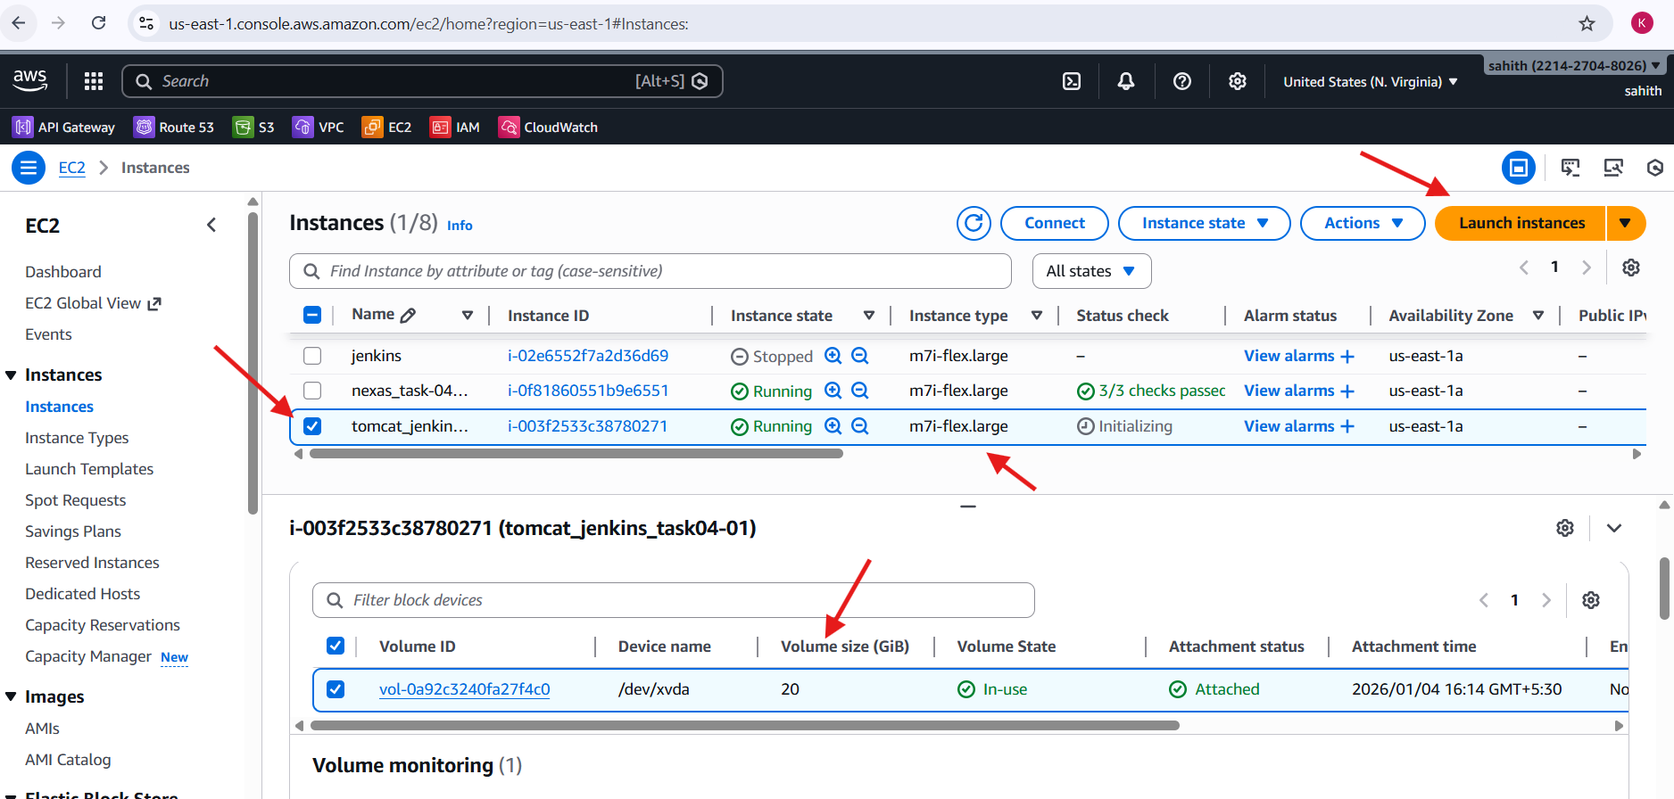

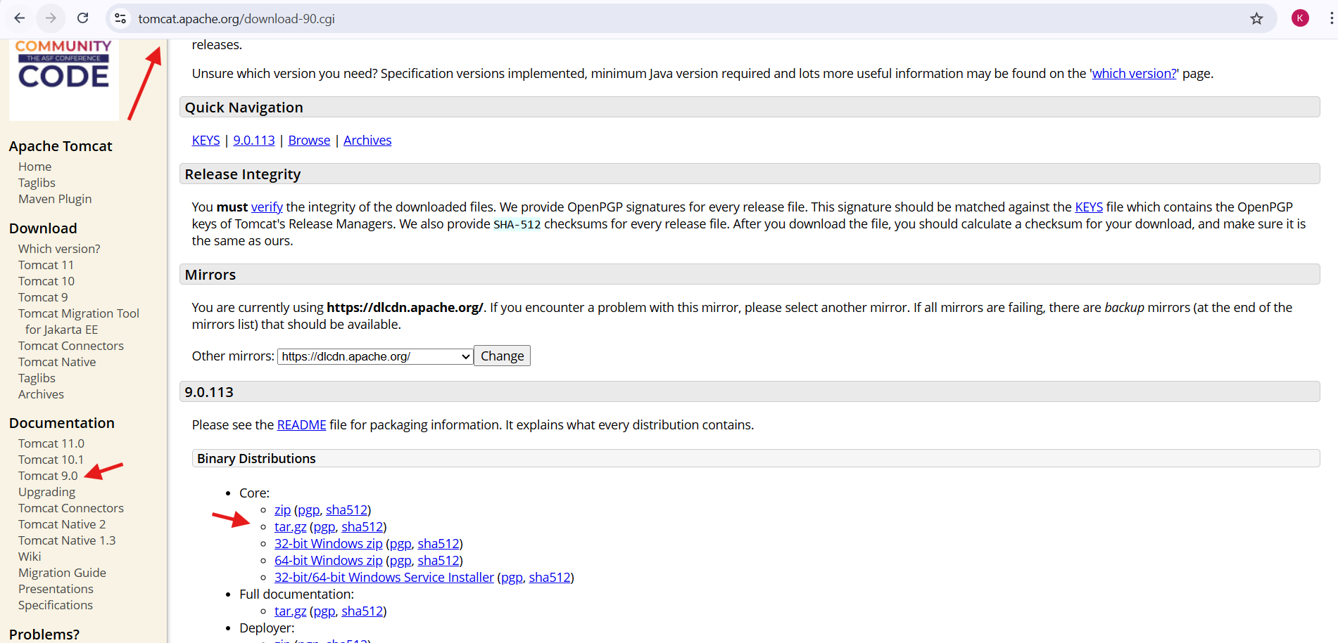

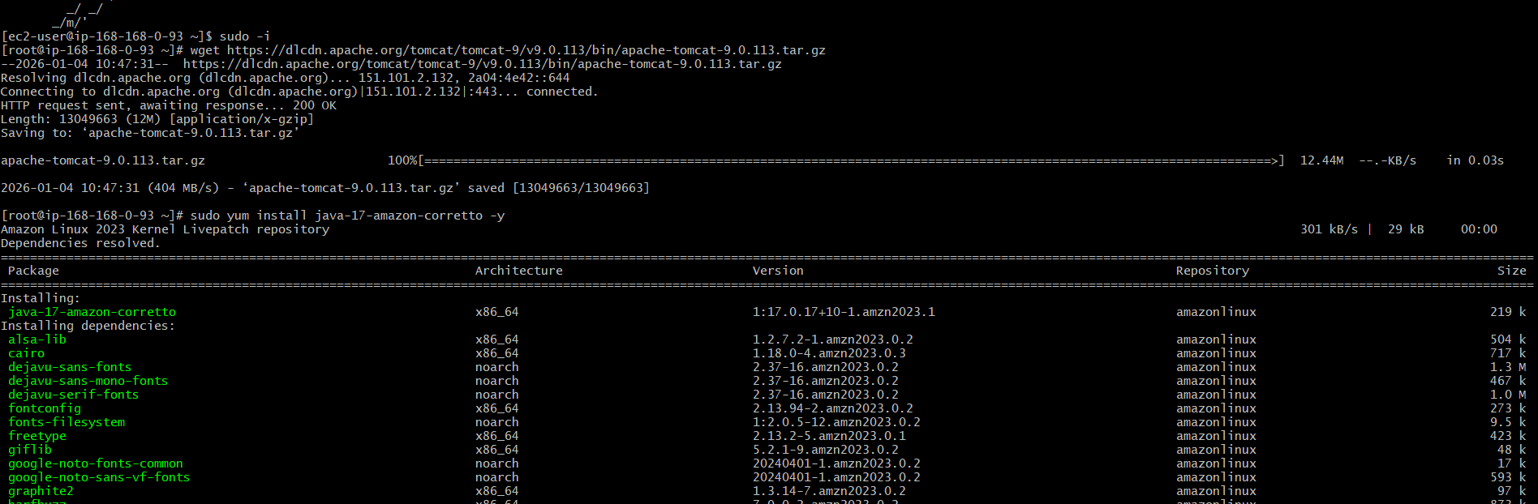

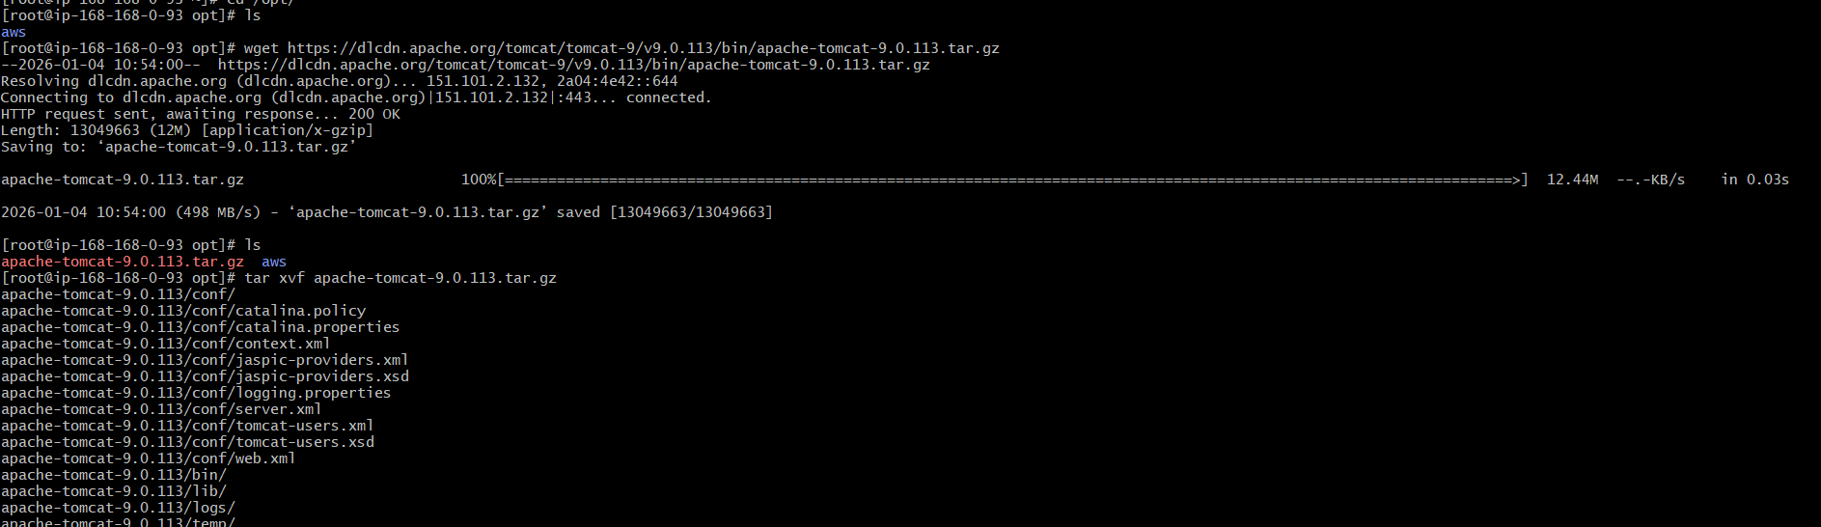

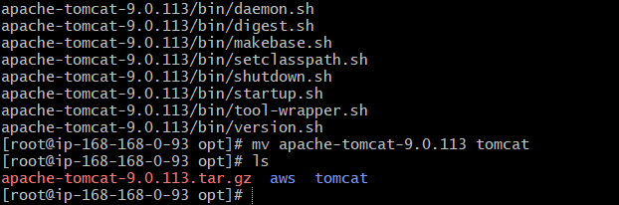

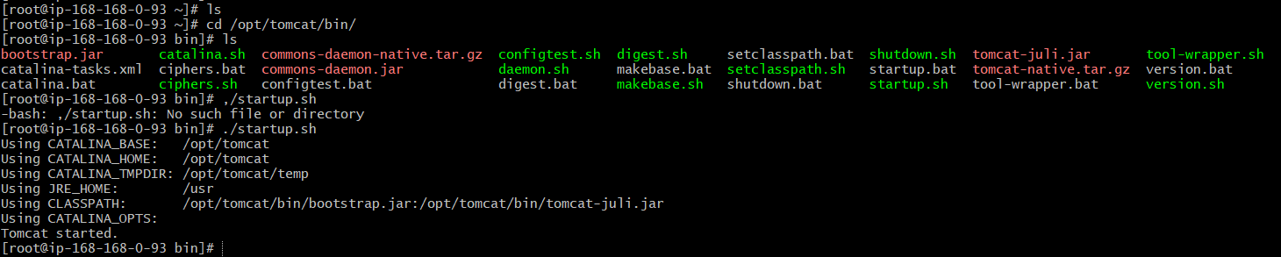

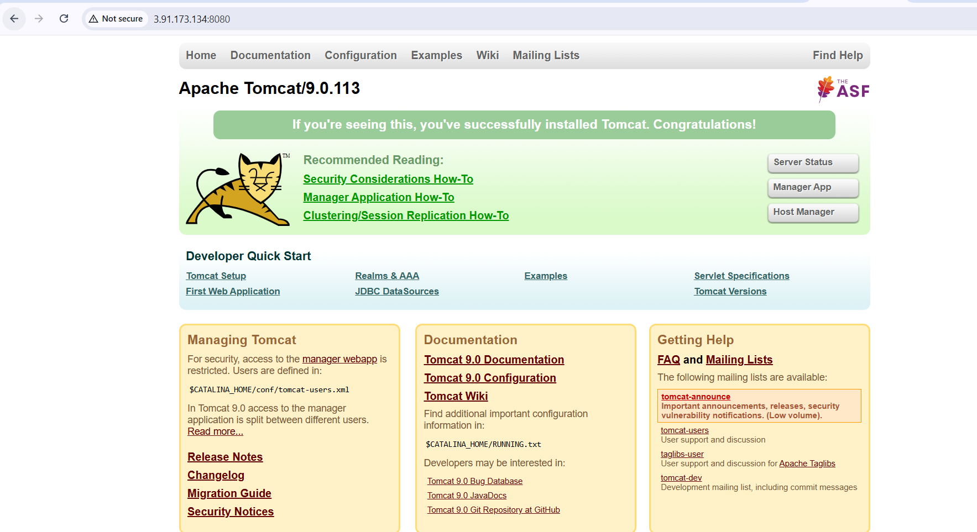. 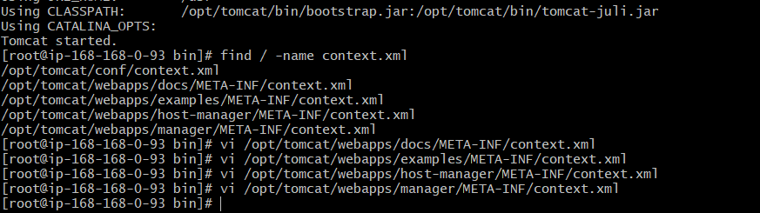

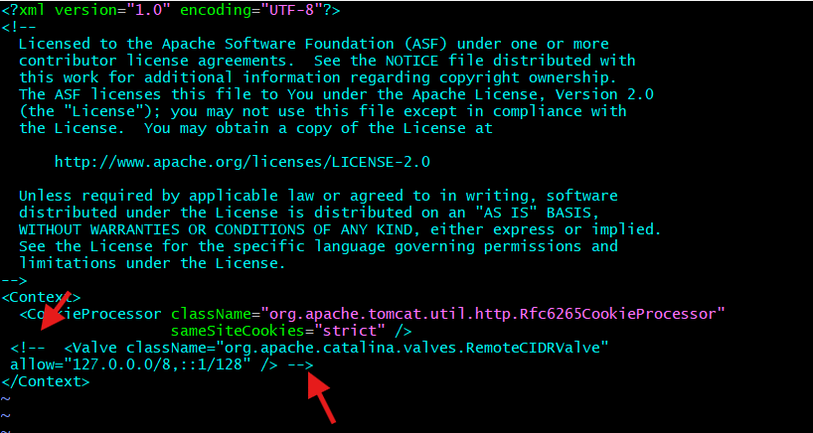

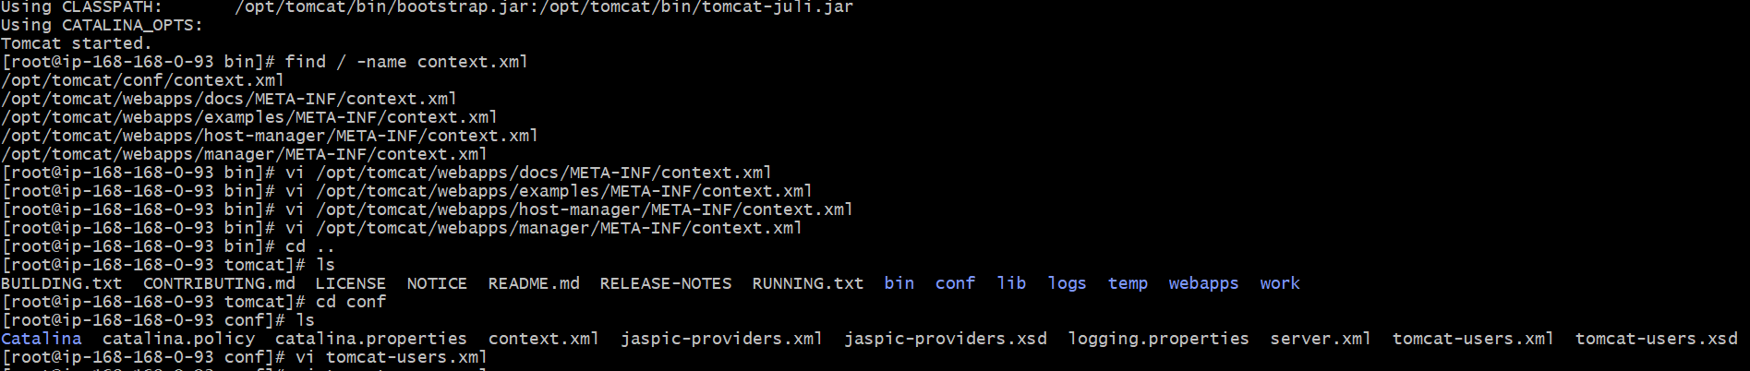

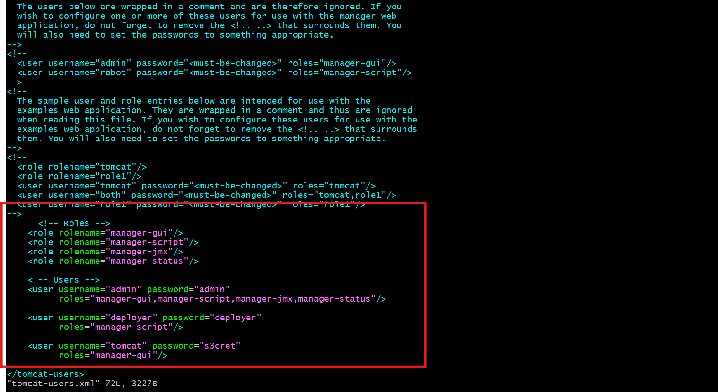

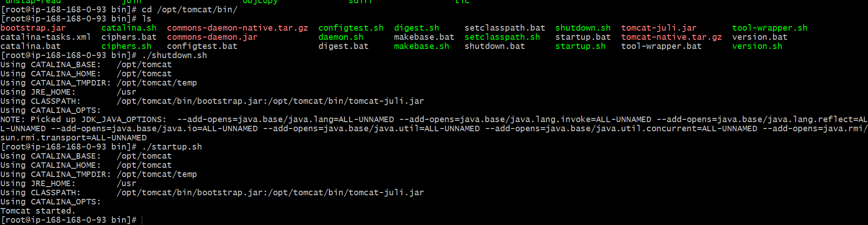

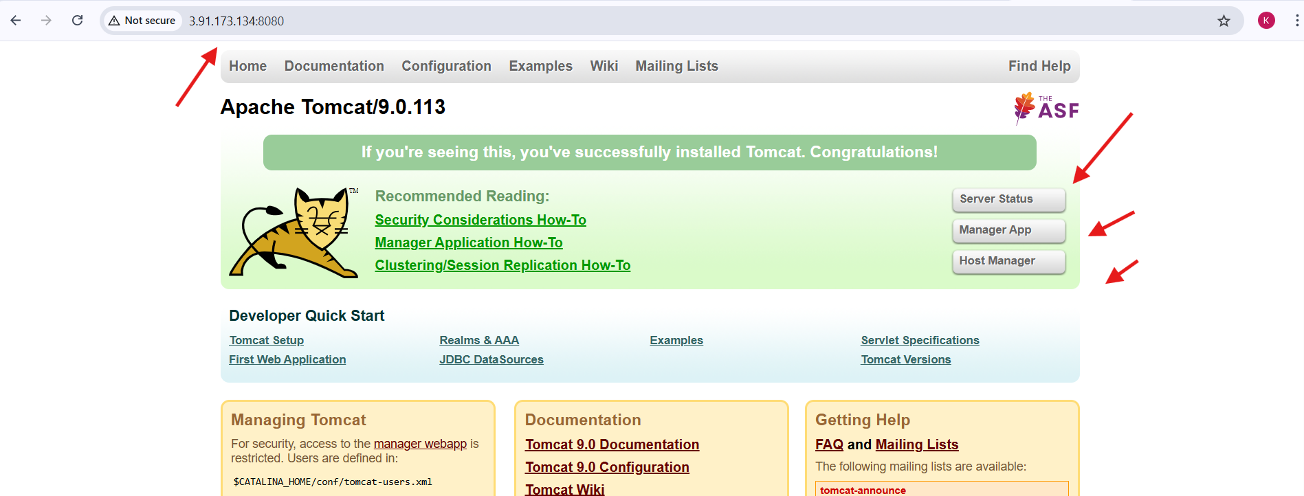

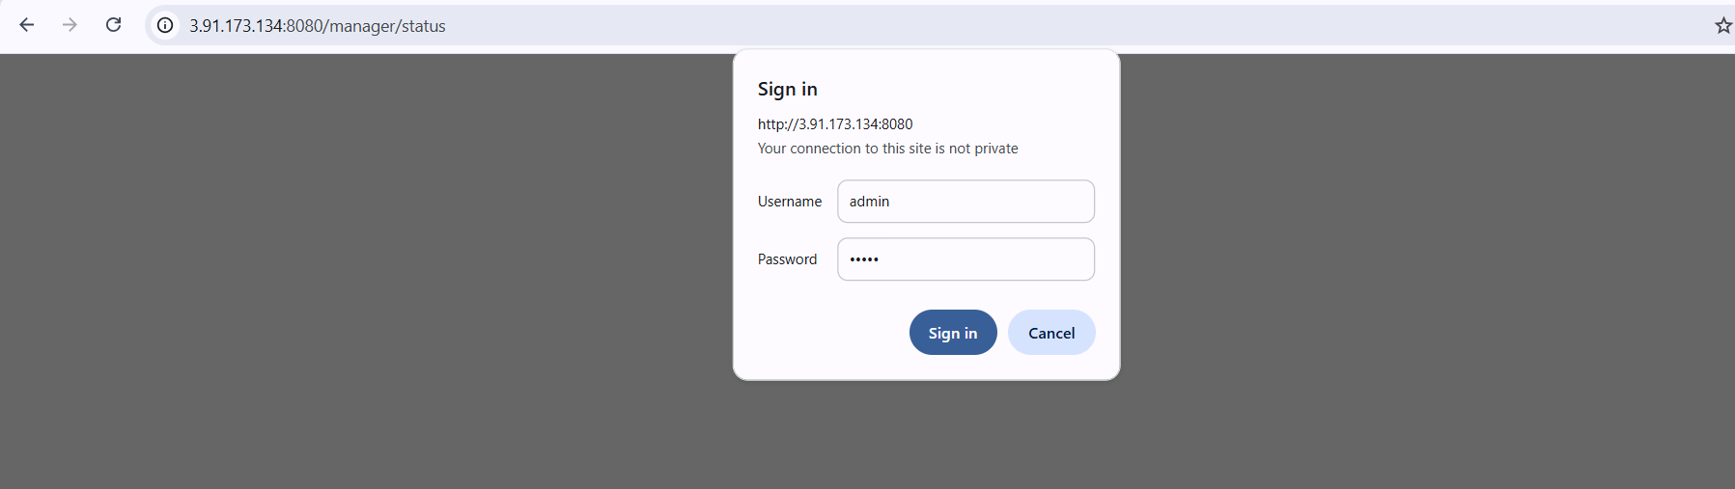

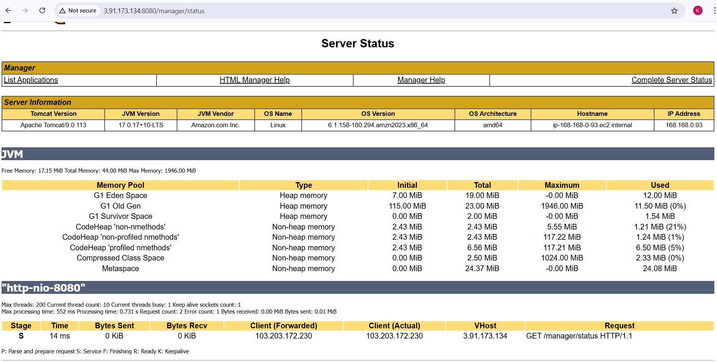

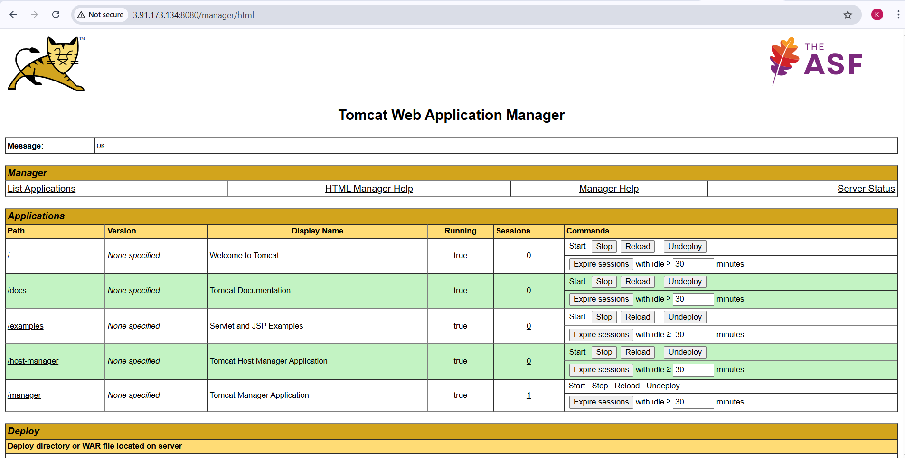

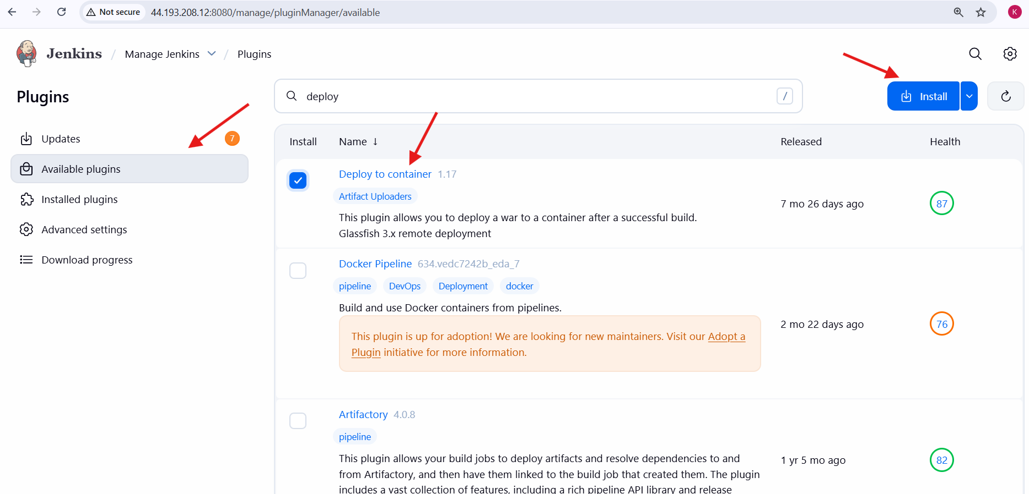

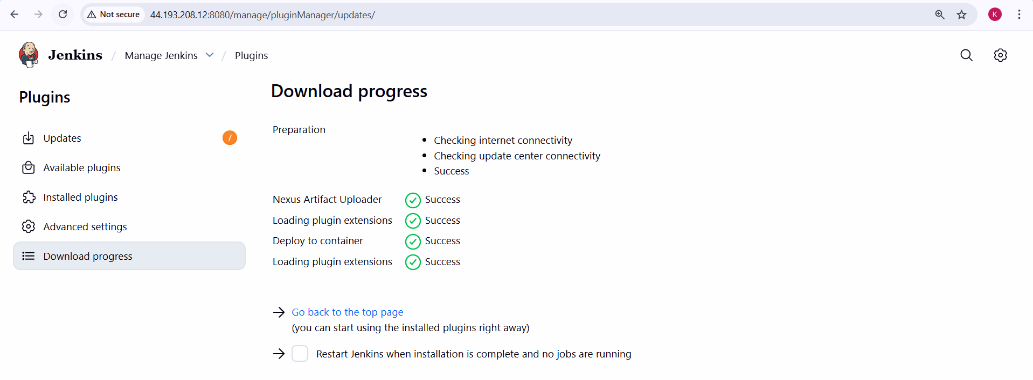

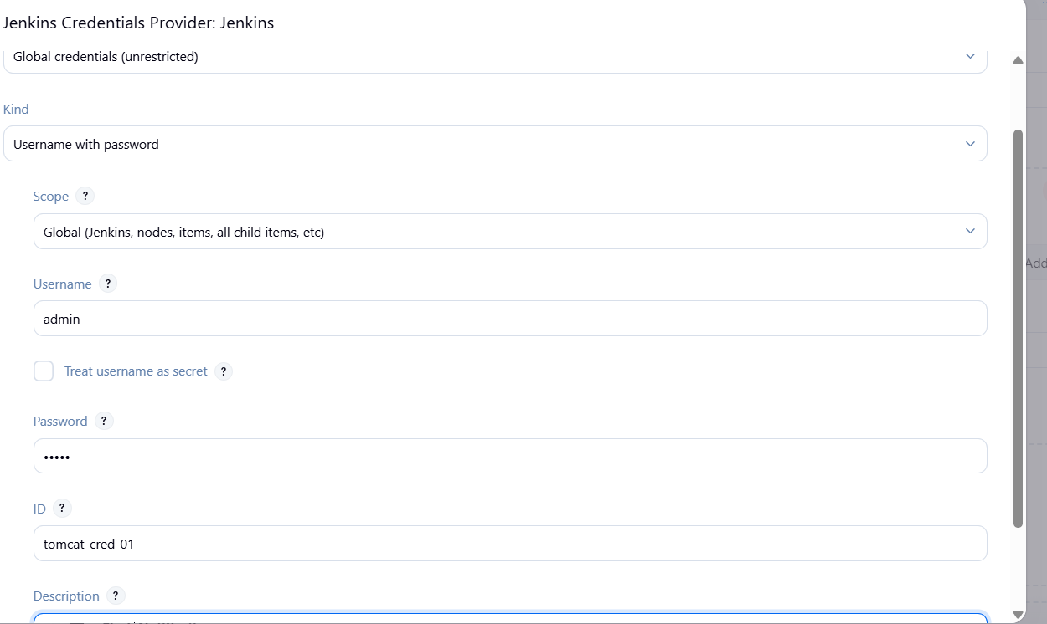

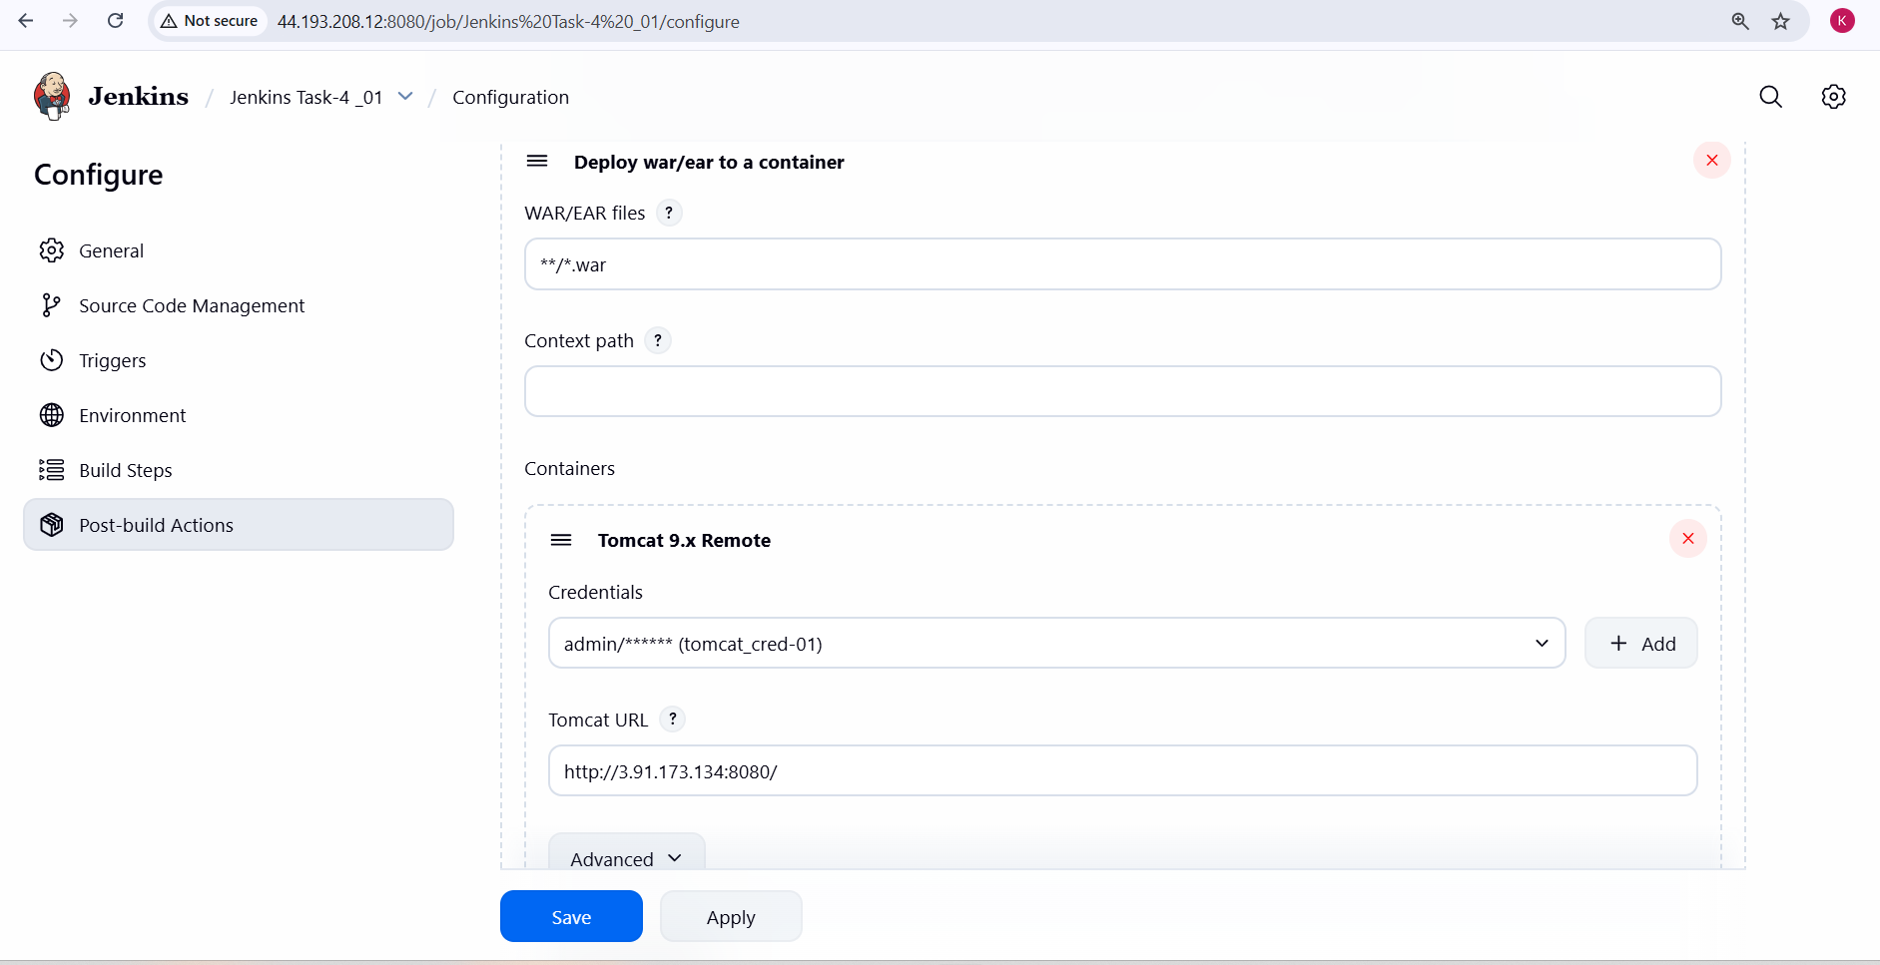

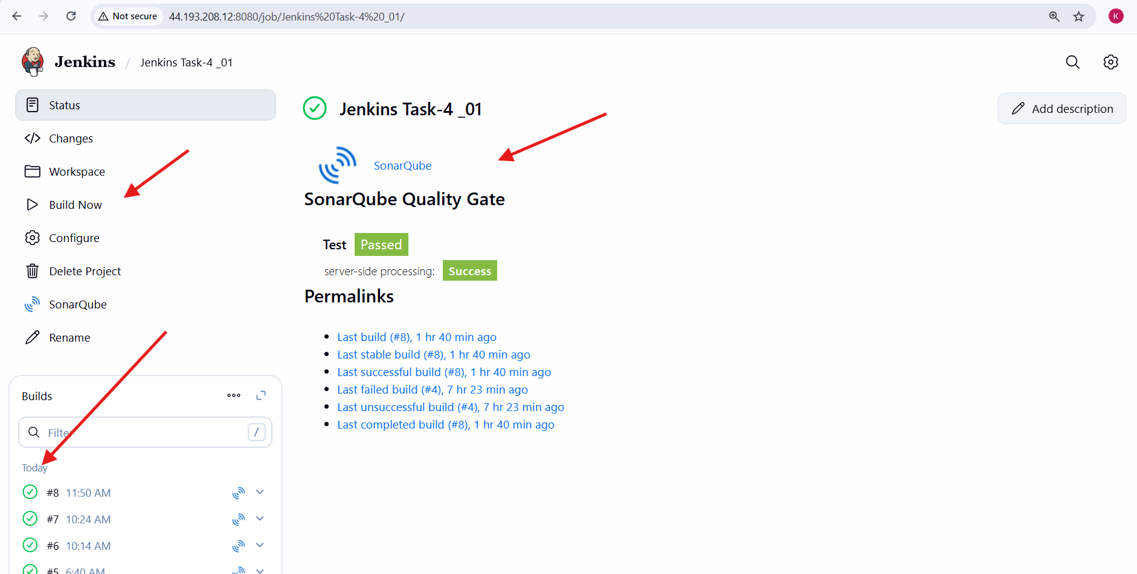

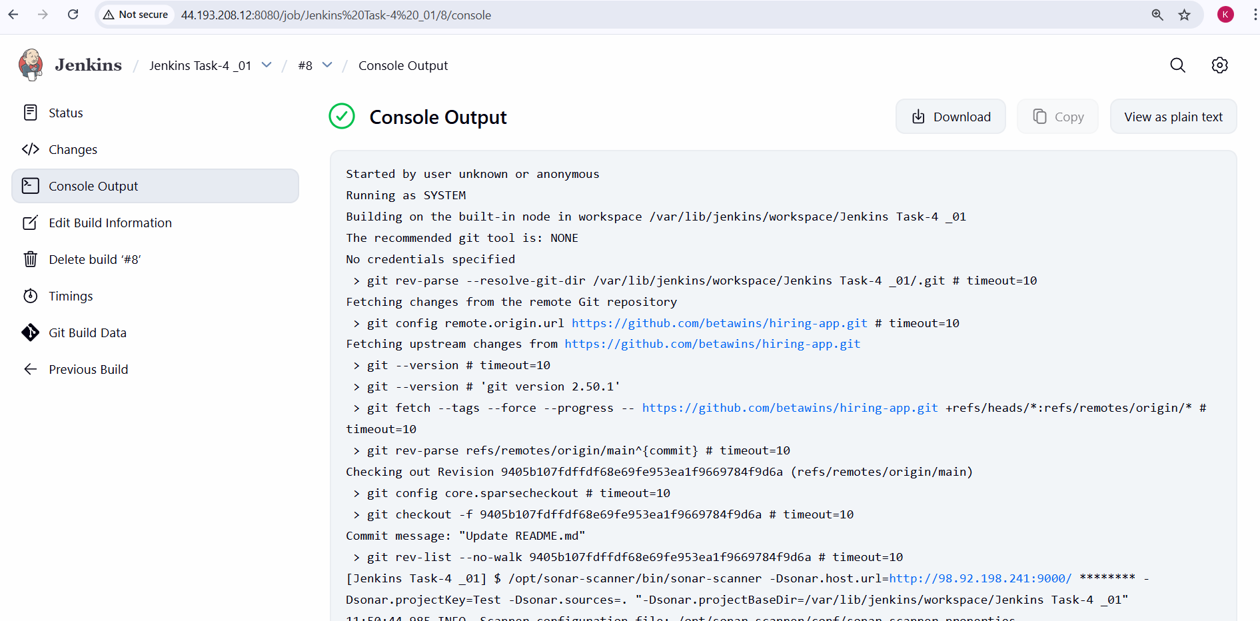

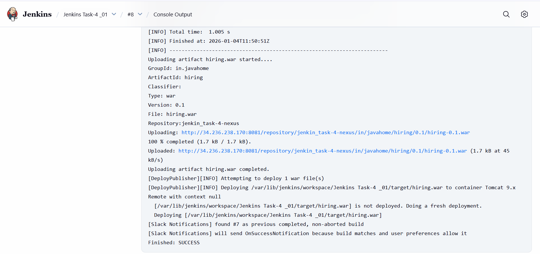

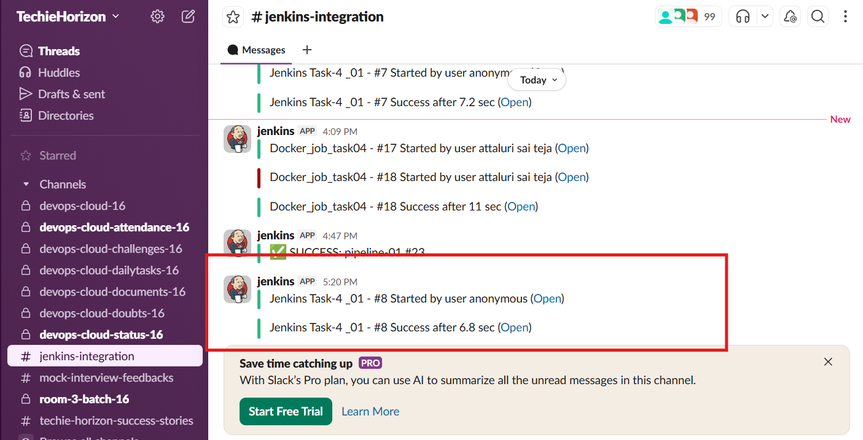

**Overall Task Validation:**

1. Git source code successfully cloned into Jenkins workspace.
2. SonarQube analysis executed and **Quality Gate passed**.
3. Maven build completed successfully with **WAR file generated**.
4. Artifact uploaded successfully to **Nexus Maven Hosted Repository**.
5. Jenkins build status notifications received in **Slack channel**.
6. WAR file deployed successfully to **Apache Tomcat server**.
7. Application accessible through Tomcat public URL.
8. Jenkins build marked as **SUCCESS** with no failed stages.

**Overall Task Issues / Errors Faced:**

* Initial permission issues while accessing Jenkins workspace and Maven repository.
* Nexus service startup failed due to directory ownership and permission mismatch.
* Tomcat Manager access restricted due to default IP-based access control.
* Jenkins deployment failed initially due to missing Tomcat credentials.
* Slack notifications not received until correct webhook and plugin configuration was completed.
* Port accessibility issues resolved by updating security group inbound rules.

**Conclusion:**

* Successfully implemented a complete **CI/CD pipeline** using Jenkins Freestyle Job.
* Automated build, test, artifact storage, notification, and deployment processes.
* Integrated industry-standard tools such as **SonarQube**, **Nexus**, **Slack**, and **Tomcat**.
* Improved deployment reliability, reduced manual effort, and ensured faster application delivery.
* The pipeline is reusable, scalable, and aligns with DevOps best practices for continuous integration and continuous deployment.

# Jenkins -04 (Task-02)

2. Setup a Jenkins CICD pipeline using Declarative pipeline using feature-1.1 branch. [https://github.com/betawins/sabear_simplecutomerapp/tree/feature-1.1](https://github.com/betawins/hiring-app.git)  
stages:  
Git Clone  
SonarQube Integration  
Maven Compilation  
Nexus Artifactory  
Slack Notification  
Deploy On tomcat

**Task Title**

Setup a Jenkins CI/CD Pipeline Using Declarative Pipeline for feature-1.1 Branch with SonarQube, Maven, Nexus, Tomcat, and Slack Integration

**Objective**

To design and implement an end-to-end Jenkins CI/CD pipeline using a Declarative Pipeline that automatically:

* Pulls source code from a GitHub feature branch
* Performs code quality analysis using SonarQube
* Builds the application using Maven
* Publishes build artifacts to Nexus Repository
* Deploys the application to an Apache Tomcat server
* Sends build status notifications to Slack

This pipeline ensures continuous integration, quality checks, artifact management, automated deployment, and real-time notifications.

**Prerequisites**

* Jenkins server installed and running
* Required Jenkins plugins installed:
  + Pipeline
  + Git
  + SonarQube Scanner
  + Nexus Artifact Uploader
  + Deploy to Container
  + Slack Notification
* GitHub repository with feature-1.1 branch  
  https://github.com/betawins/sabear_simplecutomerapp
* SonarQube server configured and reachable from Jenkins
* Maven installed on Jenkins server
* Nexus Repository Manager (Nexus 3) configured
* Apache Tomcat server installed and running
* Jenkins credentials configured for:
  + SonarQube
  + Nexus
  + Tomcat
  + Slack
* Network access between Jenkins, SonarQube, Nexus, and Tomcat

**Steps Performed**

**1. Jenkins Job Creation**

1. Logged in to Jenkins dashboard.
2. Clicked **New Item**.
3. Entered job name: **Jenkins Task-4_02**.
4. Selected **Pipeline** as the job type.
5. Clicked **OK**.
6. In **General** section:
   1. Kept job enabled.
   2. Added description as *Declarative Pipeline* (optional).
7. Navigated to **Pipeline** section.
8. Selected **Pipeline script**.
9. Pasted the declarative Jenkins pipeline script.
10. Enabled **Use Groovy Sandbox**.
11. Clicked **Save**.

**2. Git Clone Stage**

1. Configured pipeline to use **feature-1.1** branch.
2. GitHub repository used:  
   https://github.com/betawins/sabear_simplecutomerapp
3. Jenkins pulled the source code successfully into the workspace.
4. Verified checkout commit from feature-1.1 branch in build logs.

**3. SonarQube Integration Stage**

1. Configured **SonarQube server** in Jenkins Global Tool Configuration.
2. Used **withSonarQubeEnv('sonarqube-server')** in pipeline.
3. Executed Sonar Scanner with:
   1. Project Key: sabear-simplecustomerapp
   2. Project Name: SimpleCustomerApp
   3. Source directory: current workspace
   4. Java files excluded as configured.
4. SonarQube analysis completed successfully.
5. Quality Gate status shown as **Passed** in SonarQube dashboard.
6. Project visible in SonarQube UI with metrics (Security, Reliability, Maintainability).

**4. Maven Compilation Stage**

1. Configured Maven installation path in pipeline environment.
2. Ran Maven command:
3. mvn clean package -DskipTests
4. WAR file generated successfully in target/ directory.
5. Build completed with **BUILD SUCCESS**.

**5. Nexus Artifactory Upload Stage**

1. Configured Nexus Repository Manager (Nexus 3).
2. Used **nexusArtifactUploader** plugin in pipeline.
3. Nexus details used:
   1. Repository: snapshot repository
   2. Group ID: com.javatpoint
   3. Artifact ID: SimpleCustomerApp
   4. Version: ${BUILD_NUMBER}-SNAPSHOT
   5. Artifact Type: war
4. WAR file uploaded successfully to Nexus.
5. Verified artifacts in Nexus UI under:
6. com/javatpoint/SimpleCustomerApp/
7. Multiple snapshot versions visible (26, 27, 28, 29).

**6. Deploy on Tomcat Stage**

1. Configured Apache Tomcat Manager credentials in Jenkins.
2. Used **Deploy to container (Tomcat 9 adapter)**.
3. Tomcat URL used:
4. http://100.48.90.199:8080
5. Deployed WAR file from target/*.war.
6. Application deployed under context path **/sabear**.
7. Verified deployment via:
   1. Tomcat Manager UI
   2. Application available on Tomcat server
   3. Server status page confirmed successful deployment.

**7. Slack Notification Stage**

1. Configured Slack plugin and Slack token credential in Jenkins.
2. Used **slackSend** in post actions.
3. Notifications sent to Slack channel:
   1. On **SUCCESS** → Success message with job name and build number.
   2. On **FAILURE** → Failure message with job name and build number.
4. Verified Slack notification showing:
5. Sahith | Jenkins Task-4_02 #46 Success

**8. Pipeline Execution & Validation**

1. Triggered build using **Build Now**.
2. All stages executed sequentially:
   1. Git Clone
   2. SonarQube Analysis
   3. Maven Build
   4. Upload to Nexus
   5. Deploy to Tomcat
   6. Post Actions (Slack)
3. Pipeline completed with **SUCCESS** status.
4. Stage View showed green status for all stages.
5. Artifacts validated in Nexus.
6. Code quality validated in SonarQube.
7. Application validated on Tomcat.
8. Notification validated in Slack.

**Final Outcome**

1. Jenkins Declarative CI/CD pipeline successfully implemented.
2. Integrated **Git, SonarQube, Maven, Nexus, Tomcat, and Slack**.
3. Feature-1.1 branch build fully automated from code commit to deployment.
4. End-to-end CI/CD flow executed and verified successfully.

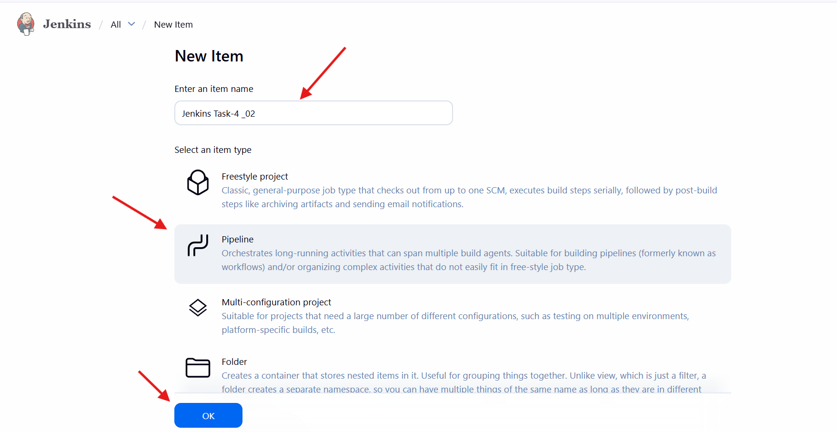

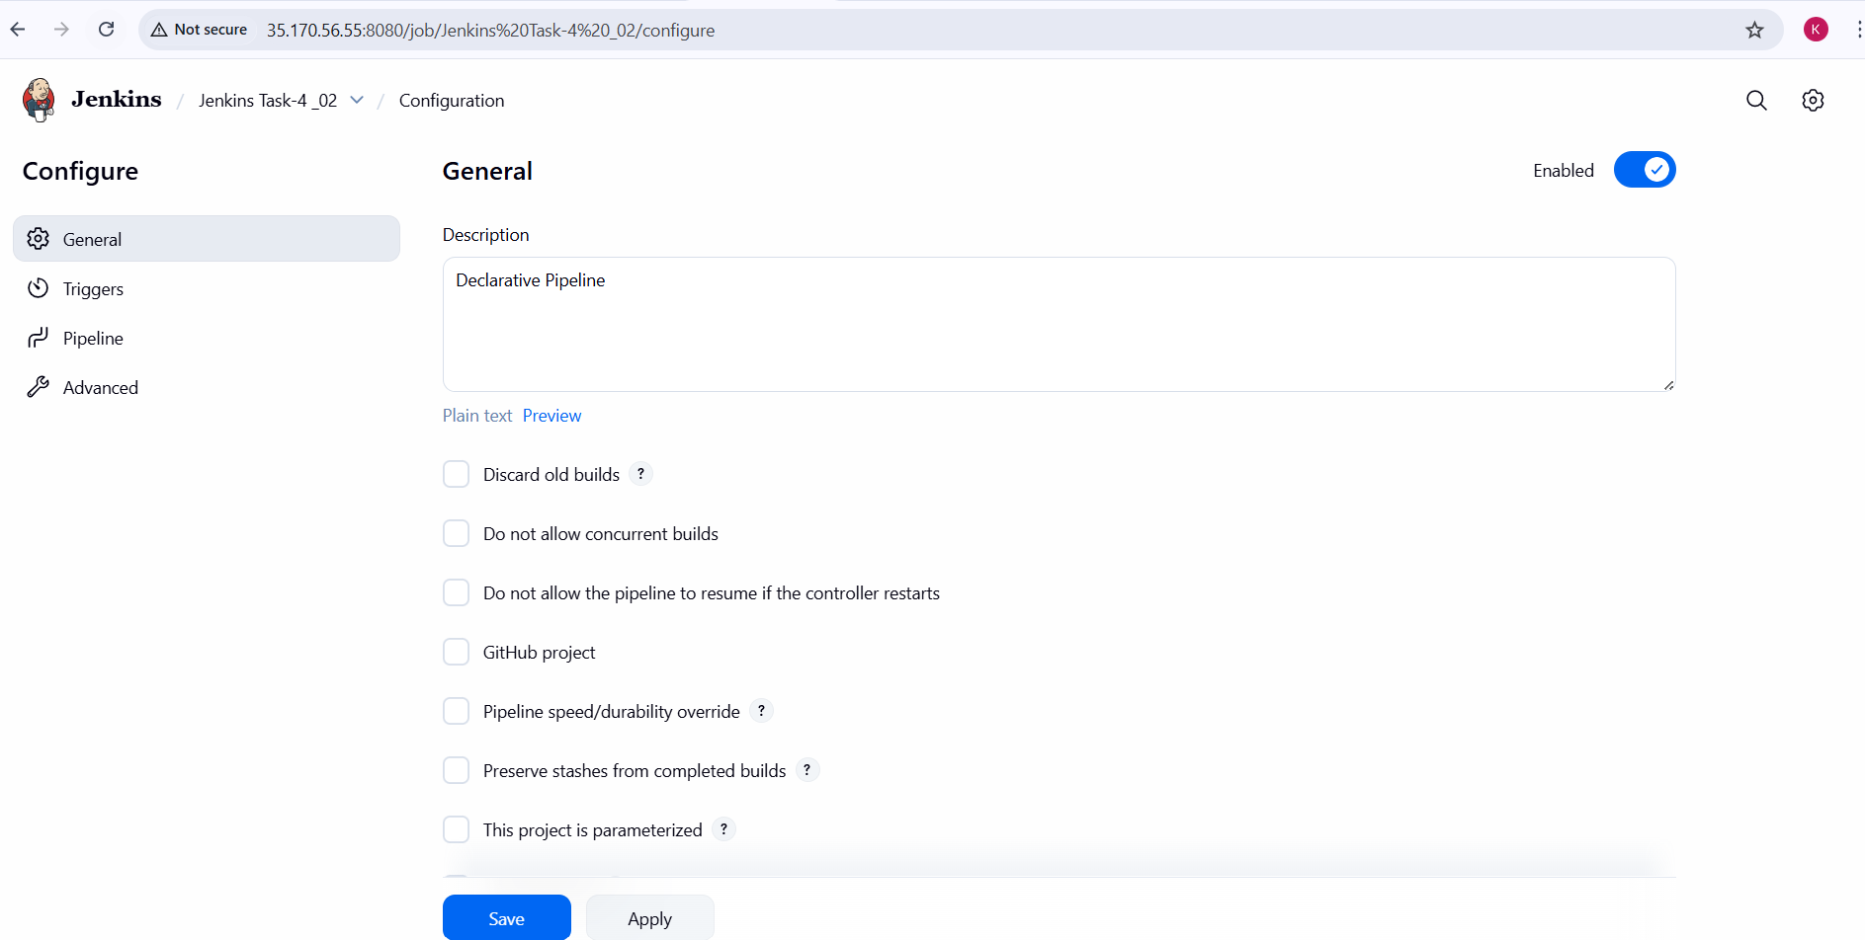

Pipline script:

pipeline {

agent any

options {

timestamps()

}

environment {

// Maven

MVN_HOME = '/opt/maven'

PATH = "${MVN_HOME}/bin:${env.PATH}"

// SonarQube

SONAR_PROJECT_KEY = 'sabear-simplecustomerapp'

SONAR_PROJECT_NAME = 'SimpleCustomerApp'

// Nexus

NEXUS_URL = '44.201.45.243:8081'

NEXUS_REPOSITORY = 'jenkin_task-4-nexus'

NEXUS_VERSION = 'nexus3'

NEXUS_PROTOCOL = 'http'

// Tomcat

TOMCAT_URL = 'http://100.48.90.199:8080'

}

stages {

stage('Git Clone') {

steps {

git branch: 'feature-1.1',

url: 'https://github.com/betawins/sabear_simplecutomerapp.git'

}

}

stage('SonarQube Analysis') {

steps {

withSonarQubeEnv('sonarqube-server') {

sh '''

/opt/sonar-scanner/bin/sonar-scanner \

-Dsonar.projectKey=${SONAR_PROJECT_KEY} \

-Dsonar.projectName=${SONAR_PROJECT_NAME} \

-Dsonar.sources=. \

-Dsonar.exclusions=**/*.java

'''

}

}

}

stage('Maven Build') {

steps {

sh '''

mvn clean package -DskipTests

'''

}

}

stage('Upload to Nexus') {

steps {

script {

def WAR_FILE = sh(

script: "ls target/*.war",

returnStdout: true

).trim()

nexusArtifactUploader(

nexusVersion: NEXUS_VERSION,

protocol: NEXUS_PROTOCOL,

nexusUrl: NEXUS_URL,

repository: NEXUS_REPOSITORY,

credentialsId: 'nexus_creds',

groupId: 'com.javatpoint',

version: "${BUILD_NUMBER}-SNAPSHOT",

artifacts: [[

artifactId: 'SimpleCustomerApp',

classifier: '',

type: 'war',

file: WAR_FILE

]]

)

}

}

}

stage('Deploy to Tomcat') {

steps {

deploy adapters: [

tomcat9(

credentialsId: 'tomcat_cred-01',

url: "${TOMCAT_URL}"

)

],

contextPath: 'sabear',

war: 'target/*.war'

}

}

}

post {

success {

slackSend(

color: 'good',

message: "Sahith | ${env.JOB_NAME} - #${env.BUILD_NUMBER} Success (<${env.BUILD_URL}|Open>)",

tokenCredentialId: 'ss'

)

}

failure {

slackSend(

color: 'danger',

message: "Sahith | ${env.JOB_NAME} - #${env.BUILD_NUMBER} Failed (<${env.BUILD_URL}|Open>)",

tokenCredentialId: 'ss'

)

}

}

}

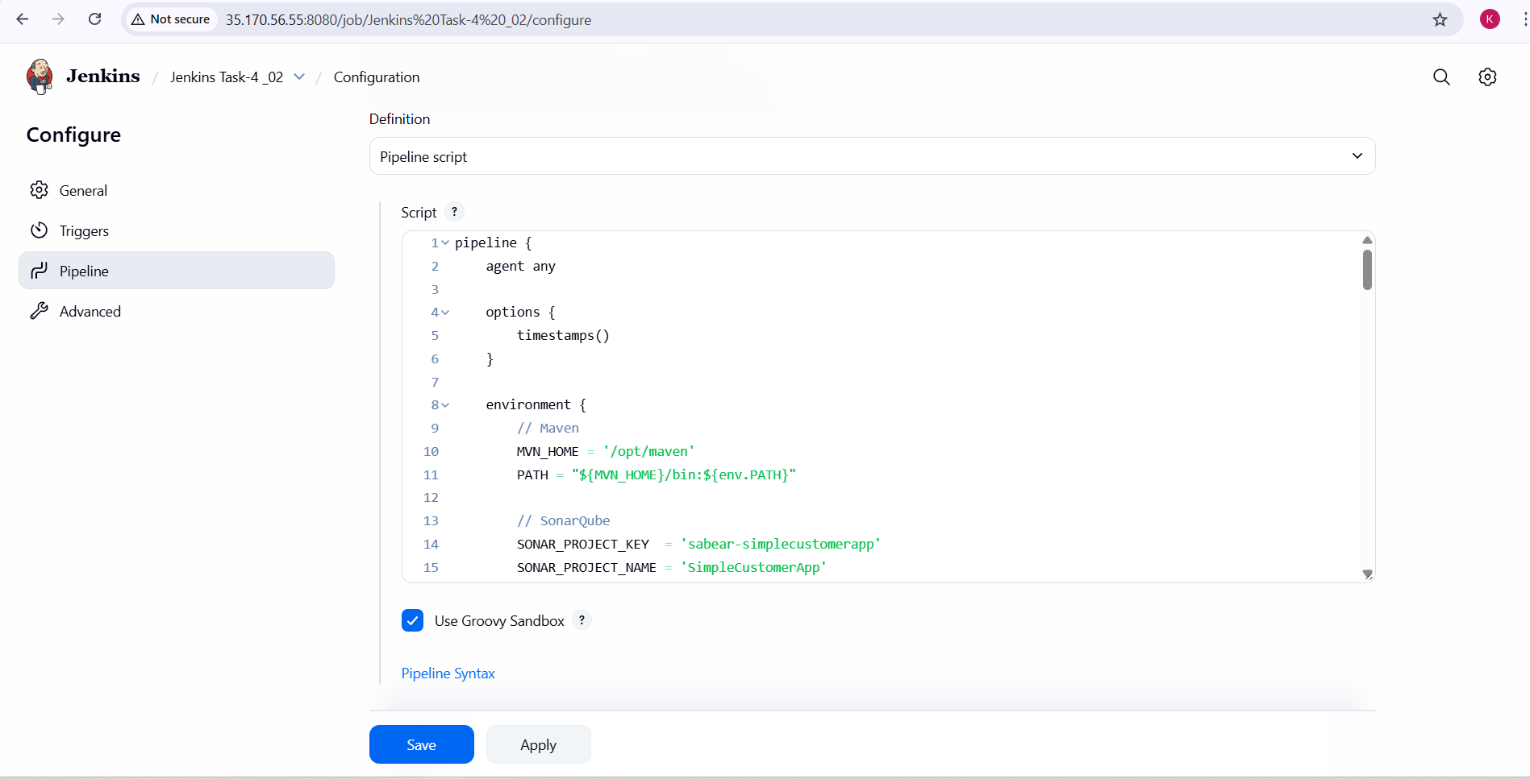

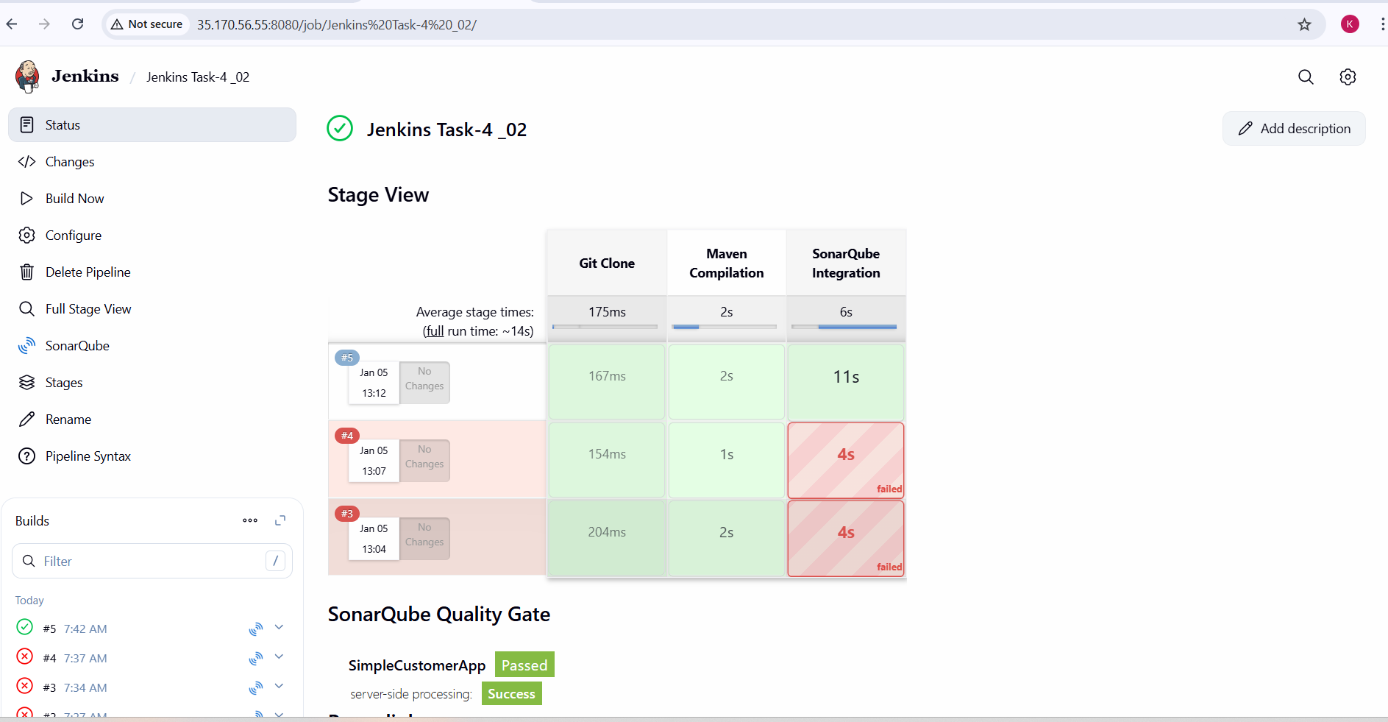

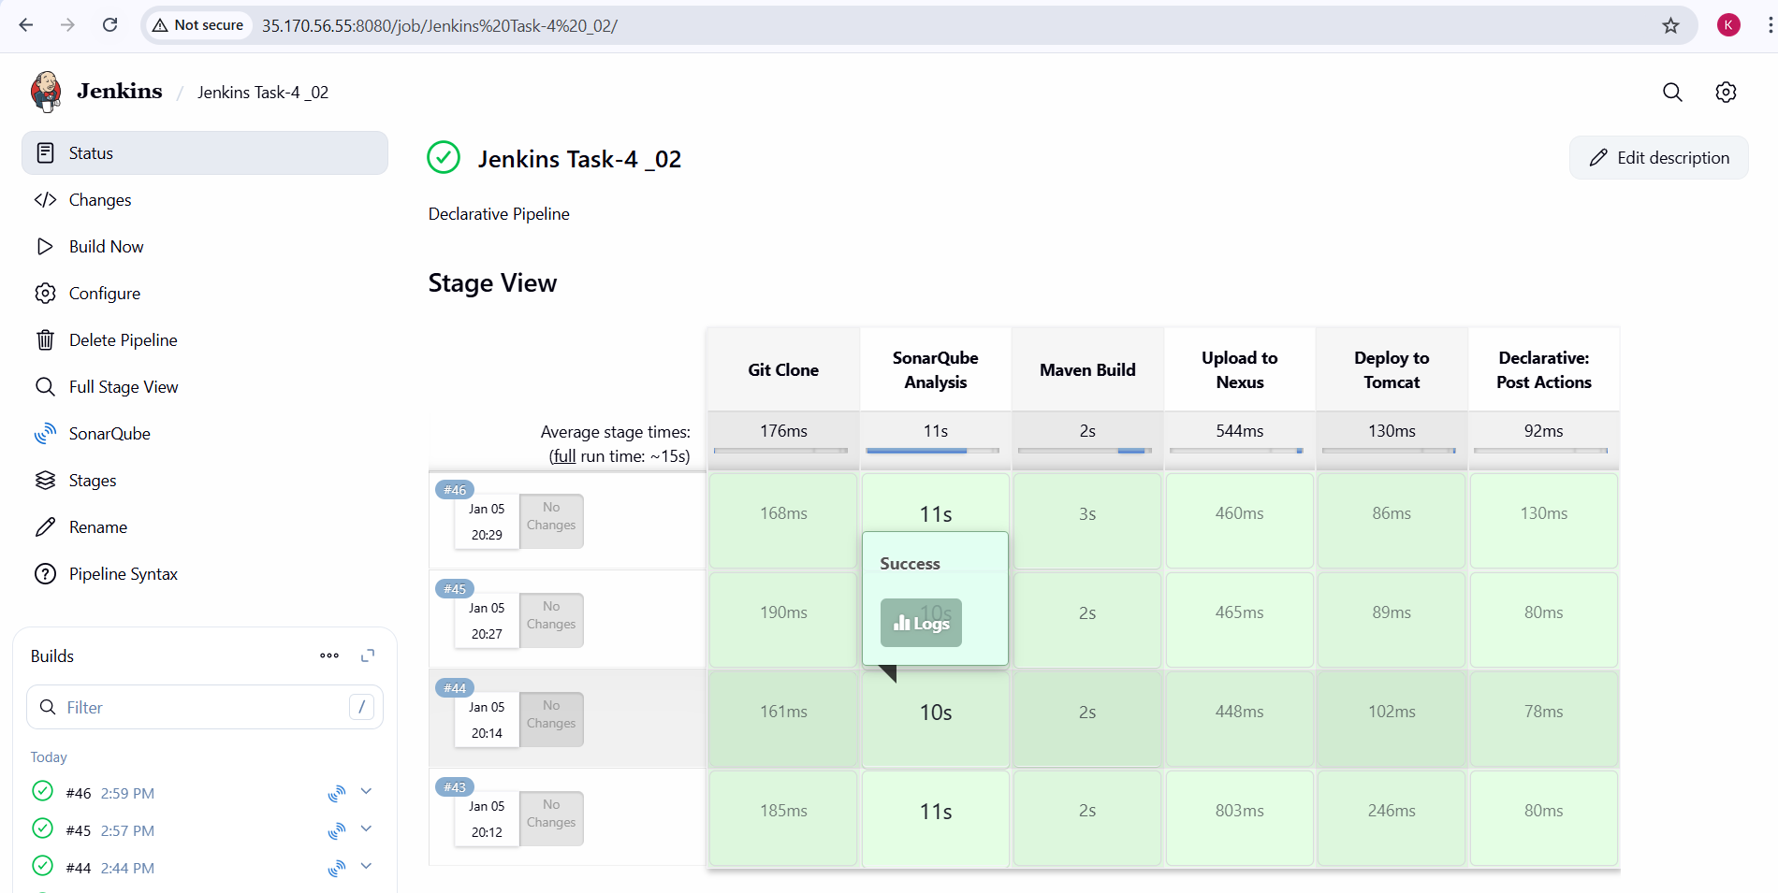

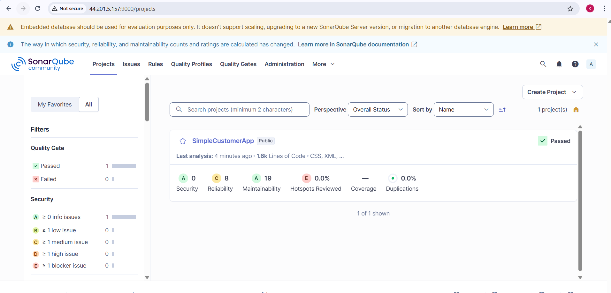

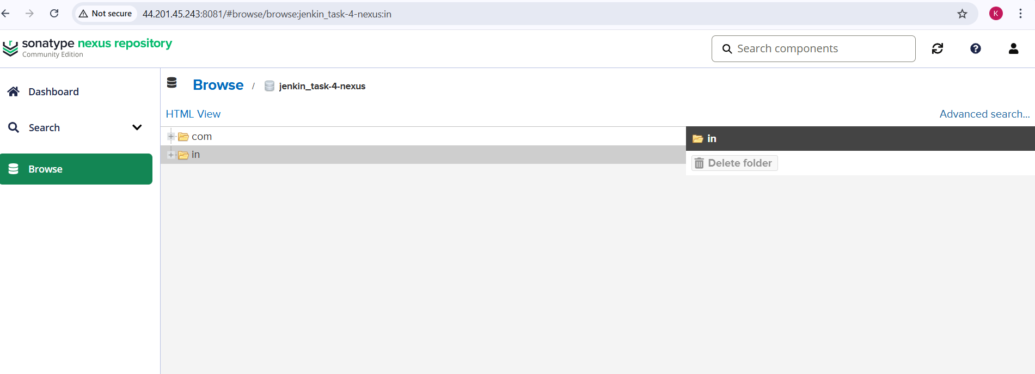

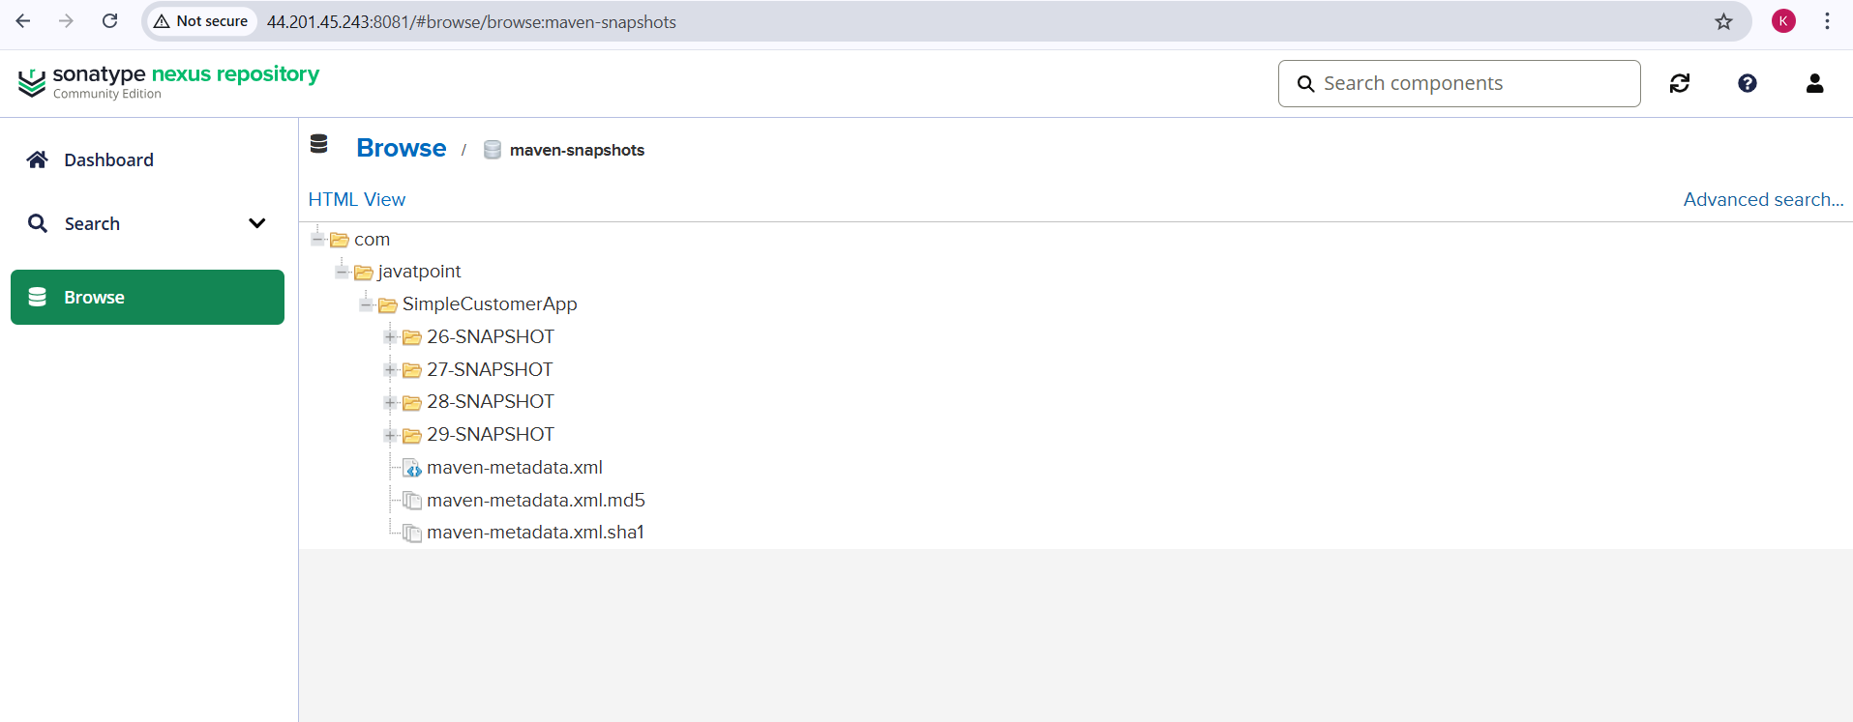

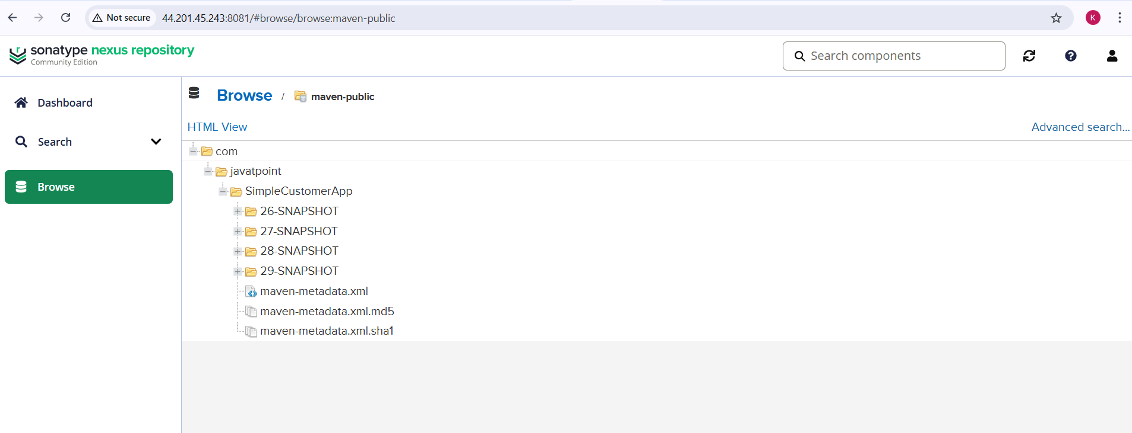

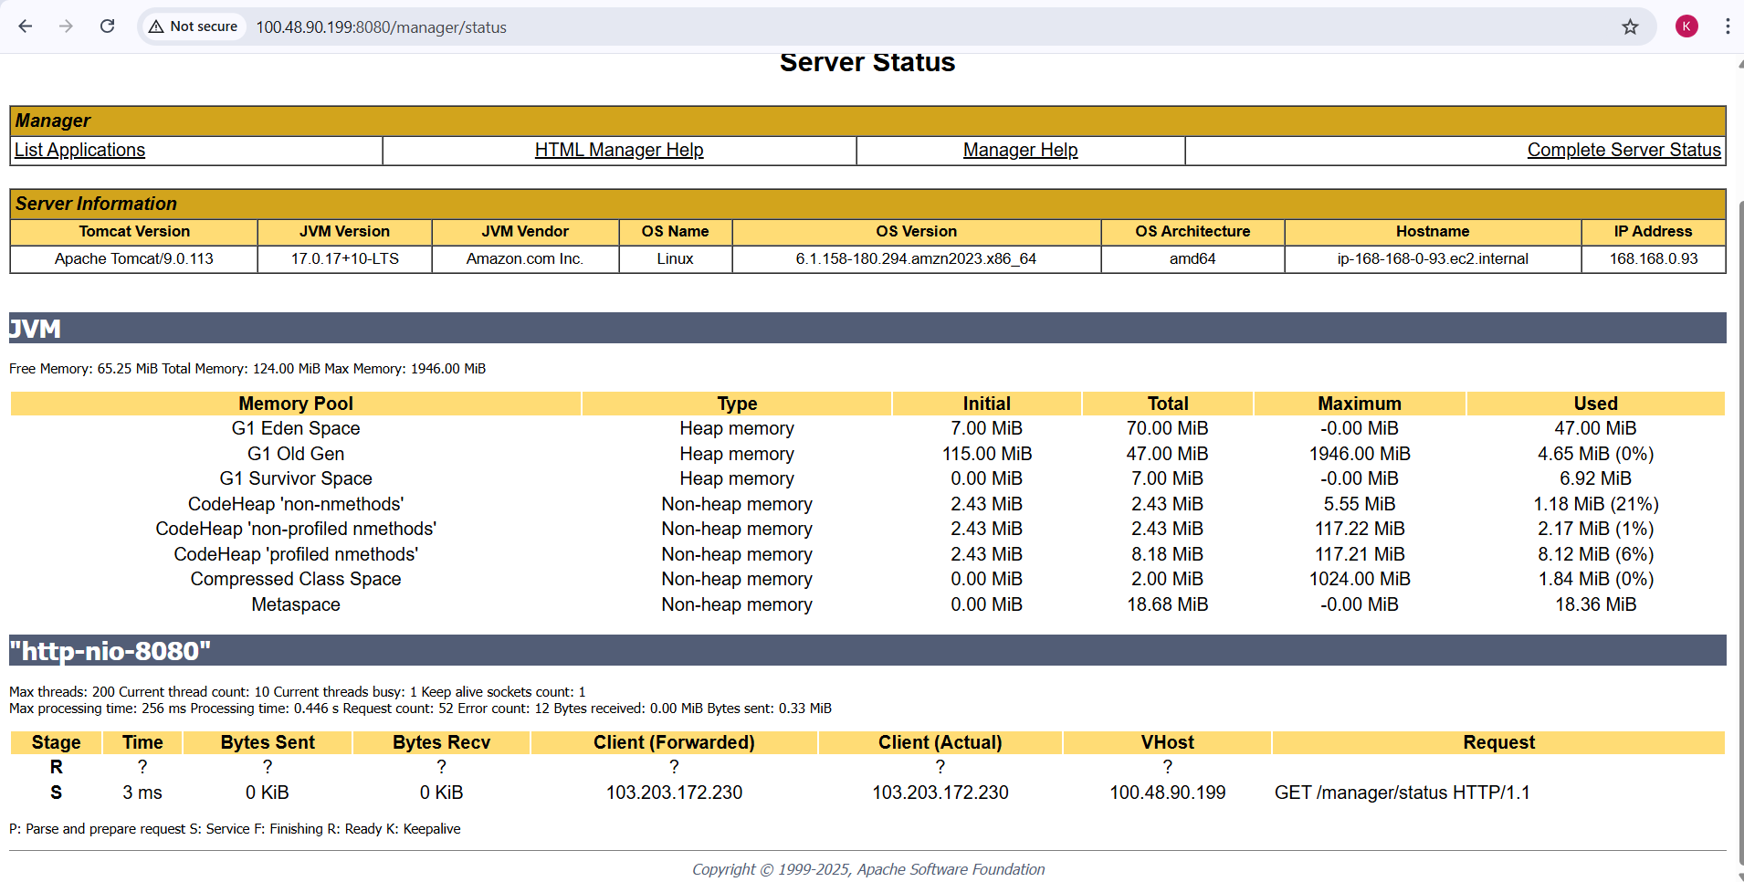

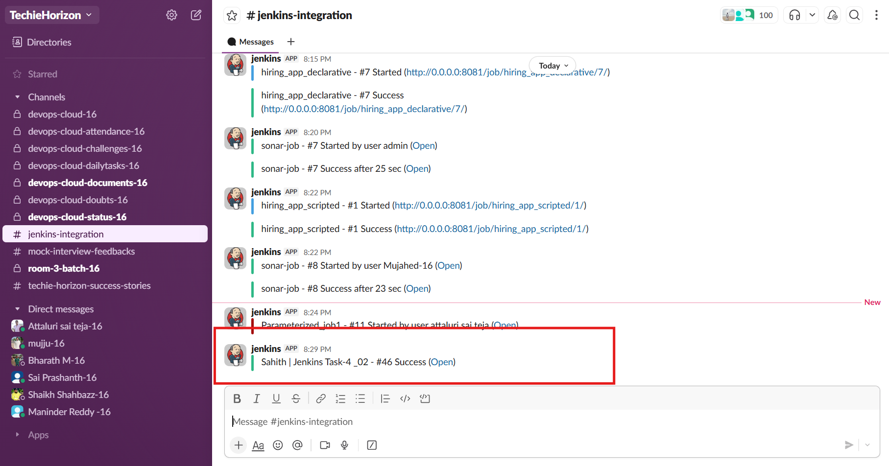

**Validation**

1. Jenkins pipeline executed successfully with all stages passing
2. Git code cloned successfully from feature-1.1 branch
3. SonarQube analysis completed and Quality Gate status marked as **Passed**
4. Maven build generated WAR file successfully
5. Artifact uploaded successfully to Nexus repository with snapshot versions
6. Application deployed successfully to Apache Tomcat
7. Application visible and running via Tomcat Manager and browser
8. Slack notifications received for successful pipeline execution
9. Jenkins Stage View displayed green status for all pipeline stages

**Errors Faced**

1. Initial SonarQube connection failure due to server connectivity issues
2. SonarQube scanner execution failed when server was not reachable
3. Slack notifications failed initially due to missing or incorrect channel configuration
4. Tomcat deployment issues occurred before correcting credentials and URL
5. Warnings during Maven build related to dynamic version usage in pom.xml
6. Errors resolved by fixing server URLs, credentials, plugin configurations, and environment variables

**Conclusion**

The Jenkins Declarative CI/CD pipeline was successfully implemented and executed. The pipeline automated the complete software delivery lifecycle including source code management, quality analysis, build, artifact storage, deployment, and notifications. This implementation improved build reliability, ensured consistent deployments, and provided clear visibility into build status through Jenkins dashboards, SonarQube reports, Nexus repositories, Tomcat deployment validation, and Slack alerts. The pipeline meets CI/CD best practices and supports scalable and maintainable DevOps workflows.

# Jenkins -04 (Task-03)

3. Setup a Jenkins CICD pipeline using Scripted pipeline using feature-1.1 branch. <https://github.com/betawins/sabear_simplecutomerapp/tree/feature-1.1>  
stages:  
Git Clone  
SonarQube Integration  
Maven Compilation  
Nexus Artifactory  
Slack Notification  
Deploy On tomcat

**Task Title**

Setup Jenkins CI/CD Pipeline Using **Scripted Pipeline** for Simple Customer App

**Objective**

To implement a complete Jenkins CI/CD pipeline using a **Scripted Pipeline** that:

1. Pulls source code from the feature-1.1 branch
2. Performs code quality analysis using **SonarQube**
3. Builds the application using **Maven**
4. Publishes the WAR artifact to **Nexus Repository**
5. Deploys the application to **Apache Tomcat**
6. Sends build status notifications to **Slack**

**Prerequisites**

1. Jenkins installed and running
2. Required Jenkins plugins installed:
   1. Git
   2. Pipeline
   3. SonarQube Scanner
   4. Nexus Artifact Uploader
   5. Deploy to Container (Tomcat)
   6. Slack Notification
3. SonarQube server configured in Jenkins (sonarqube-server)
4. Nexus Repository (Nexus 3) up and accessible
5. Tomcat server running and accessible on port 8080
6. Jenkins credentials configured:
   1. Git (public repo – no credentials required)
   2. SonarQube token
   3. Nexus credentials
   4. Tomcat Manager credentials
   5. Slack token
7. Maven installed on Jenkins server
8. GitHub repository:
   1. https://github.com/betawins/sabear_simplecutomerapp
   2. Branch: feature-1.1

**Steps Performed**

**1. Jenkins Job Creation**

1. Created a new Jenkins job: **Jenkins Task-4_03**
2. Selected **Pipeline** as job type
3. Chose **Scripted Pipeline**
4. Added description: *Scripted pipeline*

**2. Environment Configuration**

1. Configured environment variables inside the node {} block:
   1. Maven Home and PATH
   2. SonarQube project key and name
   3. Nexus URL and repository
   4. Tomcat server URL

**3. Slack Notification – Build Started**

1. Sent a Slack message at the start of the pipeline indicating:
   1. Job name
   2. Build number
   3. Build URL

**4. Git Clone**

1. Cloned source code from:
   1. Repository: sabear_simplecutomerapp
   2. Branch: feature-1.1
2. Verified successful checkout in Jenkins workspace

**5. SonarQube Integration**

* Executed SonarQube analysis using Maven Sonar plugin
* Project analyzed under:
  + **SimpleCustomerApp**
* Verified:
  + Analysis completed successfully
  + Quality Gate status: **Passed**

**6. Maven Compilation**

* Built the application using:
  + mvn clean package -DskipTests
* Generated WAR file in target/ directory
* Build completed successfully

**7. Nexus Artifactory Upload**

1. Identified generated WAR file dynamically
2. Uploaded WAR to **Nexus Maven Snapshot Repository**
3. Artifact details:
   1. Group ID: com.javatpoint
   2. Artifact ID: SimpleCustomerApp
   3. Version: <BUILD_NUMBER>-SNAPSHOT
4. Verified artifact presence in Nexus UI

**8. Deploy on Tomcat**

1. Deployed WAR file to **Apache Tomcat 9**
2. Used Jenkins “Deploy to Container” plugin
3. Context path:
   1. SimpleCustomerApp
4. Verified application deployment via Tomcat Manager UI

**9. Slack Notification – Success**

1. Sent Slack message after successful deployment
2. Message included:
   1. Job name
   2. Build number
   3. Build URL
   4. Success status

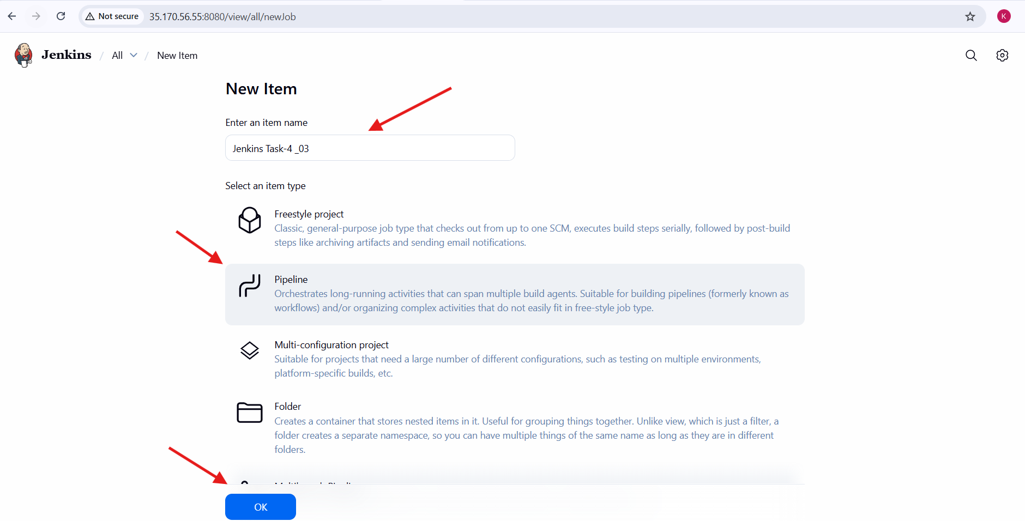

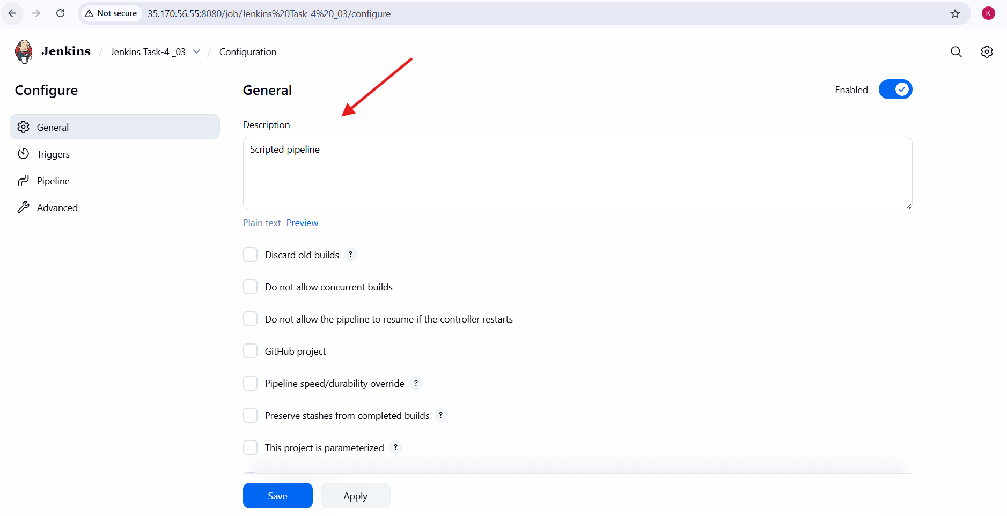

Pipeline Script:

node {

env.MAVEN_HOME = '/opt/maven'

env.PATH = "${env.MAVEN_HOME}/bin:${env.PATH}"

env.SONAR_PROJECT_KEY = 'sabear-simplecustomerapp'

env.SONAR_PROJECT_NAME = 'SimpleCustomerApp'

env.NEXUS_URL = '44.201.45.243:8081'

env.NEXUS_REPOSITORY = 'jenkin_task-4-nexus'

env.TOMCAT_URL = 'http://100.48.90.199:8080'

try {

// ---------------- SLACK : STARTED ----------------

stage('Slack Notification - Started') {

slackSend(

botUser: true,

color: '#439FE0',

message: "Sahith | ${env.JOB_NAME} - #${env.BUILD_NUMBER} Started (<${env.BUILD_URL}|Open>)",

tokenCredentialId: 'ss'

)

}

// ---------------- GIT CLONE ----------------

stage('Git Clone') {

git branch: 'feature-1.1',

url: 'https://github.com/betawins/sabear_simplecutomerapp.git'

}

// ---------------- SONARQUBE ----------------

stage('SonarQube Integration') {

withSonarQubeEnv('sonarqube-server') {

sh """

/opt/sonar-scanner/bin/sonar-scanner \

-Dsonar.projectKey=${SONAR_PROJECT_KEY} \

-Dsonar.projectName=${SONAR_PROJECT_NAME} \

-Dsonar.sources=. \

-Dsonar.exclusions=**/*.java

"""

}

}

// ---------------- MAVEN BUILD ----------------

stage('Maven Compilation') {

sh 'mvn clean package -DskipTests'

}

// ---------------- NEXUS UPLOAD ----------------

stage('Nexus Artifactory') {

def warFile = sh(

script: "ls target/*.war",

returnStdout: true

).trim()

nexusArtifactUploader(

nexusVersion: 'nexus3',

protocol: 'http',

nexusUrl: env.NEXUS_URL,

repository: env.NEXUS_REPOSITORY,

credentialsId: 'nexus_creds',

groupId: 'com.javatpoint',

version: "${env.BUILD_NUMBER}-SNAPSHOT",

artifacts: [[

artifactId: 'SimpleCustomerApp',

classifier: '',

type: 'war',

file: warFile

]]

)

}

// ---------------- TOMCAT DEPLOY ----------------

stage('Deploy On Tomcat') {

deploy adapters: [

tomcat9(

credentialsId: 'tomcat_cred-01',

url: env.TOMCAT_URL

)

],

contextPath: 'sabear',

war: 'target/*.war'

}

// ---------------- SLACK : SUCCESS ----------------

stage('Slack Notification - Success') {

slackSend(

botUser: true,

color: 'good',

message: "Sahith | ${env.JOB_NAME} - #${env.BUILD_NUMBER} Success (<${env.BUILD_URL}|Open>)",

tokenCredentialId: 'ss'

)

}

} catch (err) {

// ---------------- SLACK : FAILURE ----------------

slackSend(

botUser: true,

color: 'danger',

message: "Sahith | ${env.JOB_NAME} - #${env.BUILD_NUMBER} Failed (<${env.BUILD_URL}|Open>)",

tokenCredentialId: 'ss'

)

throw err

}

}

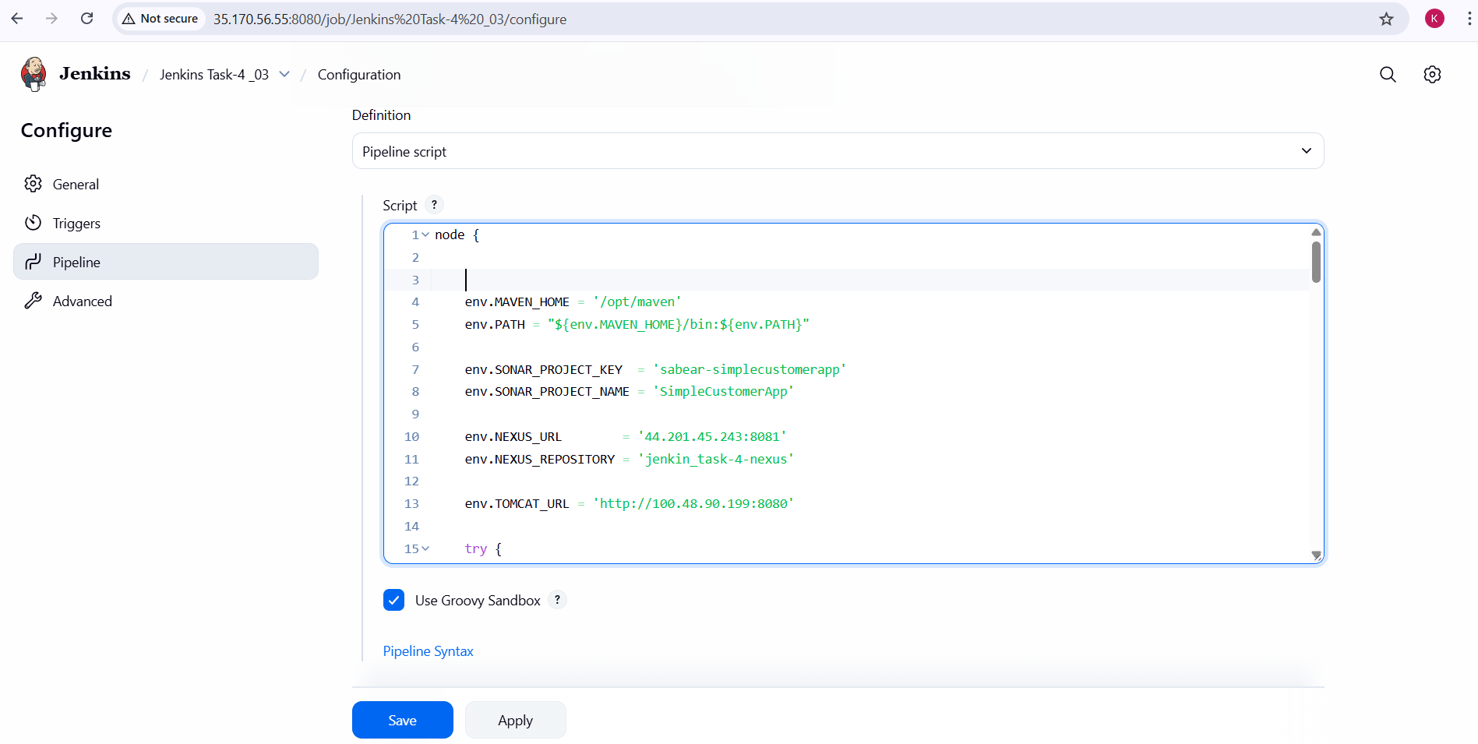

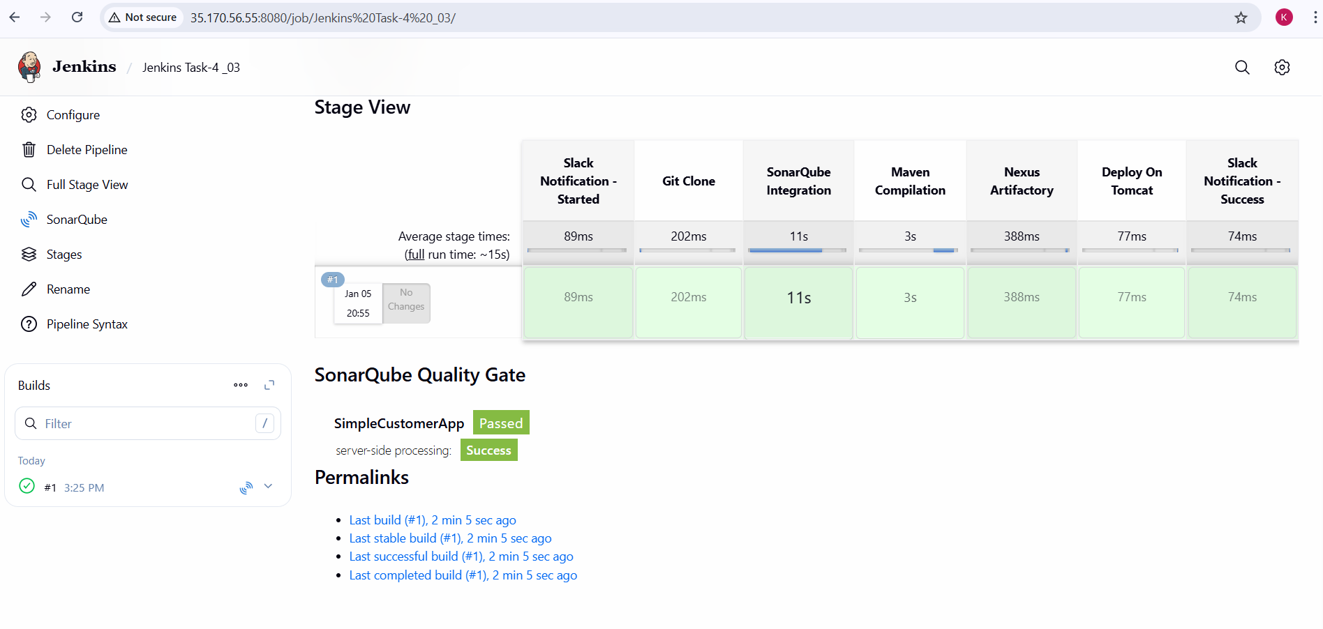

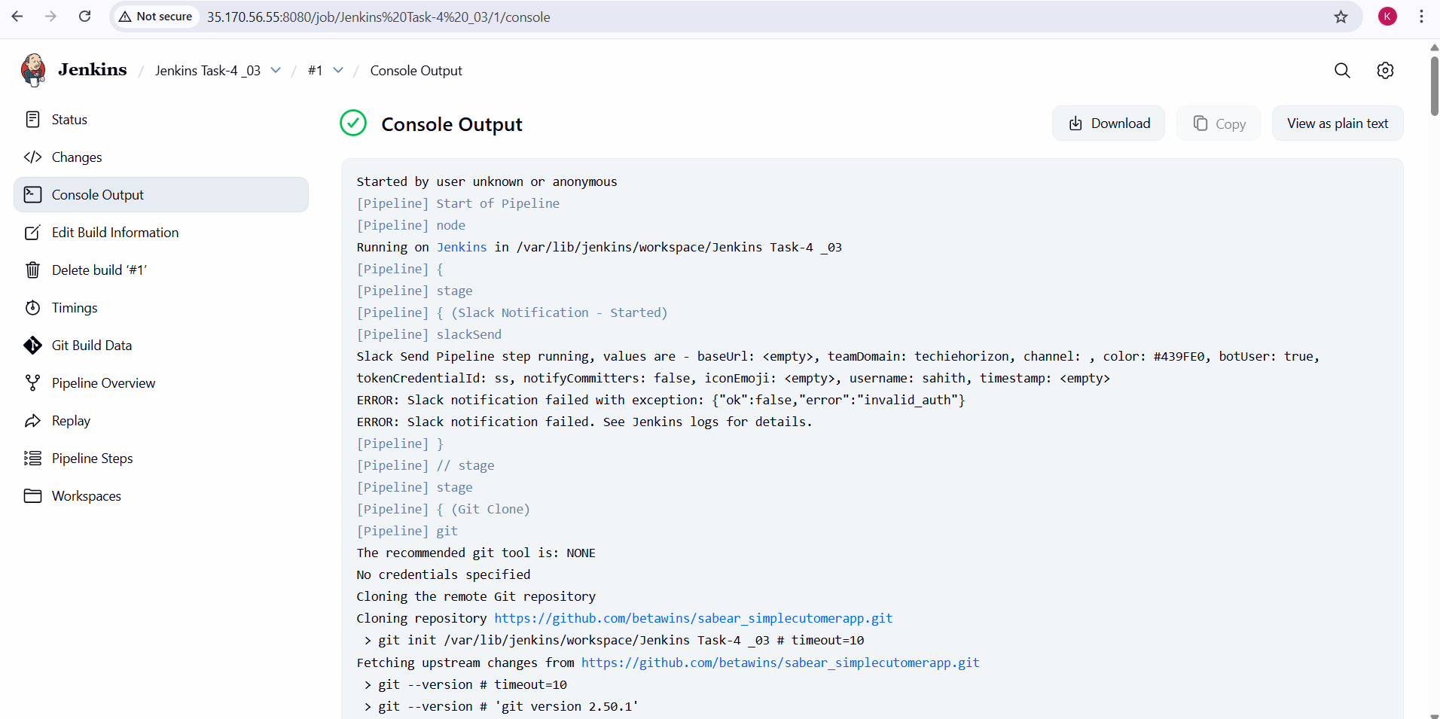

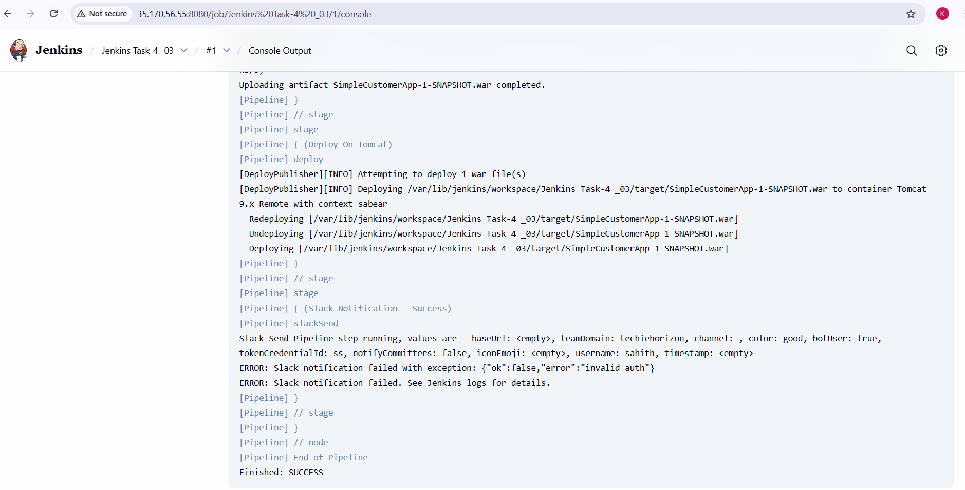

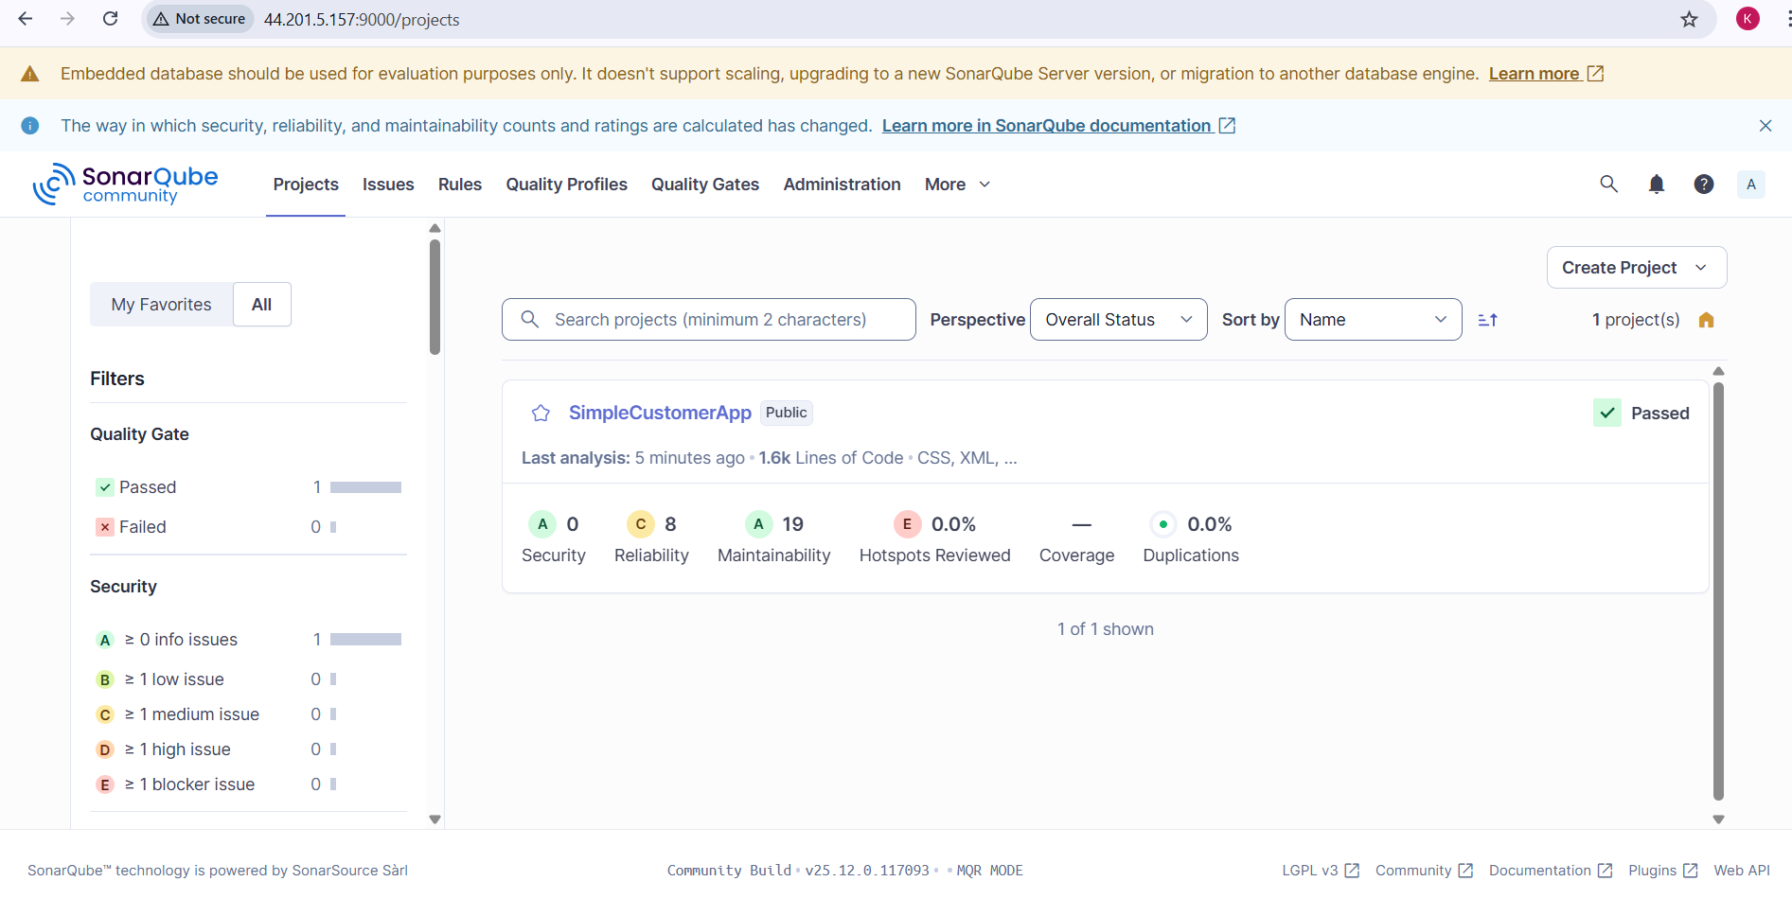

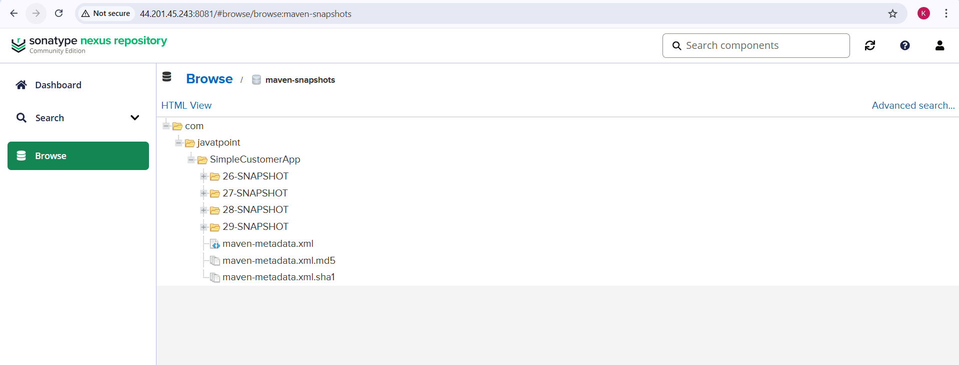

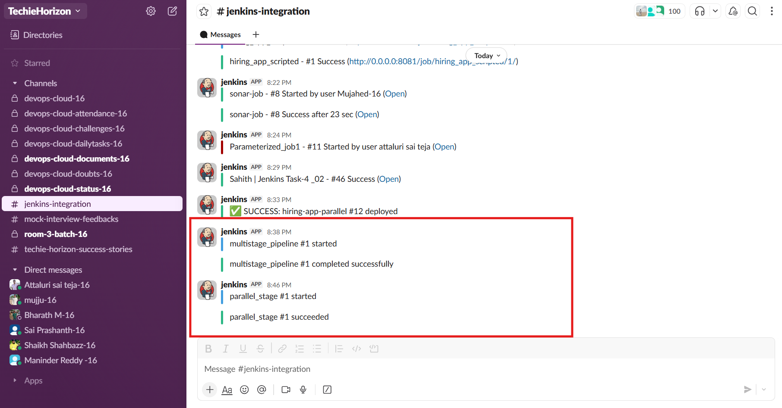

**Validation steps:**

1. Jenkins Stage View shows all stages completed successfully
2. SonarQube dashboard displays:
   1. Project analyzed
   2. Quality Gate **Passed**
3. Nexus Repository contains uploaded WAR artifacts
4. Tomcat Manager shows deployed application
5. Slack channel received:
   1. Build started notification
   2. Build success notification

**Issues / Errors Faced:**

1. Slack notifications initially failed due to:
   1. Invalid or missing Slack token
2. Resolved by:
   1. Correcting Slack credential configuration in Jenkins
3. No blocking issues in:
   1. Git clone
   2. SonarQube analysis
   3. Maven build
   4. Nexus upload
   5. Tomcat deployment

**Conclusion:**

A fully functional **Scripted Jenkins CI/CD pipeline** was successfully implemented for the SimpleCustomerApp using the feature-1.1 branch. The pipeline automates code checkout, quality analysis, build, artifact management, deployment, and notifications, demonstrating a complete real-world CI/CD workflow using Jenkins, SonarQube, Nexus, Tomcat, and Slack.

# Jenkins -04 (Task-04)

4. Write sample skeleton of pipelines.

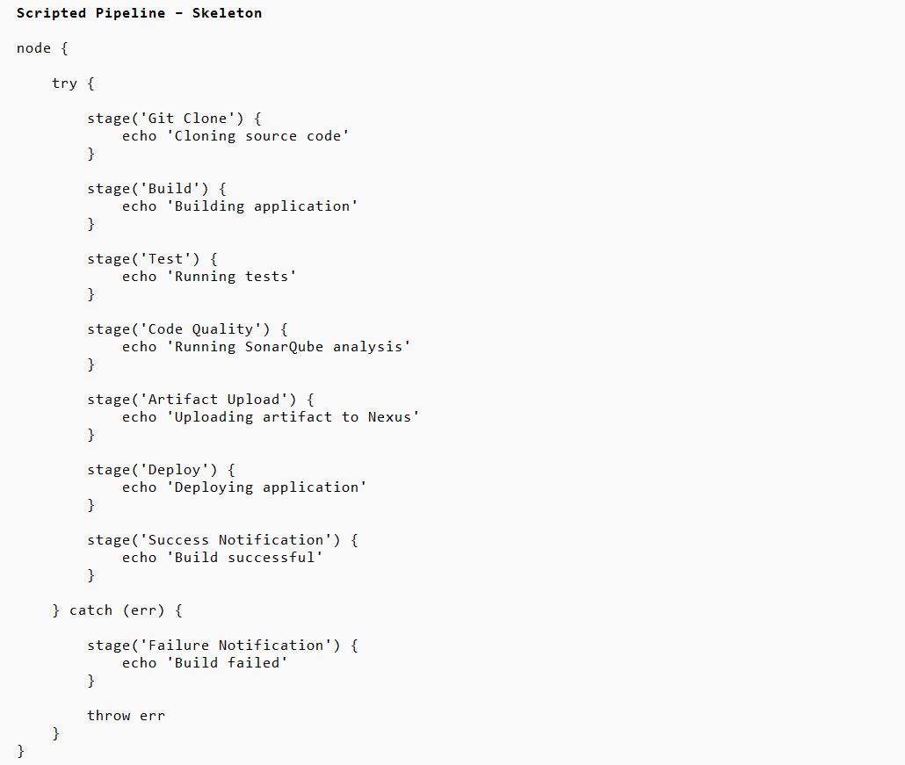

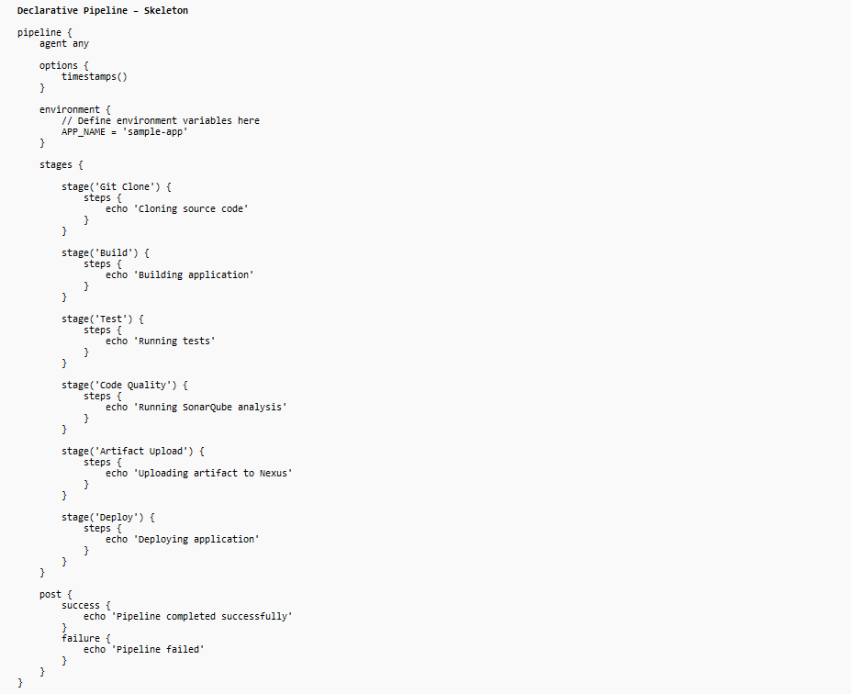

# Jenkins -04 (Task-05)

5. Create a parameterized job in Jenkins. <https://github.com/betawins/spring3-mvc-maven-xml-hello-world-1.git>

**Task Title**

Create a Parameterized Jenkins Job with Git, Maven, and Slack Integration

**Objective**

1. To create a Jenkins Freestyle job that supports **parameterized builds**.
2. To allow users to:
   1. Select the **deployment environment**.
   2. Choose the **Git branch** dynamically.
   3. Decide whether to **skip unit tests** during Maven build.
3. To integrate **Git SCM**, **Maven build**, and **Slack notifications** in a single Jenkins job.

**Prerequisites**

1. Jenkins server installed and running.
2. Jenkins user with job creation permissions.
3. Required Jenkins plugins installed:
   1. Git Plugin
   2. Maven Integration Plugin
   3. Slack Notification Plugin
4. Maven configured in **Global Tool Configuration** (MVN_HOME).
5. GitHub repository accessible:
   1. <https://github.com/betawins/spring3-mvc-maven-xml-hello-world-1.git>
6. Slack workspace and channel configured with Jenkins.
7. Internet access from Jenkins server.

**Task: Create a Parameterized Jenkins Job (Freestyle)**

**1. Create a New Jenkins Job**

1. Open Jenkins dashboard.
2. Click **New Item**.
3. Enter job name:  
   jenkins-04-spring3-parameterized-job
4. Select **Freestyle project**.
5. Click **OK**.

**2. Enable Parameterized Build**

1. Go to **Configure** page of the job.
2. Under **General** section:
   1. Enable **This project is parameterized**.

**3. Add Choice Parameter (Environment Selection)**

1. Click **Add Parameter** → **Choice Parameter**.
2. Configure as:
   1. **Name**: ENV
   2. **Choices**:
   3. dev
   4. qa
   5. prod
   6. **Description**: Environment selection for build.
3. This allows selecting environment at build time.

**4. Add String Parameter (Git Branch)**

* Click **Add Parameter** → **String Parameter**.
* Configure as:
  + **Name**: Git_Branch
  + **Default Value**: master
  + **Description**: git branch
* This enables dynamic branch selection during build.

**5. Add Boolean Parameter (Skip Tests)**

* Click **Add Parameter** → **Boolean Parameter**.
* Configure as:
  + **Name**: Skip_Tests
  + **Set by Default**: Tick
  + **Description**: skip unit tests
* This controls whether Maven tests should be skipped.

**6. Configure Source Code Management (Git)**

1. Go to **Source Code Management** section.
2. Select **Git**.
3. Enter Repository URL:
4. https://github.com/betawins/spring3-mvc-maven-xml-hello-world-1.git
5. In **Branches to build** → **Branch Specifier**, enter:
6. */${Git_Branch}
7. This connects SCM branch selection with the parameter.

**7. Configure Build Step (Maven)**

1. Go to **Build Steps** section.
2. Click **Add build step** → **Invoke top-level Maven targets**.
3. Configure as:
   1. **Maven Version**: MVN_HOME
   2. **Goals**:
   3. clean package -DskipTests=${Skip_Tests}
4. Maven build behavior now depends on the boolean parameter.

**8. Configure Post-Build Actions (Slack Notifications)**

1. Go to **Post-build Actions**.
2. Add **Slack Notifications**.
3. Enable:
   1. ✔️ Notify Build Start
   2. ✔️ Notify Success
4. This sends build status updates to Slack channel.

**9. Save and Run the Job**

1. Click **Save**.
2. Click **Build with Parameters**.
3. Select:
   1. ENV (dev / qa / prod)
   2. Git_Branch
   3. Skip_Tests (true/false)
4. Trigger the build.

**10. Validate Slack Notification**

1. Verify Slack channel receives:
   1. **BUILD STARTED**
   2. Job name and build number
   3. Triggered user details
2. Confirms Jenkins–Slack integration is working.

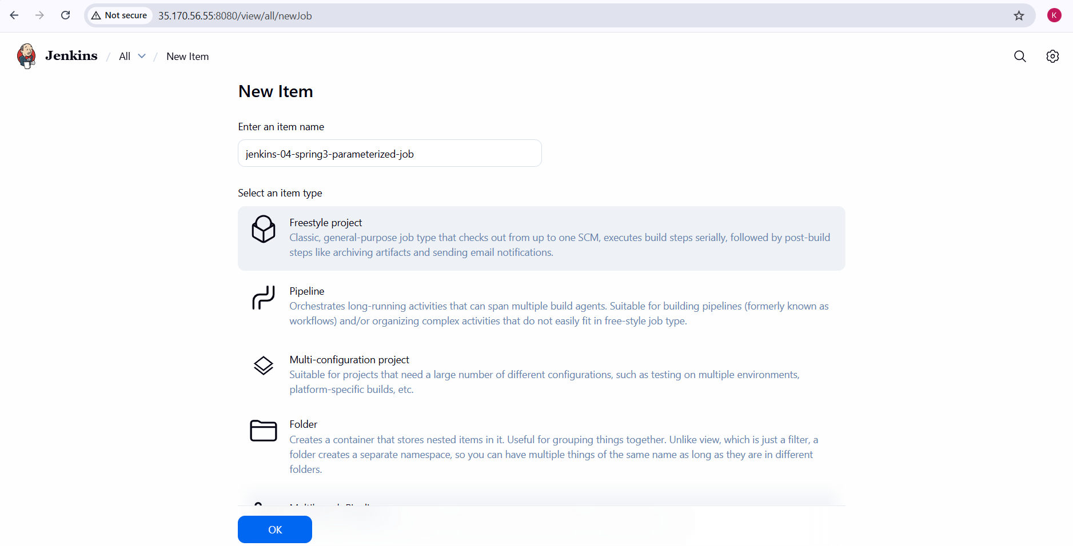

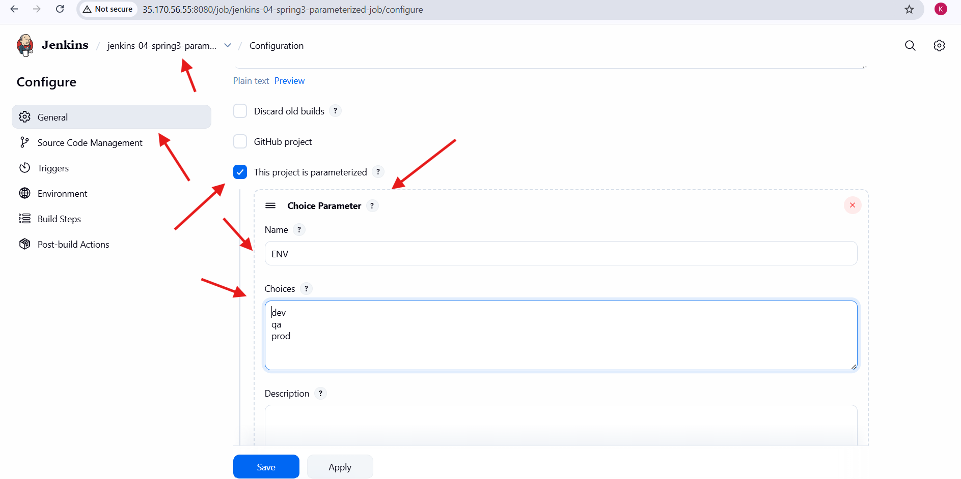

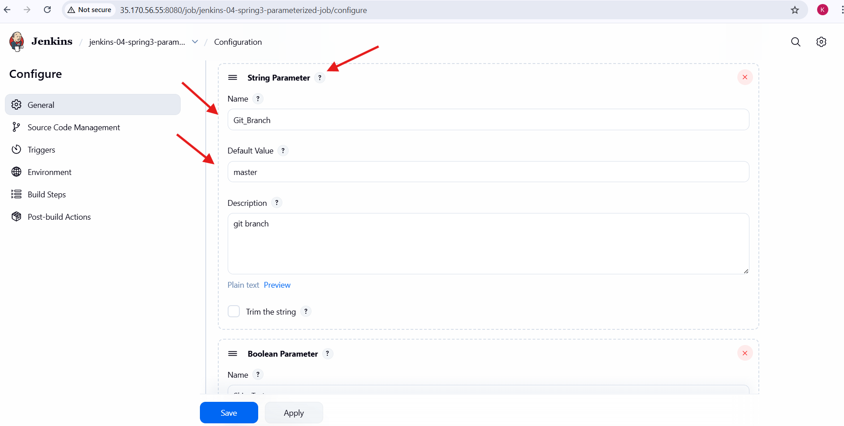

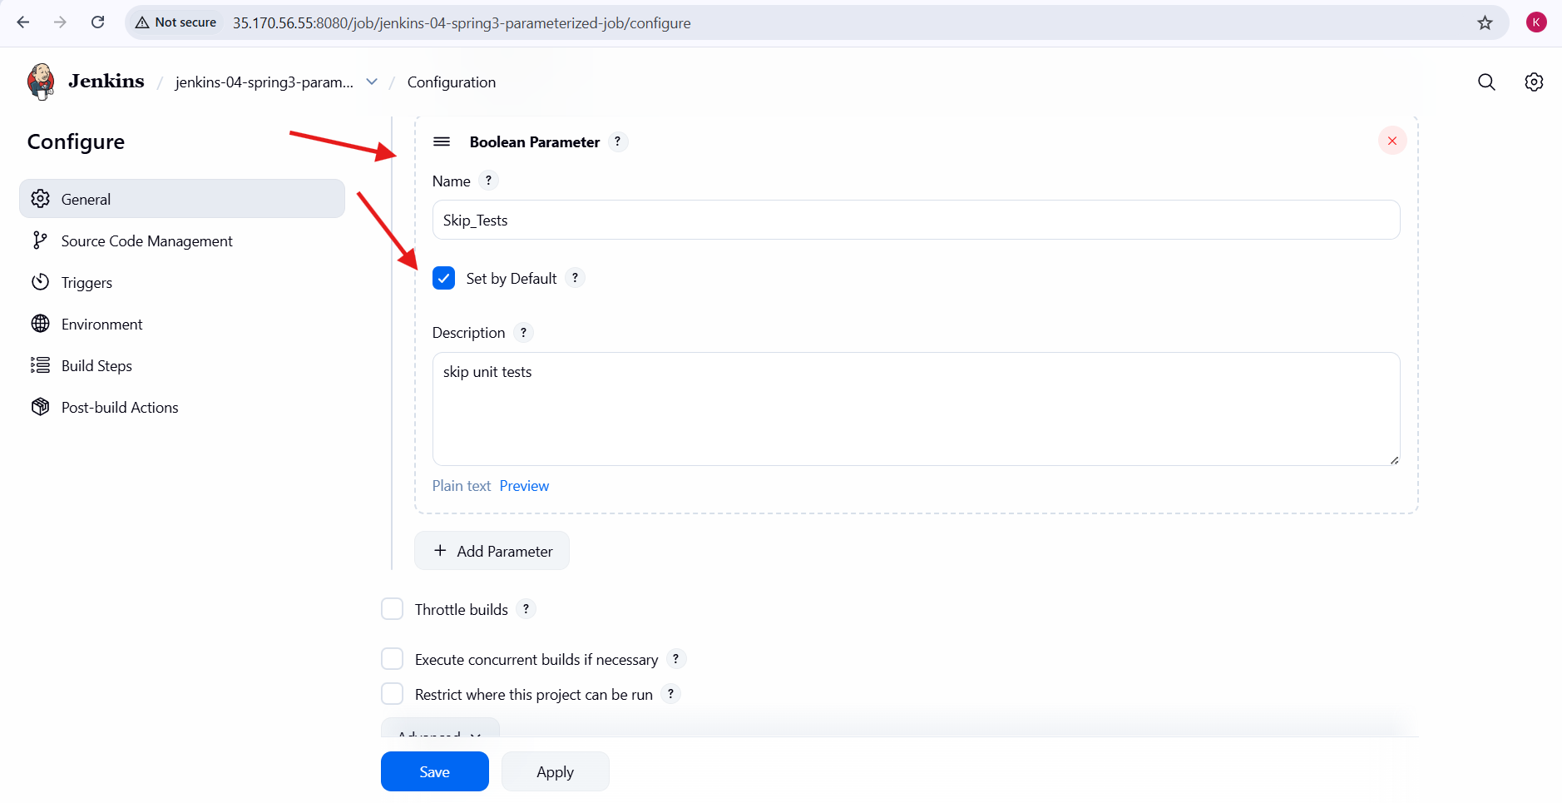

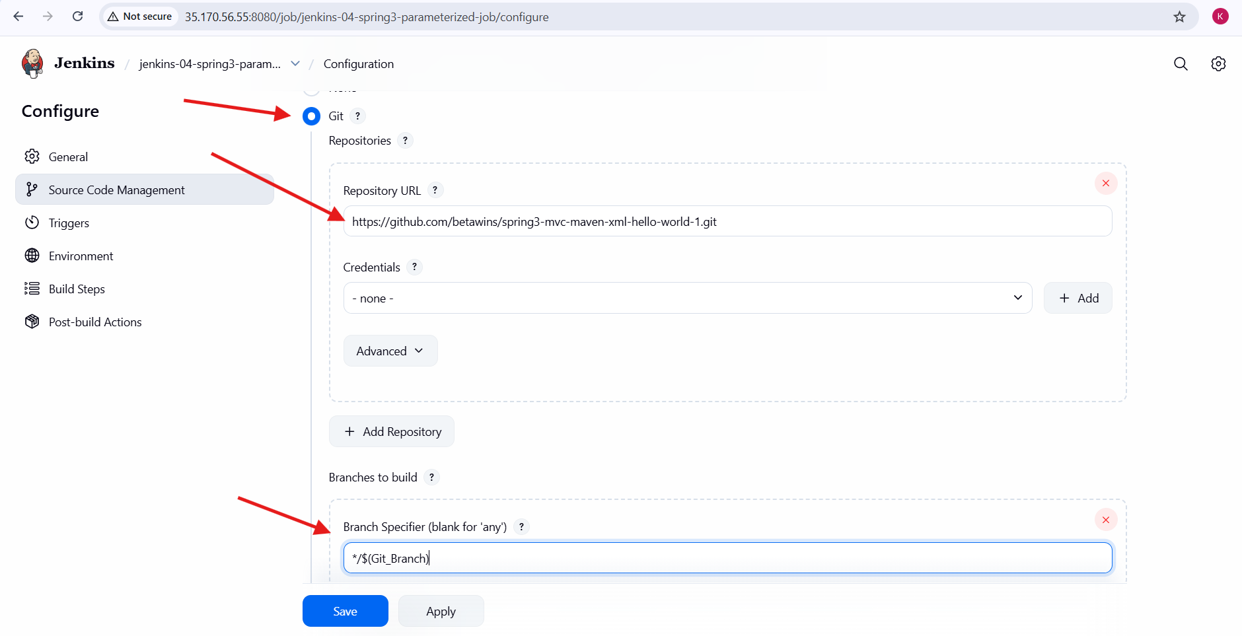

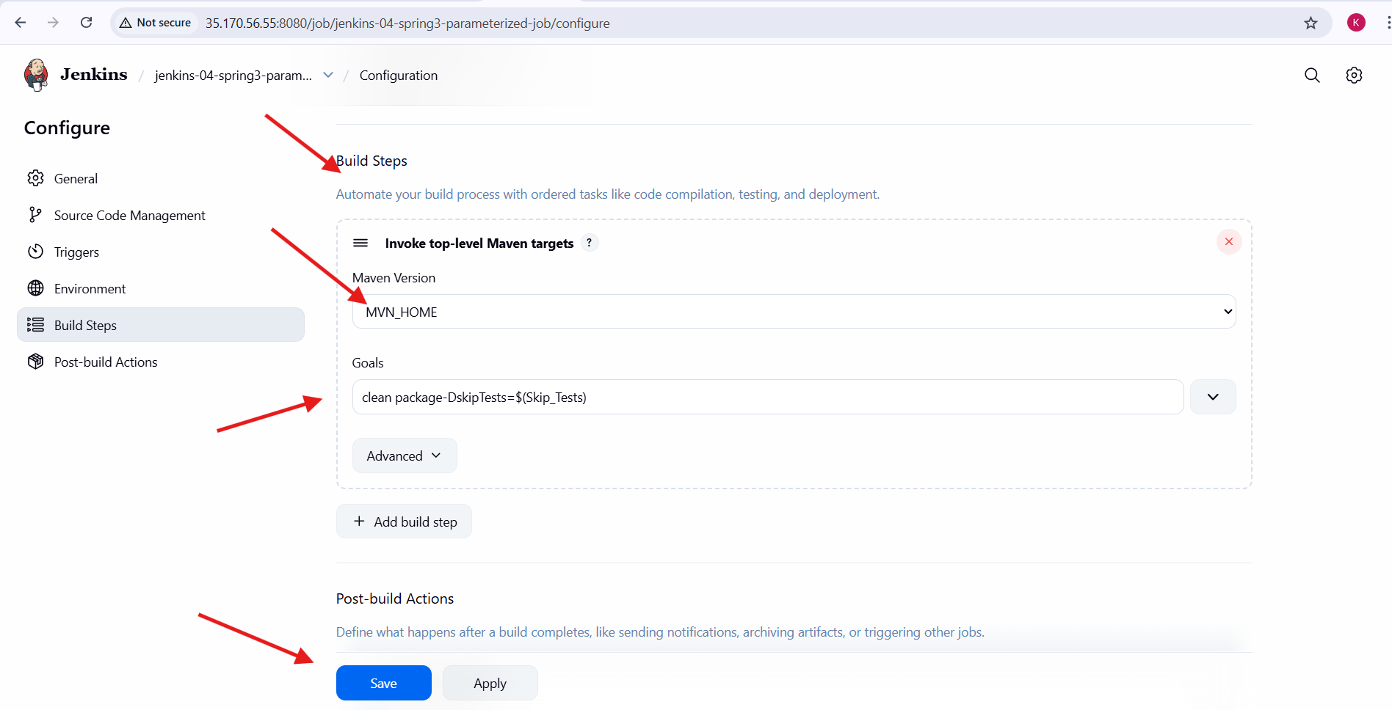

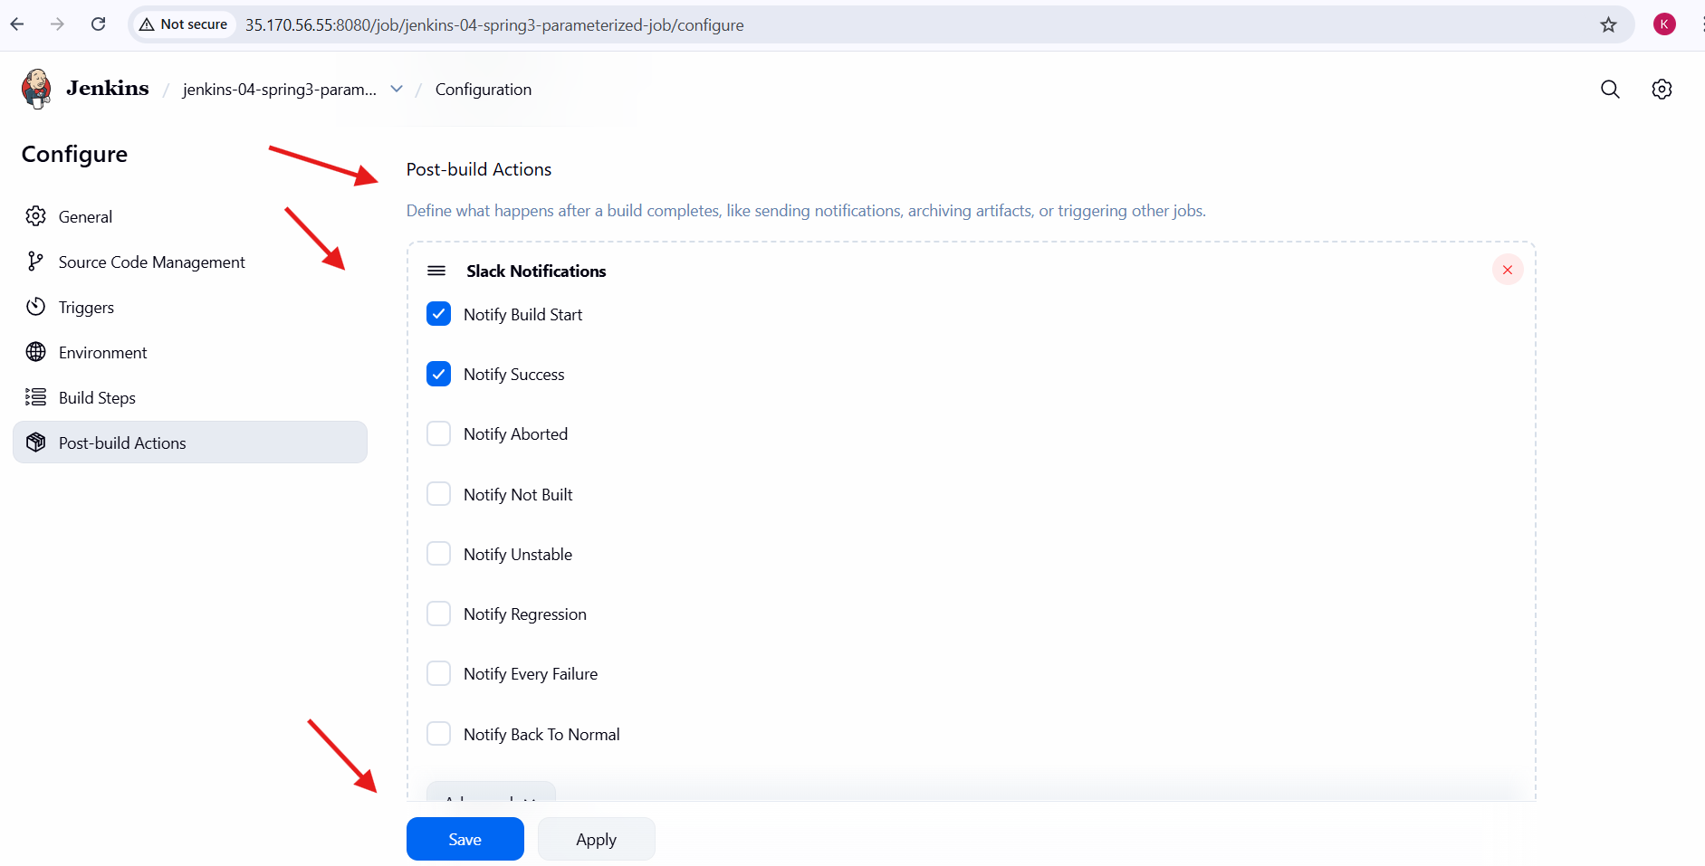

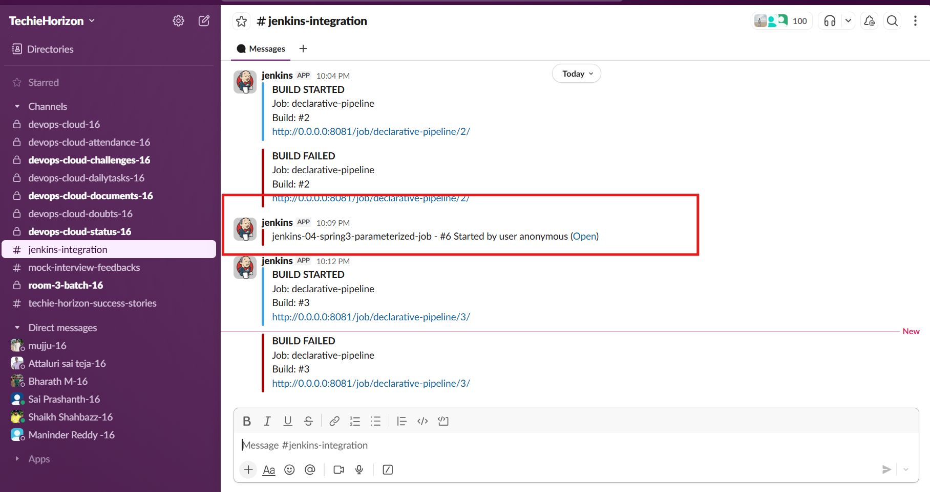

**Validation steps:**

1. Jenkins job appears with **Build with Parameters** option.
2. ENV parameter displays options: dev, qa, prod.
3. Git branch changes based on the Git_Branch parameter.
4. Maven build executes successfully with:
   1. Tests skipped when Skip_Tests = true.
   2. Tests executed when Skip_Tests = false.
5. Build logs show successful Git checkout and Maven execution.
6. Slack channel receives:
   1. Build started notification.
   2. Build success notification with job name and build number.

**Errors**

* **Incorrect branch name** in Git_Branch parameter causes SCM checkout failure.
* **Maven not configured** in Jenkins results in build failure.
* **Slack plugin misconfiguration** prevents notifications from being sent.
* **Network or permission issues** may block GitHub repository access.
* **Incorrect parameter reference** (${Git_Branch} or ${Skip_Tests}) may break the build logic.

**Conclusion**

* Successfully created a **parameterized Jenkins Freestyle job**.
* Parameters improved build flexibility and reusability.
* Integrated Git SCM, Maven build automation, and Slack notifications.
* This setup supports controlled, dynamic builds suitable for CI environments.
* The job can be easily extended for deployment stages or environment-specific actions.

# Jenkins -04 (Task-06)

**Task Title**

6. Setup one slave machine for Jenkins.

**Objective**

To configure one Jenkins slave (agent) machines and connect them to a Jenkins master server using SSH-based authentication on AWS EC2 instances.

**Prerequisites**

1. AWS account
2. 3 EC2 instances:
   1. 1 Jenkins Master
   2. slave-01
3. Amazon Linux 2 / Amazon Linux 2023 AMI
4. Java installed on all instances
5. Jenkins installed and running on Master
6. Port **22** open for SSH and **8080** open for Jenkins in Security Groups

**Architecture Overview**

1. Jenkins Master manages jobs
2. Jenkins Slaves execute jobs
3. Communication between Master and Slaves happens via SSH using key-based authentication

**Step 1: Launch EC2 Instances**

1. Launch **three EC2 instances** (t3. micro is sufficient for practice).
2. Name them:
   1. Master
   2. slave-01

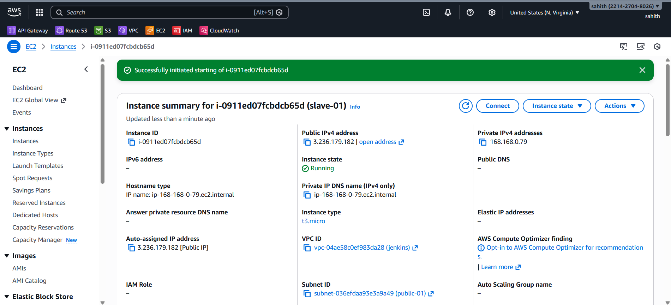

**3.Attach Security Group with:**

* 1. SSH (22) – Anywhere or your IP
  2. Custom TCP (8080) – Anywhere (for Jenkins UI)

**Step 2: Install Java on All Instances**

1. Login to Master, slave-01.
2. Install Java using the below command:

sudo yum install java-17-amazon-corretto -y

1. Verify Java installation using:

java -version

**Step 3: Install Jenkins on Master**

1. Login to Master instance.
2. Install Jenkins using the following commands:

sudo wget -O /etc/yum.repos.d/jenkins.repo https://pkg.jenkins.io/redhat-stable/jenkins.repo  
sudo rpm --import <https://pkg.jenkins.io/redhat-stable/jenkins.io-2023.key>  
sudo yum install jenkins -y

1. Start and enable Jenkins service:

sudo systemctl start jenkins  
sudo systemctl enable jenkins

1. Open Jenkins UI in browser using:

http://<Master-Public-IP>:8080

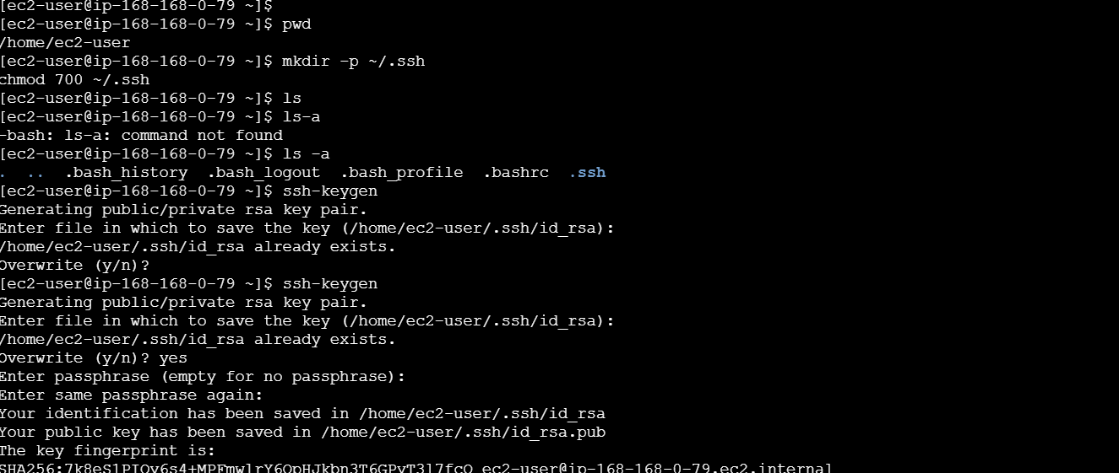

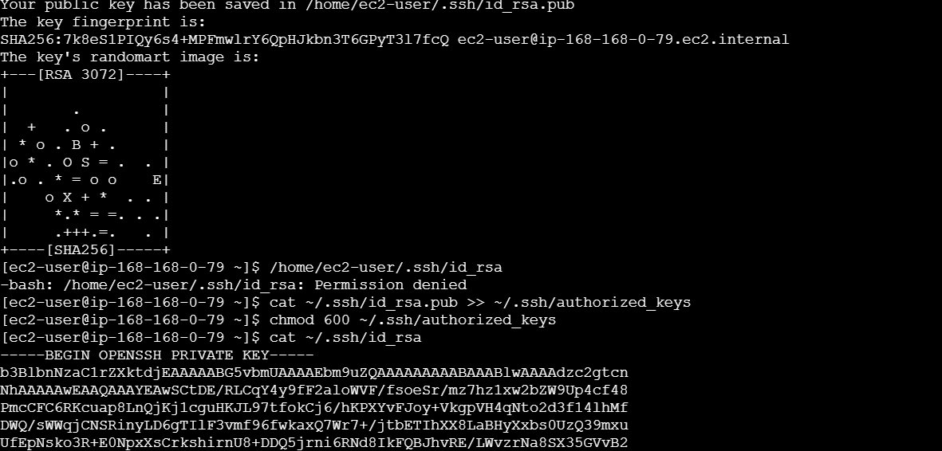

**Step 4: Generate SSH Keys on Slave Machines**

1. Login to slave-01 instance.
2. Create .ssh directory:

mkdir -p ~/.ssh  
chmod 700 ~/.ssh

1. Generate SSH key pair:

ssh-keygen

1. Press Enter for all prompts (do not set passphrase).

**Step 5: Configure Authorized Keys on Slaves**

* On slave machine, run:

cat ~/.ssh/id_rsa.pub >> ~/.ssh/authorized_keys  
chmod 600 ~/.ssh/authorized_keys

* Verify files exist using:

ls ~/.ssh

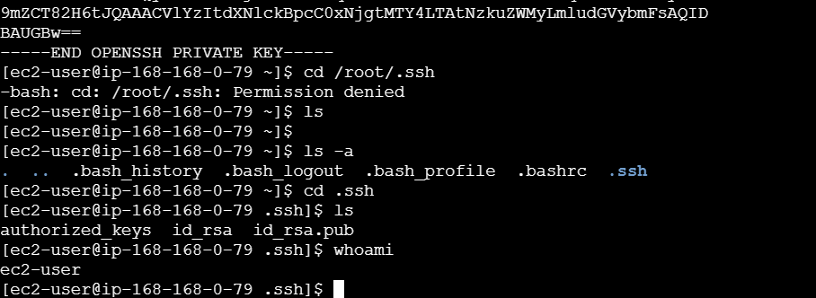

**Step 6: Add SSH Credentials in Jenkins**

1. Open Jenkins dashboard.
2. Go to Manage Jenkins → Credentials → System → Global credentials.
3. Click on Add Credentials.
4. Select Kind as “SSH Username with private key”.
5. Enter username as ec2-user.
6. Select “Enter directly” for private key.
7. Copy the private key from slave machine using:

cat ~/.ssh/id_rsa

1. Paste the private key into Jenkins.
2. Set ID as slave-01.
3. Save the credentials.
4. Repeat the same steps for slave-02.

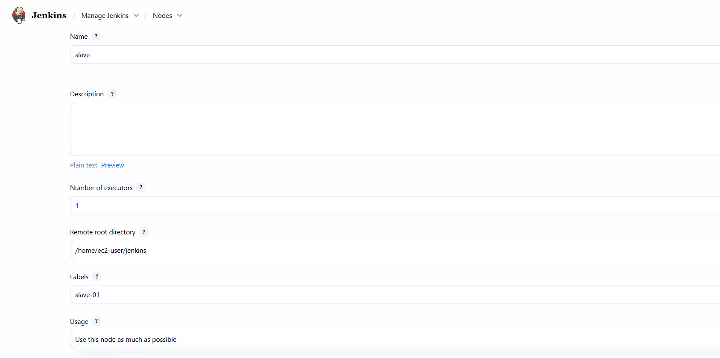

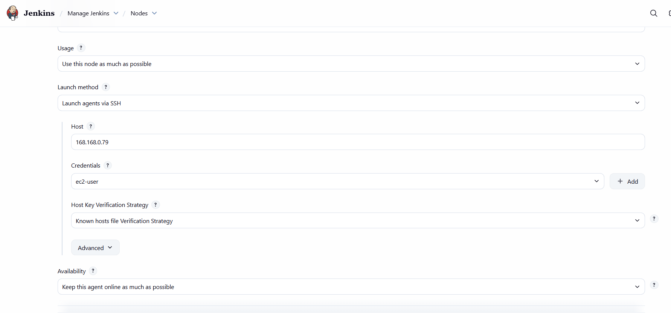

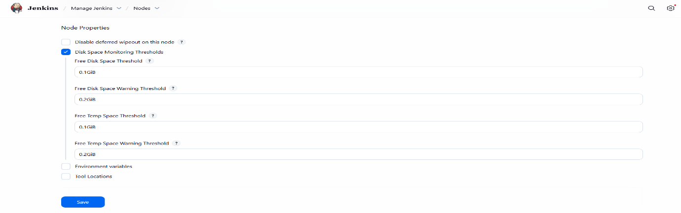

**Step 8: Verify Slave Connection**

1. Go to Manage Jenkins → Nodes.
2. Check the status of slave-01 and slave-02.
3. Both nodes should appear Online.
4. Executor status should show 1/1.

**Conclusion:**

In this task, Jenkins master was successfully configured with two slave (agent) machines using SSH on AWS EC2 instances. SSH key-based authentication was implemented to allow secure communication between the master and slave nodes. Both slave nodes were added as permanent agents and verified to be online and ready to execute build jobs. This setup helps distribute build workloads efficiently, improves performance, and demonstrates a practical understanding of Jenkins distributed architecture in a real-time AWS environment.